CenturyLink EASE VFO

ASR User Guide

Version - Revision History

All versions of this document are listed in chronological order:

ASOG Version | Date | Description
58.0 | 3/16/2019 | Final
58.1 | 5/14/2019 | Update External App, - EASE ASR Status Tool
58.2 | 5/16/2019 | Update – Password Reset

This document has been through a formal review process. To the best of our knowledge, it is accurate. There may be further modifications and we reserve the right to make those modifications. The content of the document may change after issuance.

Table of Contents
Documentation Overview 5
CenturyLink IT Wholesale Systems Help Desk Roles and Responsibilities 6
Limitations for CenturyLink ASR Support 6
Hours of Availability for EASE 6
Change Management Process 7
Service Level Agreements 7
ASR Ordering Systems Information Guide 8
Implementing UOM Pre-Order, UOM Ordering, and/or EASE VFO 11
EASE VFO ASR Overview 12
Navigating in EASE 12
EASE Access 13
EASE Login Instructions 15
EASE Home Page ICONs 17
Filtering Information for the Order List 18
EASE Home Page Tabs 19
ORDER Tab 21
New 21
Search 22
Save As Order 24
Save As Template 31
View History 34
Create Response 36
Resend 37
Disconnect 38
Reassign Order 40
External APP Data Overview 40
Archival GUI 41
ASR Notes 43
ASR Status Tool 44
BAN Inquiry 46
NC/NCI Inquiry 50
PREORDER Tab 54
EASE CFA Inquiry 55
EASE CLLI_SCAN Inquiry 60
EASE Ethernet Inquiry 65
EASE Location Inquiry 72
EASE PREORDER Search Function 80
TEMPLATE Tab 83
Creating a NEW template 84
Using SEARCH in the Template Tab 87
Viewing the Template List 87
Selecting a Template 87
Deleting a Template 88
Creating an Order in EASE VFO 89
ORDER Tab 95
PREORDER Tab 98
Order Header Information 99
Associated ASR forms 100
Navigating within the Created Order 101
Appendix 1 - Order Status 106
Appendix 2 - Order Types 116
Appendix 3 – EASE UOM Implementation Guidelines 120

Documentation Overview

Overview | This User guide provide additional information on the implementation process, business and configuration parameters, and provides the user with instruction for using the EASE system to preform Pre-Order Activities as well as create, modify, cancel, and submit Access Service Requests (ASRs). This guide is meant for a generic order representation only.  The EASE ordering process follows the Access Service Request Ordering Guidelines (ASOG) located at http://www.atis.org/atis/clc/obf/download.htm. The Customer is responsible for obtaining permissions and rights to the ATIS documentation. The ASOG and custom business rules should be referenced for specific guidelines in the population of fields for specific order submission.  The content of the document may change after issuance. To notify CLECs/IXCs of any changes to EASE, CenturyLink will issue an Addendum to the document. The Addendum will be placed on the CenturyLink website and a Release Notification will be distributed to the CLECs/IXCs. Additionally, the Order Technical Specifications Document will be updated as required to correct for documentation and/or system bugs.  Information specific to each ASOG Industry Upgrade is made available to the CLEC/IXC/WSP based on CMP guidelines and summarized in the schedule in  Table 1.

PUBLICATION | SCHEDULED DELIVERY
Draft Order/Pre-Order Technical Specifications | 73 days before Industry Upgrade Date
Draft EASE ASR Technical Specifications | 73 days before Industry Upgrade Date
Final Order/Pre-Order Technical Specifications | 45 days before Industry Upgrade Date
Final EASE ASR Technical Specifications | 45 days before Industry Upgrade Date
Table 1

Whom to Call and When | If you need an account created or changes to your CCNA permissions or personal information (name, email address, etc.), contact your EASE system administrator at Helpdesk.EASE@CenturyLink.com.  For ASR Ordering Systems Information, go to http://EASE.centurylink.com/.  Requirement updates and additional questions and answers can be found at the CenturyLink ASR Ordering Systems web site at http://EASE.centurylink.com/.  For all other problems, call the Wholesale Systems Help Desk:  1-888-796-9102, option 2  Monday – Friday 6:00 am – 7:00 pm (Mountain Time)  Saturday 7:00 am to 2:00 pm (Mountain Time)

CenturyLink IT Wholesale Systems Help Desk Roles and Responsibilities | CenturyLink IT Wholesale Systems Help Desk (WSHD) personnel will provide information and resolution for EASE Pre-order transaction processing problems that are caused by failure of CenturyLink environment hardware or software components. This resolution may be in the form of direct action or through escalation to the appropriate individuals within CenturyLink.  If the WSHD cannot resolve the issue during the initial phone call, they will escalate to Tier 2 Production Support. The Tier 2 Support Team will then resolve and close the issue directly with the person that reported the issue.

Limitations for CenturyLink ASR Support | The CenturyLink IT Wholesale Help Desk is not designed to provide assistance with transaction failure caused wholly or in part by failure of any component of the CLEC/IXC/WSP ASR processing environment.  Questions regarding Order content, Order writing procedures or transaction status should be referred to the CLEC CenturyLink Service Manager or refer to the Industry ASOG documents.

Hours of Availability for EASE | The hours of availability can be found at: http://www.centurylink.com/wholesale/cmp/ossHours.html

Change Management Process | CenturyLink facilitates a regularly-scheduled forum in which CenturyLink and the CLECs/IXCs communicate about Operational Support System (OSS) interface changes, release lifecycles, release notifications, and communication intervals. The CenturyLink CLEC/IXC/WSP Industry change management forum is referred to as the Change Management Process (CMP).  CenturyLink encourages CLECs implementing EASE to participate in the CMP process. Online registration can be found on the CMP website page. Release notifications, team meeting information, and change requests are also provided to all registered team members via e-mail. For further CMP information, please refer to the following website: http://www.centurylink.com/wholesale/cmp/index.html  During testing with CLECs/IXCs, situations may occur that require CenturyLink to submit a Change Request internal to CenturyLink to fix an issue in CenturyLink's Test systems. When an issue is discovered that substantially impacts a CLEC'/IXC’s ability to send an ASR transaction, notification will be distributed via e-mail within three (3) business-days. Notification of any production issues will follow the CMP guidelines section 2.0. Please refer to the following URL for more information: http://www.centurylink.com/wholesale/cmp/whatiscmp.html CenturyLink will notify all CLECs/IXCs that have subscribed to the unplanned event notifications and Test environment notifications. It is the CLEC/IXC/WSP’s responsibility to subscribe to those notifications they wish to receive. The notification will include a description of the problem and, if known, a potential fix date. If a fix date is not known, CenturyLink will update all impacted CLECs/IXCs with the fix date when known.

Service Level Agreements | Outside of the CenturyLink Interconnect Agreement, CenturyLink does not maintain separate service level agreements with CLECs, nor will CenturyLink have a service level agreement with any Service Bureau directly. However, a CLEC may have specific contractual date and time frames for service delivery stated in their Interconnection Agreement with CenturyLink. In this situation, those contractual date and time frames for service extend to the Service Bureau, who is acting as an Agent for the CLEC.

ASR Ordering Systems Information Guide

Overview | CenturyLink ordering systems is based on guidelines maintained by the American Telecommunication Industry Standards (ATIS) Ordering and Billing Forum (OBF). CenturyLink utilizes information within the Access Service Order Guidelines (ASOG) to determine industry and custom requirements for all access orders. Additional information regarding ATIS can be found at: http://www.atis.org/obf/index.asp.  CenturyLink follows the Access Service Ordering Guidelines (ASOG) for ordering. These guidelines define order attributes as well as the published implementation date for implementation of the industry standards. In addition to the Summary of Changes that outlines the industry changes, CenturyLink will also provide all company specific differences and custom rules.  The CenturyLink Business Rules Differences List is comprised of the differences in CenturyLink’s implementation to the industry guidelines.

Record Retention Policy | ASRs that have been submitted to CenturyLink and accepted will be retained in the database for a period of 2 years. CenturyLink will perform a purge of these records twice annually in January and July. The purge date will be based on the date of the last activity transmitted on the ASR. For example, if the date the C/NR form for completion or cancellation of the ASR is November 2015, the deletion of this record would occur in January 2018 and once purged will no longer be accessible to you.  Requests that have been created but not submitted to CenturyLink will not be purged from the database regardless of the date created. However, unsubmitted ASRs that have not been modified for more than 2 years whose "Last Edited User" is no longer a valid user in the system may be purged at CenturyLink's discretion.

Browser Guidelines | Your browser may ask whether you want passwords and information you type to be saved for future use. If you see a message asking you to save your password or other information, do not do so. Saving your password may create security problems. Saving other information may not work as intended within the system.

Password Rules | Customer users can change their own passwords using the following rules:  Passwords chosen must:  - Be at least 8 characters in length but not more than 16 characters  - Contain at least one character from any three of the following four categories  - Uppercase alphabets (A-Z)  - Lowercase alphabets (a-z)  - Numbers (0-9)  - Special characters (~ ` ! @ # $ % ^ & * ( ) - _ = + { } [ ] \ | ; : ‘ “ , . < > / ?)  Passwords chosen must not:  - Contain a space  - Be “password” itself  - Be the same as the login user name  Be the same as the old password that is being changed

Methods for submitting an ASR | The CenturyLink EASE ASR ordering system currently supports 3 methods of order submission: Paper, EASE VFO (Virtual Front Office), EASE UOM Ordering Interface.  Please note: All paper orders received by CenturyLink will be entered into VFO.

EASE VFO (Virtual Front Office) | - The Electronic Administration & Service Exchange Virtual Front Office (EASE VFO) if the on-line GUI application for the EASE ASR.  - VFO will support Internet Explorer version 11 and Google Chrome. Users will receive the following prompt when trying to use any other version:  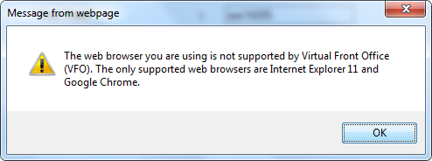  - EASE VFO is an online application GUI that provides Wholesale customers the ability to submit ASR order and pre-order transactions to CenturyLink over the internet. Because this is a GUI application, form and field edits are performed upfront giving the user an opportunity to correct any errors before the transaction is submitted. Responses are returned to the customer’s GUI in real time.  - Because this is a web services interface, there are no dedicated circuit requirements for access. The CLEC/IXC/WSP must have internal policies and processes in place to support sending and receiving pre-order transactions over the public internet. Because this is a web services interface, there are no dedicated circuit requirements for access. The CLEC/IXC/WSP must have internal policies and processes in place to support sending and receiving pre-order transactions over the public internet.  - Information obtaining access to EASE VFO can be found on the CenturyLink Wholesale Business website at http://www.centurylink.com/wholesale/systems/ossconsolid.html.  - Internal CenturyLink employees will have access to VFO for order submission and tracking.  - Orders submitted to CenturyLink can be tracked in VFO.

EASE VFO Standards | Following are standard guidelines to follow when working in EASE VFO  - UPPERCASE must be used when creating orders. Failure to use UPPERCASE may cause issues with an order not routing properly, or not routing at all.  - A user can edit all fields unless they are grayed out. Fields that are systematically populated cannot be edited.  - Avoid copying/pasting text from other applications (Word, Excel, PDF, and so on) into fields. Doing so may introduce "garbage characters" (carriage returns, tabs, line feeds, unsupported non-ASCII characters, and so on) that cannot be interpreted or translated properly when the data is transferred. Once a situation like this occurs, the only workaround is to perform a copy-to-new function and fix the offending field prior to requesting a validation, which forces the user to submit the ASR under a different PON. The workaround is cumbersome, and data could be unrecoverable if the situation occurs on a SUP.

EASE UOM Ordering Interface | - The UOM XML is developed according to industry guidelines provided by OBF. The UOM XML Interface is based on Telecommunications XML standards found in the UOM (Unified Order Model) document.  - Access to the EASE UOM XML functions will be over the public internet. XML Pre-Order uses a web services interface using http basic authentication with user name and password provided by CenturyLink. Specifics associated with the web service will be provided by CenturyLink as part of the implementation prior to connectivity testing.

Implementing UOM Pre-Order, UOM Ordering, and/or EASE VFO | When you are ready to process orders within the CenturyLink regions, your CenturyLink Service Manager would be happy to refer your company to the appropriate CenturyLink ASR implementation project manager on your behalf to begin the ASR Implementation Process. If a Third-Party Software Vendor or Service Bureau is involved in the testing, they can also be a part of the kick-off meeting.  After initial contact with the service manager, each CLEC/IXC/WSP will be provided with a CenturyLink Implementation Project Manager. The Implementation Project Manager will work with the CLEC/IXC/WSP throughout the implementation and will fill the following roles:  - Project Manager (PM): Responsible for facilitating meetings, coordinating the overall project plan, and is the primary point of contact for CLEC/IXC/WSP during the entire implementation process.  - Business Analyst (BA): Responsible for providing assistance with the business rules that govern the ASR process and are enforced by the EASE Gateways

Historical Information | All historical documentation regarding ordering can be found at: http://www.centurylink.com/wholesale/systems/ossconsolid.html

EASE VFO ASR Overview | CenturyLink’s EASE ASR ordering system currently supports the following industry defined functionality:  Pre-Order Functions  - CFA Inquiry  - CLLI_SCAN Inquiry  - Ethernet Inquiry  - Location Inquiry  Order Functions  - CenturyLink supports all ATIS/OBF-ASO ordering guidelines for the products and services outlined in the various CenturyLink tariffs and product description documents.  - Provider initiated Order Responses such as:  - Clarification/Notification Requests  - Completion Notification  - Design Layout Record  - Firm Order Confirmation  - Jeopardy Notification  CenturyLink also supports additional custom EASE functionality thru a custom tab entitled External App Data:  - ArchivalGUI  - NcNciInquiry  - BANInquiry  - ASRNotes  - ASRStatusTool

Navigating in EASE | To navigate in EASE, use the top row of buttons and the system tabs:

 | Click this button / tab... |  | To do this...
 | Home |  | Return to the Order List page
 | About |  | Open a pop-up window that lists login name of current user, current user’s full name, date and time the current version of the application was installed, VFO copyright information
 | Logout |  | Logout of VFO and return to the login page
 | Order |  | Access functionality to create or search for an order
 | PreOrder |  | Initiate, search, and / or submit pre-order transactions
 | Template |  | Access functionality to create or search for a template
 | Administration |  | Access User Profiles and other security related information. This tab will only be visible if you have sufficient permissions
 | Help |  | Access VFO Online Help
EASE Access |  | EASE is accessed via the following URL: http://EASE.centurylink.com

TAB | Explanation
Home | The home page of EASE will present with several tabs: Home, VFO, Guide, Schedules, Contact Us, as well as a hyperlink to the Address Validation Utility Tool.  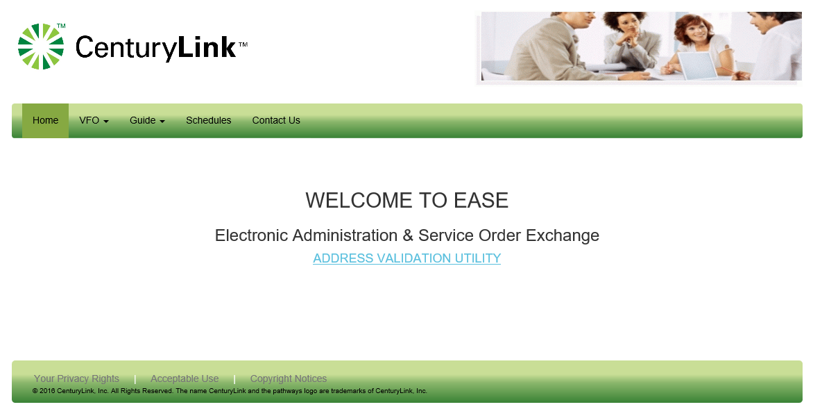
VFO | The VFO dropdown provides access to the Virtual Front Office (ASR) and the Reference Table Maintenance (ASR).  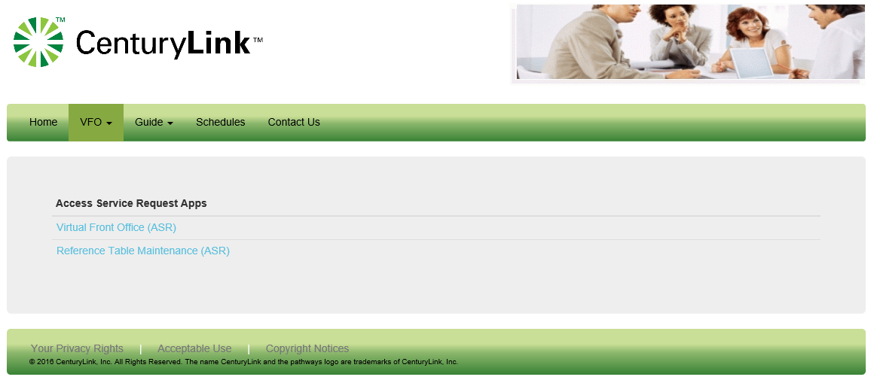
Guide | The Guide dropdown provides access to guides for ASR and LSR. For the purpose of this document, only the ASR portion is discussed. By Selecting the ASR option, a user will have the ability to view several guides housed in EASE.  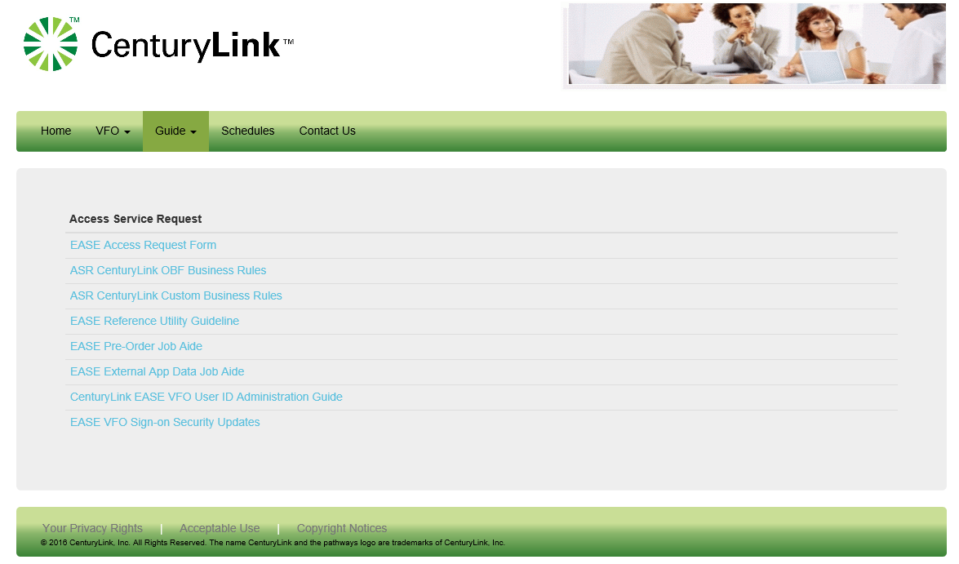
Schedules | The Schedules dropdown provides additional information regarding any upcoming changes.  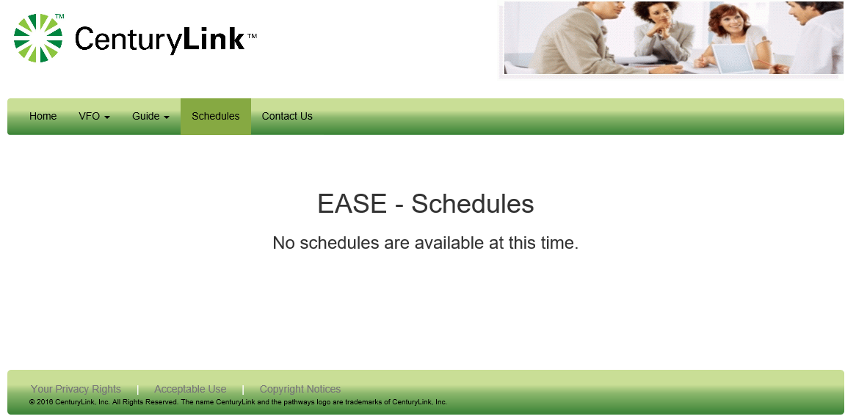
Contact Us | Contact Us provides additional contact information for EASE support as well as ordering and provisioning questions.  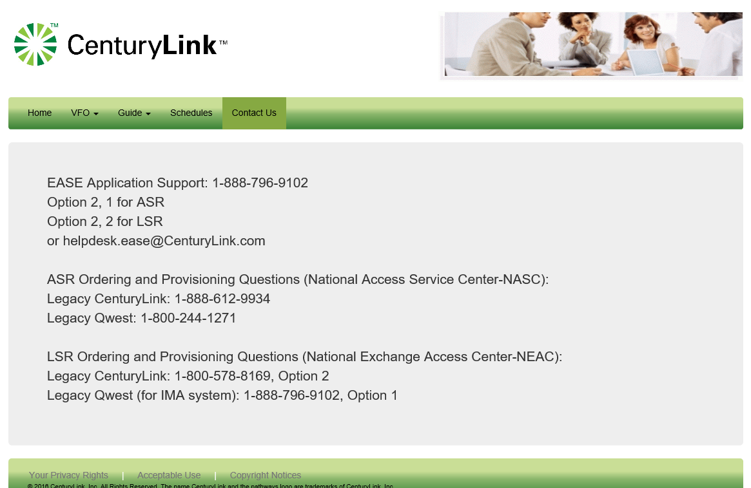
EASE Login Instructions | To Login to the EASE VFO application, please use the following steps:
  STEP | Action
  1 | EASE is accessed via the following URL: http://EASE.centurylink.com  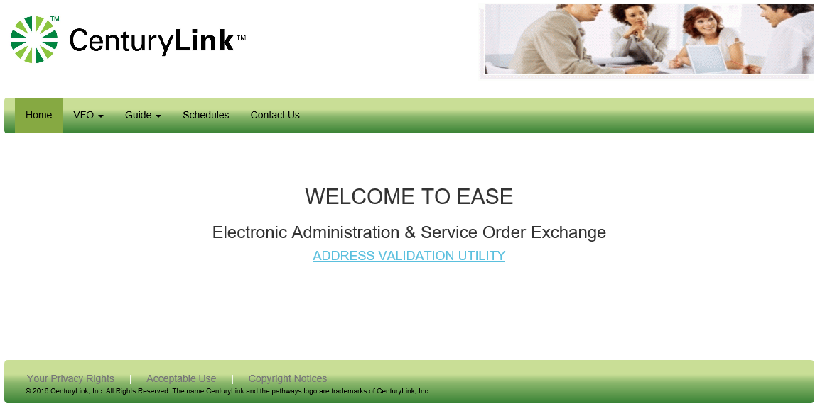
  2 | Select ASR from the VFO drop-down menu  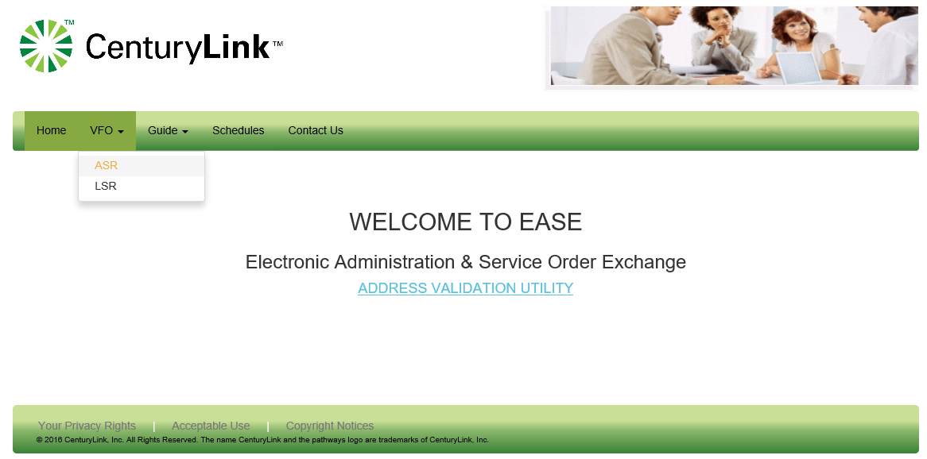
  3 | Select Virtual Front Office (ASR) from the Access Service Request Apps  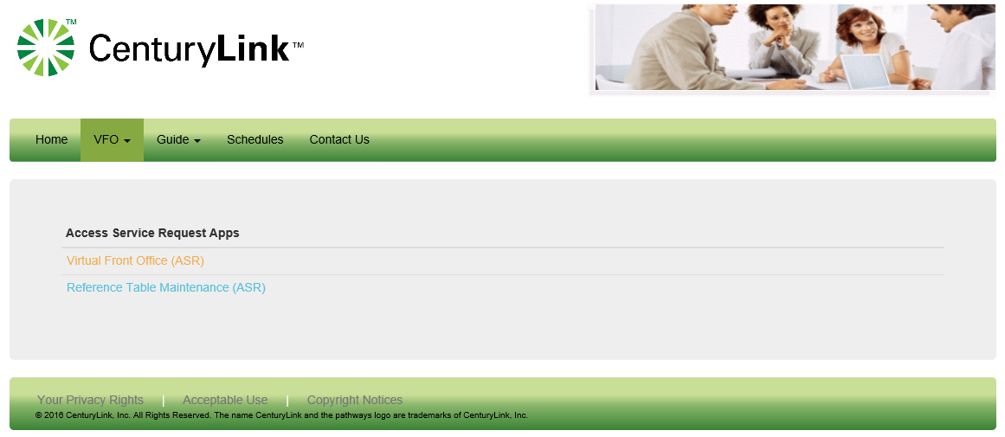
  4 | EASE VFO users are required to login with established credentials.  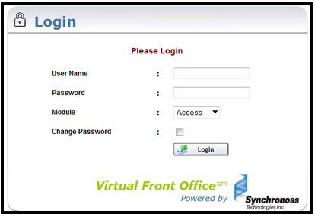  You will be required to enter:  - User Name  - Password  - Select ‘Access” from the Module drop-down  - Click on the login button
  5 | Upon successful login, the user will be taken to the EASE homepage. External customers will only be able to view/access information associated to their specific customer ESP.  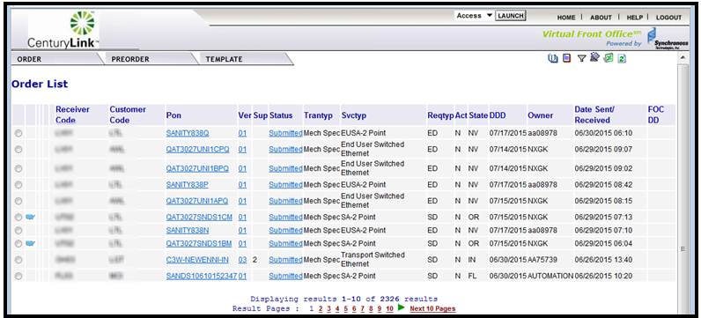

EASE Home Page ICONs | The upper right-hand corner of the VFO Home Page has 6 action icons to select.

ICON | DEFINITION
 | User Profile – provide a link to the User Profile details. Users can use this link to reset their profile email, password and security questions.
  History | Provides a detailed history of an order, including Errored, Confirmed, Clarification, Jeopardy, DLR/Design, Completed, etc.
Create Response | Allows user to create a manual response such as a Jeopardy or Clarification for a selected order
Filter | Provides a way to filter orders from the order list. Clicking this ICON prompts another screen to open and requires the user to filter the criteria. Once filtered, user must clear the filter to return the order list to default view.
Return to Default Sort | Allows user to return the order list to the default sort order
Export to Excel | Exports an order selected from the Order List into an excel document
Refresh | Refreshes the Order List to show the latest order activities including new orders and updates to existing orders. This is NOT used to clear a filter or a sort, but only to update the Order List

Managing the User Profile | Users will have the ability to modify some attributes on their EASE user profile such as Password, Confirm Password, Email Address and Security Questions/Security Answers.  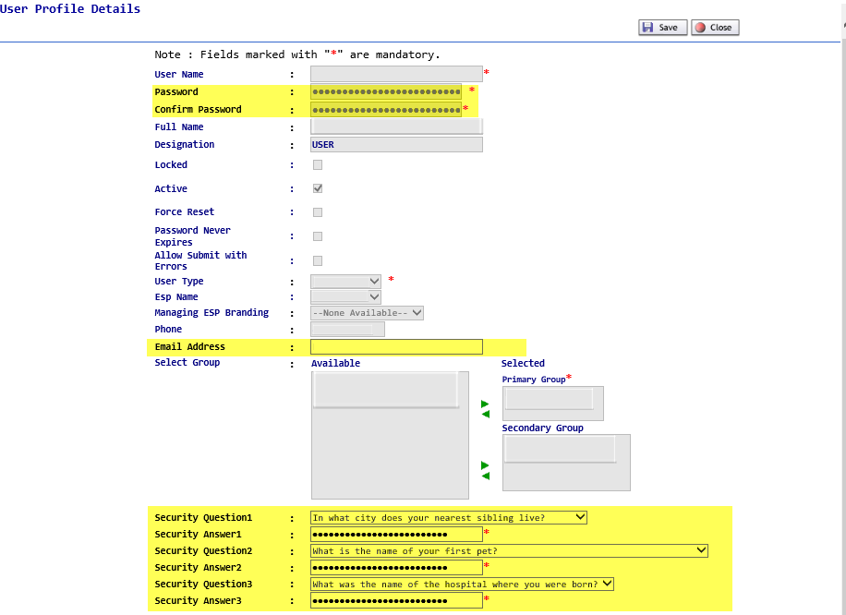

Modifying the User Profile Information | To modify the User Profile Information:
  Step | Action
  1 | Click on the User Profile ICON from the EASE Main Menu to access the User Profile Information.
  2 | Users can alter the following information:  - Password  - Confirm Password  - Email Address  - Security Questions/Answers
  3 | When finished, click on  Save to keep the modified information  Close to exit the User Profile without any modification.

Filtering Information for the Order List | EASE VFO has the ability to filter the Order List information. This allows users the ability to view a subset of information within their ESP. Users can determine the information to be returned on the order list thru the various fields.  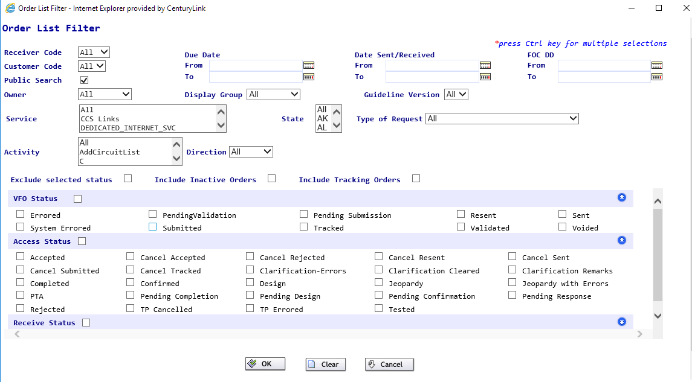  To use the Filter option,
  Step | Action
  1 | To bring up the Order List Filter, click on the filter icon..
  2 | Select the filter options by entering the fields or using the drop-down menus to show the options. Within the drop-down menu, users can select more than one option by holding down the CTRL key while selecting multiple options.
  3a | When the filter criteria has been determined, click on the OK key to start the filter option.  
  4 | The filter screen will be closed. All orders meeting the filter criteria within EASE will be displayed on the Order List Screen.
  4b | To clear the criteria selected, click on the Clear key
  4c | To cancel the filter option, click on the Cancel key. The user will be returned to the Order List screen.

EASE Home Page Tabs | The top menu bar offers three options: Order, Pre-Order, and Template. Each of these tabs contain drop down menus. The user can return to this screen at any time by clicking the Home link in the top right of the screen.

Tab | Function
Order | New – Initiate a new order
Order | Search – Search existing orders
Order | Save as Order – Replicate an existing order
Order | Save As Template – Create a template from an existing order
Order | View History – View the history of an existing order
Order | Create Response - Create a manual response for a selected order
Order | Resend – Resend a selected order
Order | Disconnect – Select an existing, completed order to create a disconnect order for installed services
Order | Reassign Order – Reassign an order to someone else
Order | External App Data – CenturyLink specific enhanced system functionality  - Archival GUI – View Archived PON data  - NC/NCI Inquiry – Search for valid NCNCI combinations  - BAN Inquiry – Search for active customer BANs  - ASR Notes – View Notes associated with an ASR  - ASR Status Tool – View ASR processing status
PreOrder | Ability to initiate NEW inquiries in the below listed areas  - CFA Inquiry – Perform Channelized Facility Assignments inquiries  - CLLI SCAN Inquiry – Perform inquiry of associated Facilities by CLLI  - ETHERNET Inquiry – Perform inquiry of switched ethernet services  - LOCATION Inquiry – Perform addressed based inquiries
PreOrder | Search – Search for a preorder that was previously saved
Template | New – Create an order template
Template | Search – Search for an existing order template

Order Status | The Status column in EASE VFO displays the most current status of orders in the Order List. These statuses also show when viewing the history of an order. Appendix 1 – Order Status List provides a definition, action, and user action for each status.

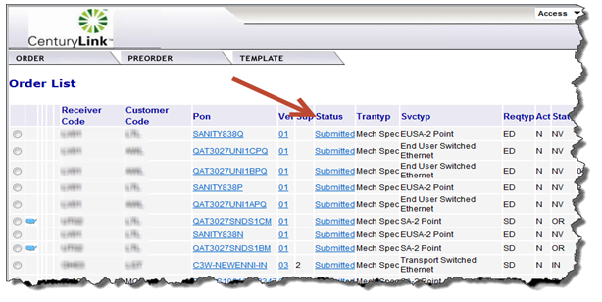

Order Status ICONs | Status ICONs may display to the left of the Receiver Code column on the Order List. These status ICONs are designed to assist with identifying the current status of orders in the Order List. Below is a list of all available status ICONs that may display on the Order List in EASE VFO.

Status ICON | Definition
 | Cancelled
 | Confirmed
 | Completed
 | Errored
 | Jeopardized
 | Pending (FOC or DLR)
 | Rejected
 | Tracking Only (This means that the order was placed outside of VFO and it is in VFO for tracking only)
 | Multi-EC – More than 1 ICSC is involved on the order.

ORDER Tab

Overview | In this section, we will review the information contained in the Order Tab. The order tab allows users to create new orders, search for existing orders, view order history as well as many other options.  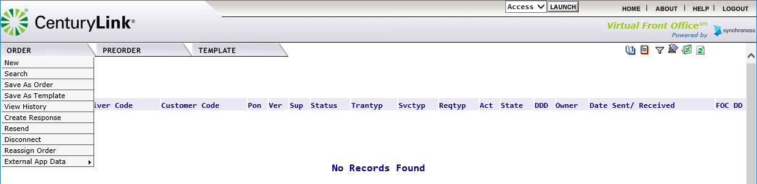

New | This option allows users to create a new order. When this option is selected, users will be taken to the Order Initiation menu shown below.  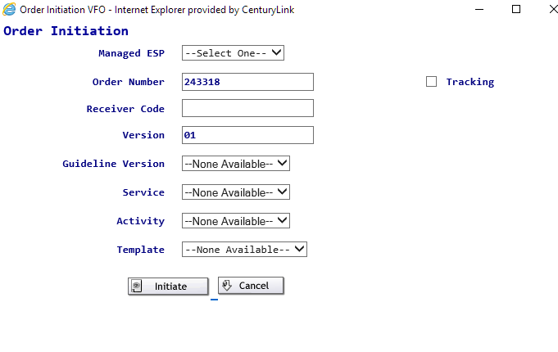  Please note: Additional information on creating a new order can be found in this document in the Creating an Order in EASE VFO Section.

Search | This option will allow users to search the order database thru a variety of methods. The order database houses a 2-year inventory of orders that have been saved, processed or cancelled. When this option is selected, users will be taken to a Search menu.  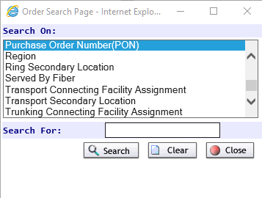

Available Search Options | Search is defined thru the following options. The default search option is Purchase Order Number (PON).
  Search On:
  ACI Connecting Facility Assignment
  ACI Telecommunications Service Priority
  ACTL
  ARI Secondary Location
  ASR Access Service Coordination Exchange Company
  ASR Case Number
  ASR Circuit Reference Number
  ASR Customer Name
  ASR Exchange Company Circuit ID
  ASR Number
  ASR Project ID
  ASR Service and Product Enhancement Code
  ASR Telecommunications Service Priority
  ASR Two Six Code
  Bandwidth
  Confirmation Case Number
  Confirmation Circuit Reference Number
  Confirmation Exchange Company Circuit ID
  Confirmation Order Number
  Confirmation Project ID
  Confirmation VC Circuit ID
  Confirmation Wats Open billing Project ID
  E911
  EUSA Secondary Location
  FGA Secondary Location
  Initiator
  MSL Secondary Location
  Market
  Mobile Technology
  Multi-EC order
  Other Exchange Company
  Project Code 1
  Project Code 2
  Project Code 3
  Protected Circuit
  Provider Name
  Purchase Order Number(PON)
  Region
  Ring Secondary Location
  Service by Fiber
  Transport Connecting Facility Assignment
  Transport Secondary Location
  Trunking Connecting Facility Assignment
  Trunking Related Exchange Company Circuit ID
  Trunking Related Exchange Company Circuit ID 2
  Trunking Secondary Location

Using the Search Function | To use the Search Function,
  Step | Action
  1 | Select the option to Search on by using the Scroll bar on the right-hand side.  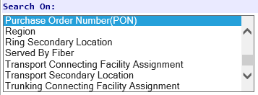
  2 | Place the search details in text box to the right of Search For:  The information provided can be the exact value, part of the value or contain % as a wildcard value.
  3 | Click the Search button from the options on the screen.
  4 | Orders meeting the criteria will be displayed in the order list section.  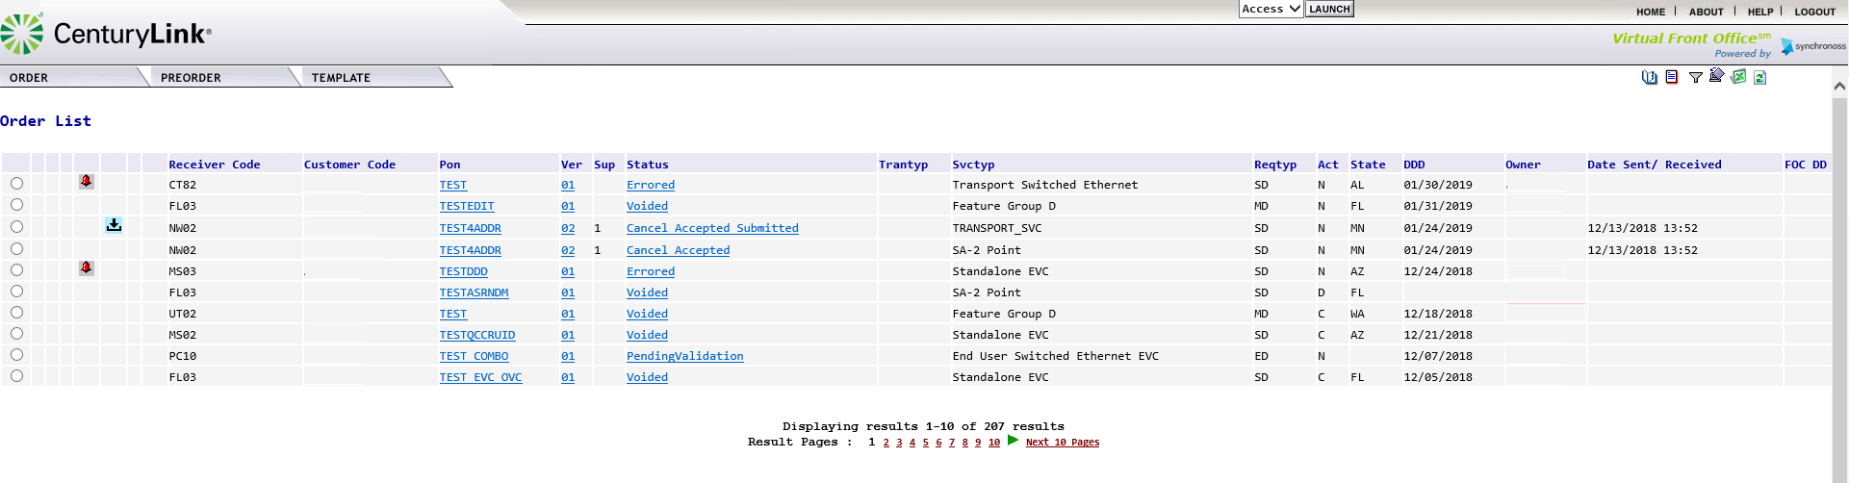  Users will see the total number of results at the bottom of the screen. Up to 10 pages of results are present at any given time. Users can scroll thru the results using the page number and arrow buttons.
  5 | Users can access the order detail by clicking on the PON name. This is a hyperlink that will open the requested order.

No Records Found | When the search criteria is unable any results, users will receive the message “No Records Found”. Users can initiate the Order – Search function to begin a new search.  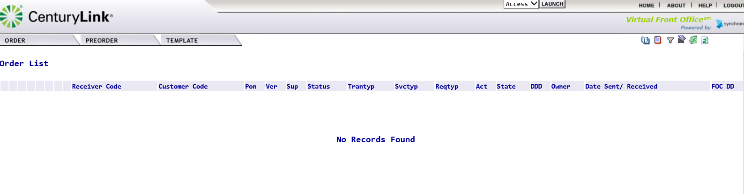

Save As Order | This option allows a user to save an existing order with a different PON. The Save As Order can be done from the main order menu or while a user is working within a PON by selecting Order – Action – Save As Order.

Save As Order from the Main Order Menu | This option can be used to save an order from the main order menu.
  Step | Action
  1 | Locate the PON in the Order List and click the associated radial button the far left-hand side of the PON name.  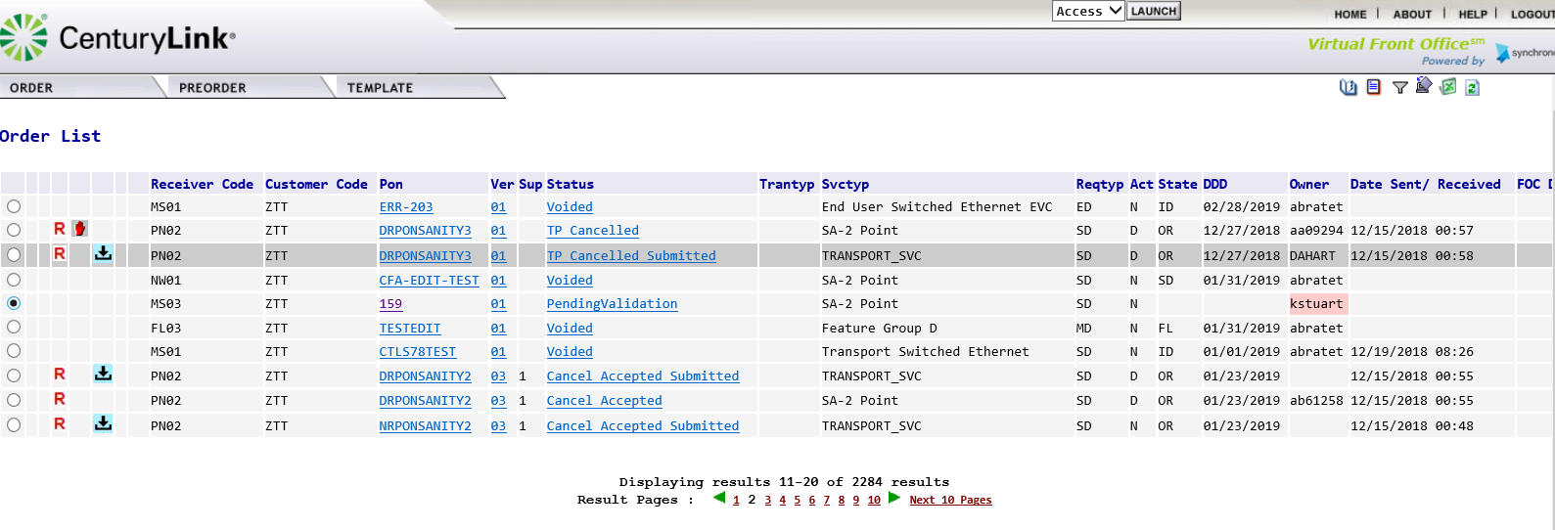  The radial button will now have a black dot in the middle, showing it has been selected.
  2 | From the Order Menu, move the cursor to the Save As Order option and click to select the option.  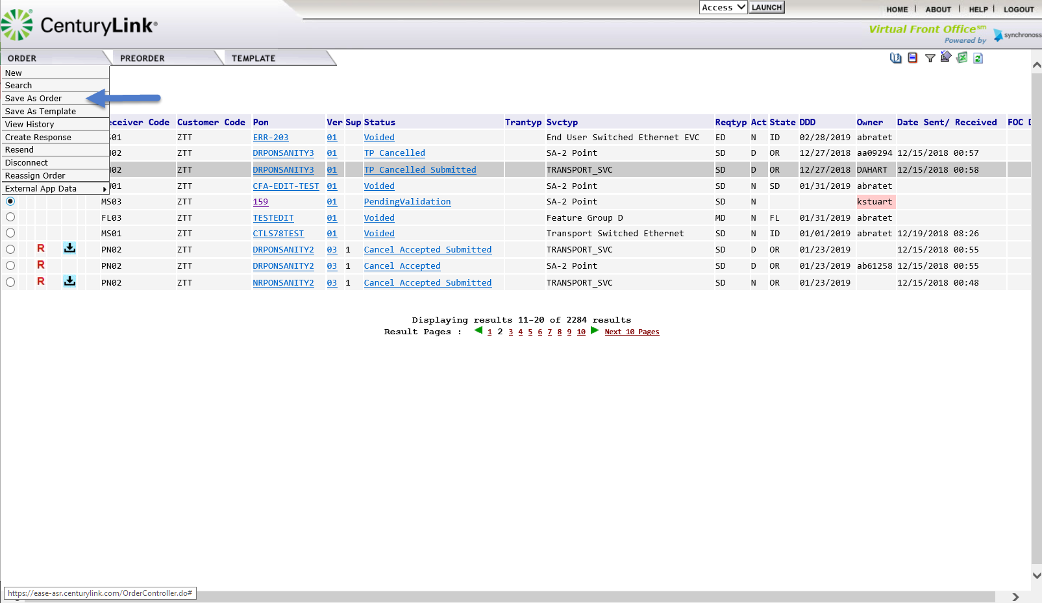
  3 | Users will be taken to the Save as New Order screen.  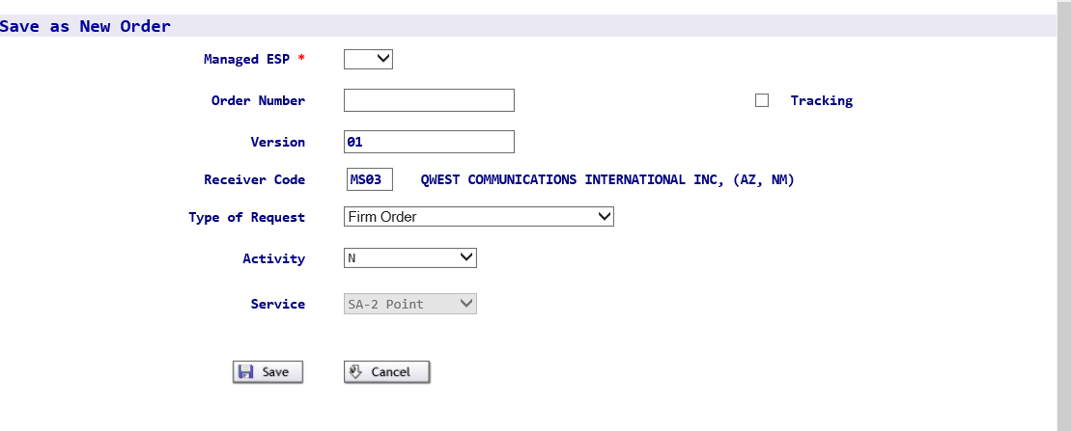
  4 | Users will have the option to change several of the fields listed. Below is a matrix of the field information. In some cases, users are advised not to alter the information provided or are prohibited from changing the field.
    Field | Details
    Managed ESP | This field should remain part of the same ESP group to allow the user to have access to the order. This is not the order CCNA.
    Order Number | Assign a 16-digit unique PON number
    Version | The default should be 01.
    Receiver Code | This is the ICSC from the copied order. If the ICSC is changed, the system will display the valid values. Users will have to select a correct option from the results provided to continue.  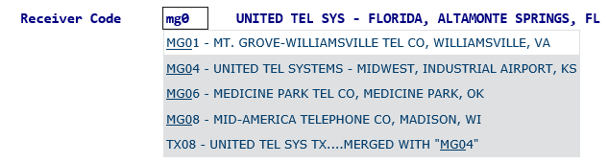
    Type of Request | This field should remain as Firm Order. CenturyLink does not support the other Type of Request options.
    Activity | If desired, the order activity can be changed.
    Service | This option cannot be altered.
  5 | Once all changes have been made, users should select SAVE to create the new order.  
  6 | Users will be taken into the order in the Pending Validation State.  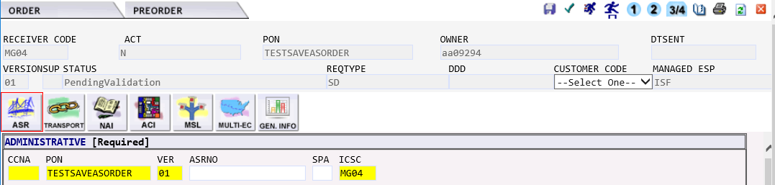  The new order will require users to select a new Customer Code (CCNA) and a new DDD (Desired Due Date).  Please note: Since existing fields from the original order have been copied over, users are advised to double check existing field entries in the field to ensure that they are applicable to the newly created order.
  7 | Users can click the Cancel button to Cancel the Save As Order Request. If an order is canceled at this stage, users will be returned to the Order List Menu.

Using the Save As Order within an active Order | This option can be used to create a new order while the user is working within an order.
  Step | Action
  1 | Within the working order, click the Order Tab to display the menu drop-down options.  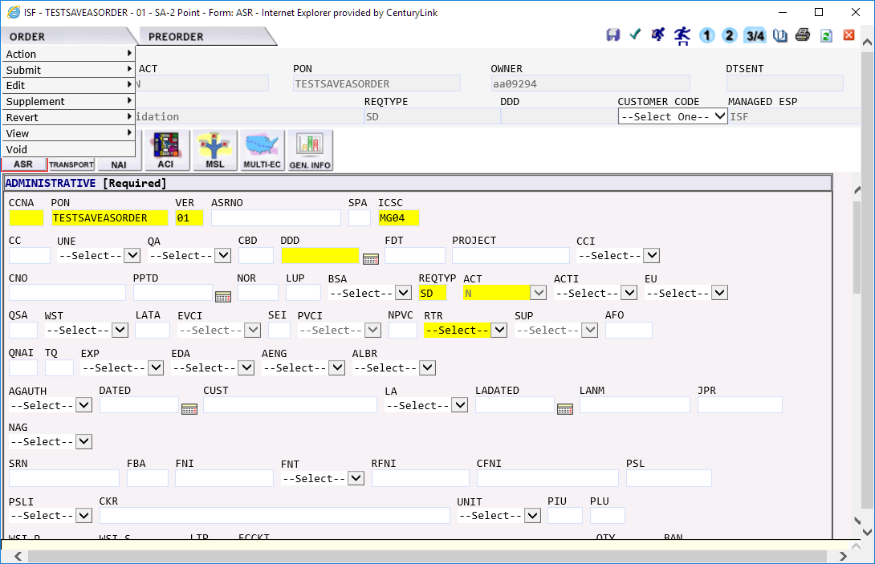
  2 | Select the Save As Order option from the associated drop-down menu.  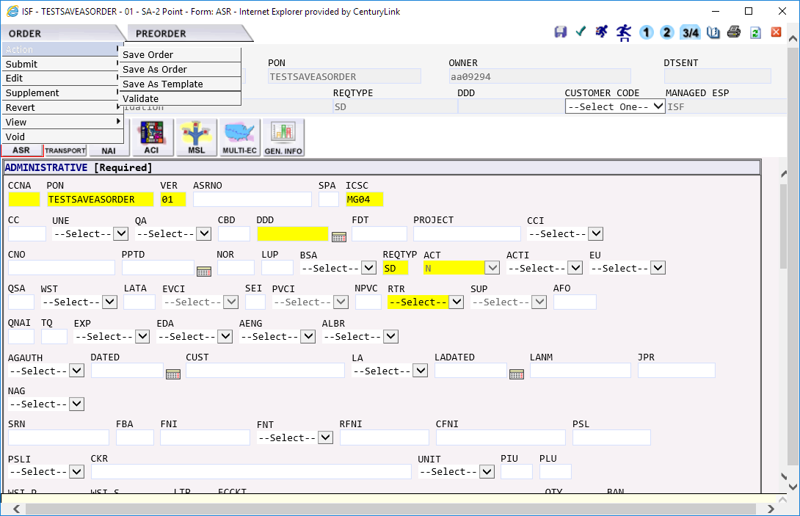
  3 | Users will be taken to the Save as New Order Screen.
  4 | Users will have the option to change several of the fields listed. Below is a matrix of the field information. In some cases, users are advised not to alter the information provided or are prohibited from changing the field.
    Field | Details
    Managed ESP | This field should remain part of the same ESP group to allow the user to have access to the order. This is not the order CCNA.
    Order Number | Assign a 16-digit unique PON number
    Version | The default should be 01.
    Receiver Code | This is the ICSC from the copied order. If the ICSC is changed, the system will display the valid values. Users will have to select a correct option from the results provided to continue.
    Type of Request | This field should remain as Firm Order. CenturyLink does not support the other Type of Request options.
    Activity | If desired, the order activity can be changed.
    Service | This option cannot be altered.
  5 | Once all changes have been made, users should select SAVE to create the new order.
  6 | Users will be taken into the order in the PendingValidation State.  The new order will require users to select a new Customer Code (CCNA) and a new DDD (Desired Due Date).  Please note: Since existing fields from the original order have been copied over, users are advised to double check existing field entries in the field to ensure that they are applicable to the newly created order.
  6 | Users can click the Cancel button to Cancel the Save As Order Request. If an order is canceled at this stage, users will be returned to the Order List Menu.

Save As Template | This option allows a user to create a Template from an existing order. A template is used to create order that contain the same information. It is up to the user to decide if the template is created with the most basic or complex field information. Once a template is created, it is visible to all users within an CCNA.  The Save As Template can be done from the main order menu, while a user is working within a PON by selecting Order – Action – Save As Template, or thru the Template Tab on the Main VFO menu.  Please note: Templates are unique to each ASOG order version created. They are not systematically updated as a new version is installed.

Save As Template option from the Main Order Menu | This option can be used to create a Template from the main Order menu.
  Step | Action
  1 | Locate the PON in the Order List and click the associated radial button the far left-hand side of the PON name.  The radial button will now have a black dot in the middle, showing it has been selected.
  2 | From the Order Menu, move the cursor to the Save As Template option and click to select the option.  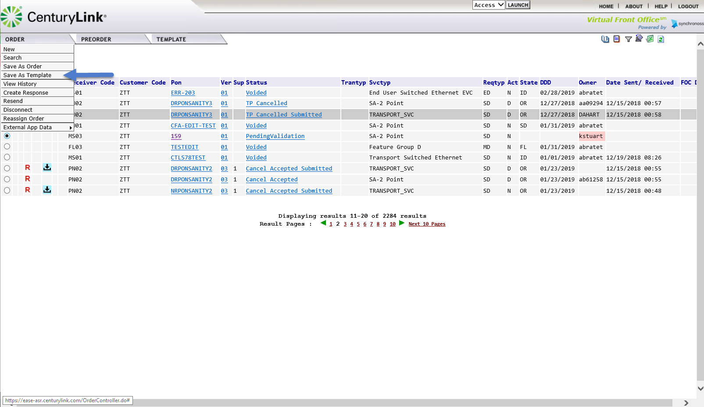
  3 | Users will be taken to the Template Initiation menu.  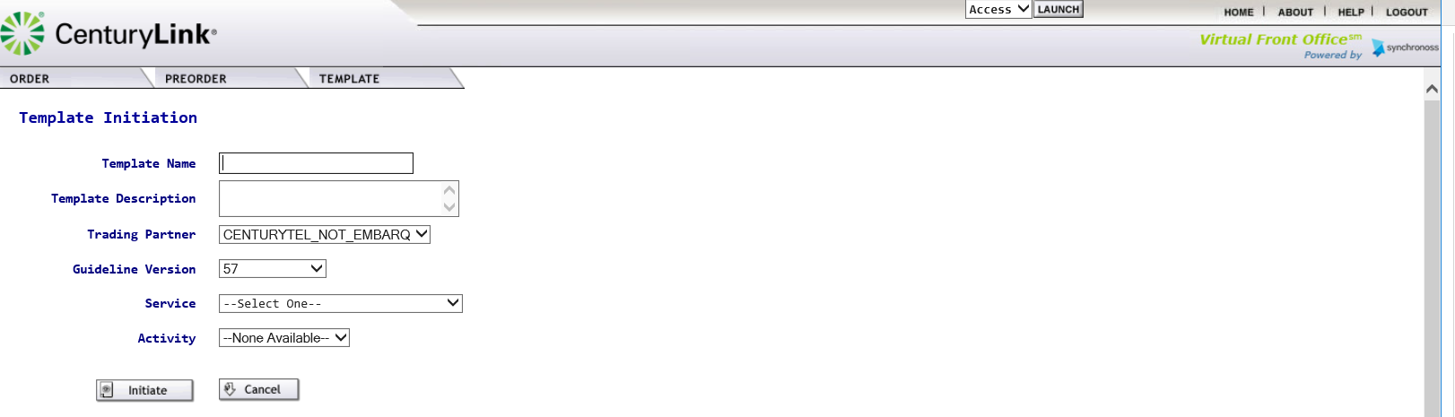
  4 | Users will have the option to change several of the fields listed. Below is a matrix of the field information. In some cases, users are advised not to alter the information provided or are prohibited from changing the field.
    Field | Description
    Template Name | Provide a unique name of up to 20 alphanumeric characters.
    Template Description | This is a brief description of the template and its use
    *Trading Partner | This field is set to the default and should not be altered
    *Guideline Version | This is the most current ASOG version. Templates are only valid for a specific version.
    Service | Users will need to select the appropriate Service type for the template
    Activity | Users will need to select the activity type for the template
  5 | Users can click on Initiate to save the template.  
  6 | Users can click the Cancel button to Cancel the Save As Template Request. If an order is canceled at this stage, users will be returned to the Order List Menu.
  7 | Users who are not part of an ESP group are not able to use this template option. When trying to use the “Save As Template” option from the main menu, they will receive the following message.  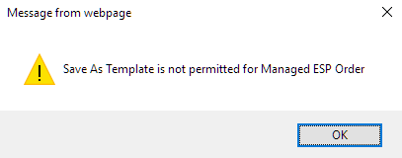  However, users will have the option to create templates thru the Template Tab.

View History | Currently within EASE, orders are kept for a 2 year timeframe. For each order, a user can view the order version(s) and order status.  To view the history of an order thru the Order tab,
  Step | Action
  1 | Locate the PON in the Order List and click the associated radial button the far left-hand side of the PON name.  The radial button will now have a black dot in the middle, showing it has been selected.
  2 | From the Order Menu, move the cursor to the View History option and click to select the option.  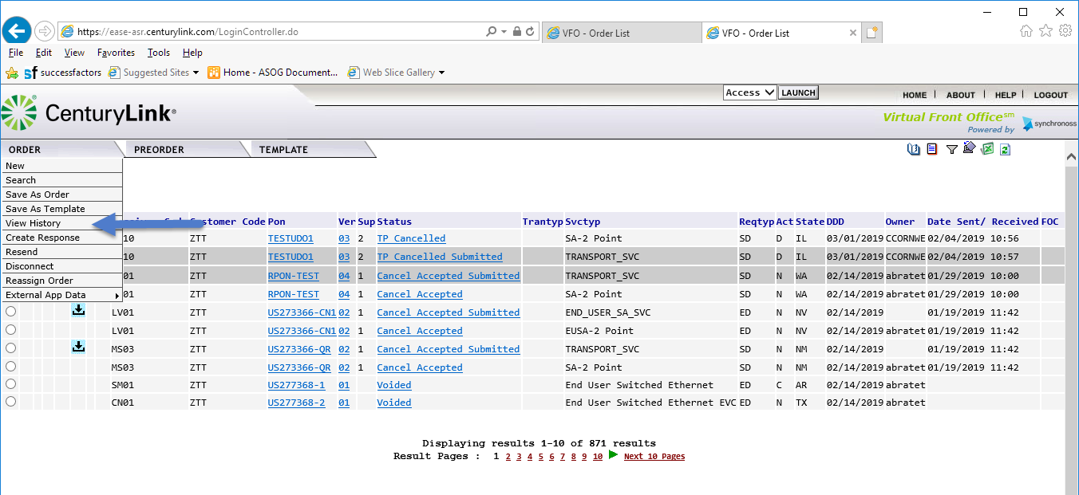
  3 | The order history will be displayed from the most current order activity to the oldest order activity.  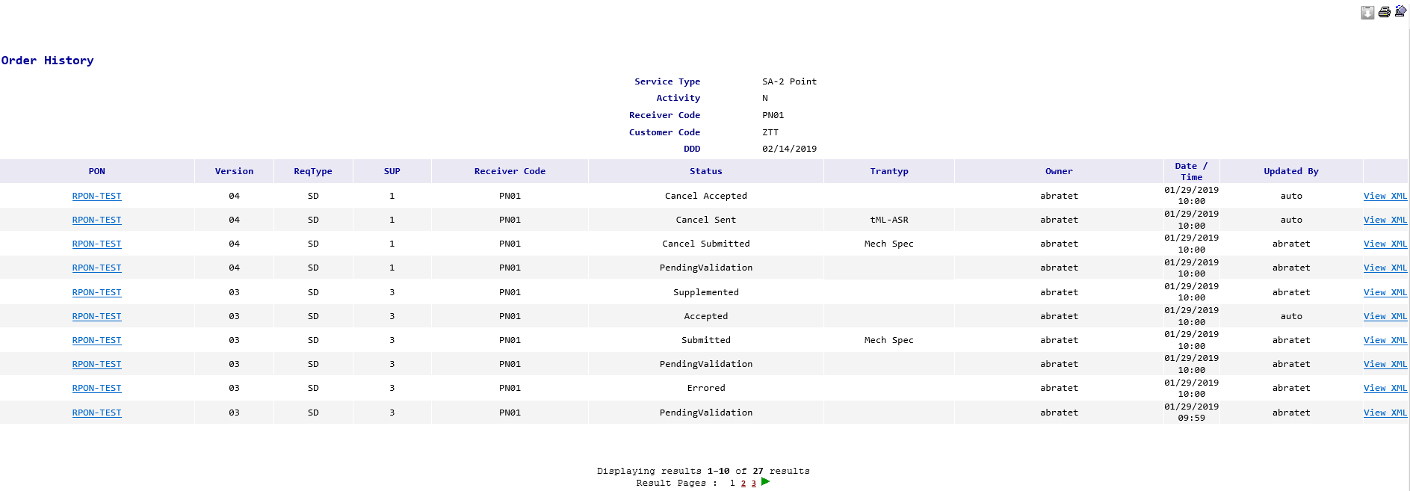
  4 | By clicking on the hyperlinks under the PON section, users will see the details associated to that specific order status.  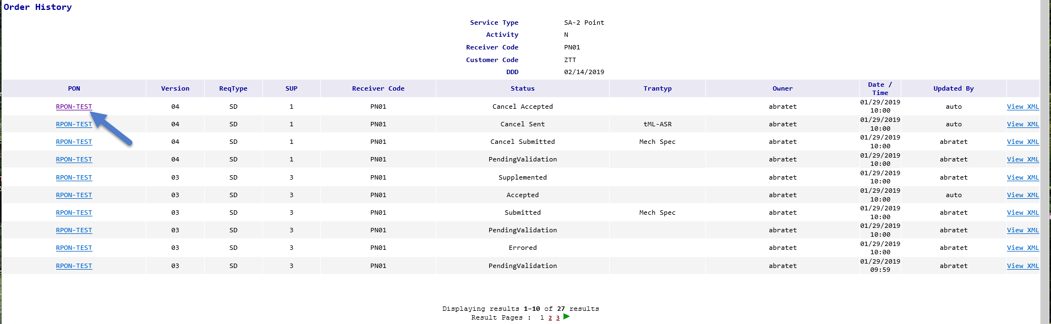
  5 | The information displayed will be specific to the requested status.  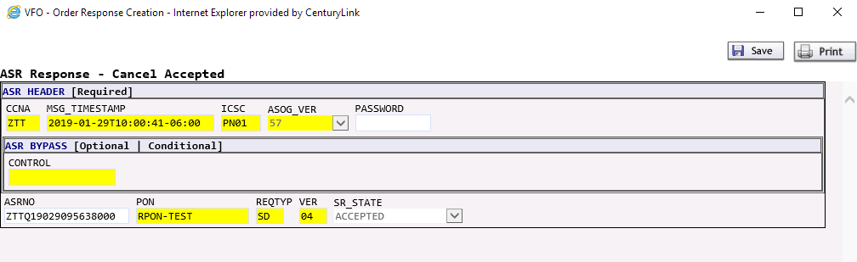
  6 | Users can click on Save to save the information.  
  7 | Users can click the Print button to print the displayed information.
  8 | By clicking on the hyperlinks under the XML section, users will see the details associated to that specific order status  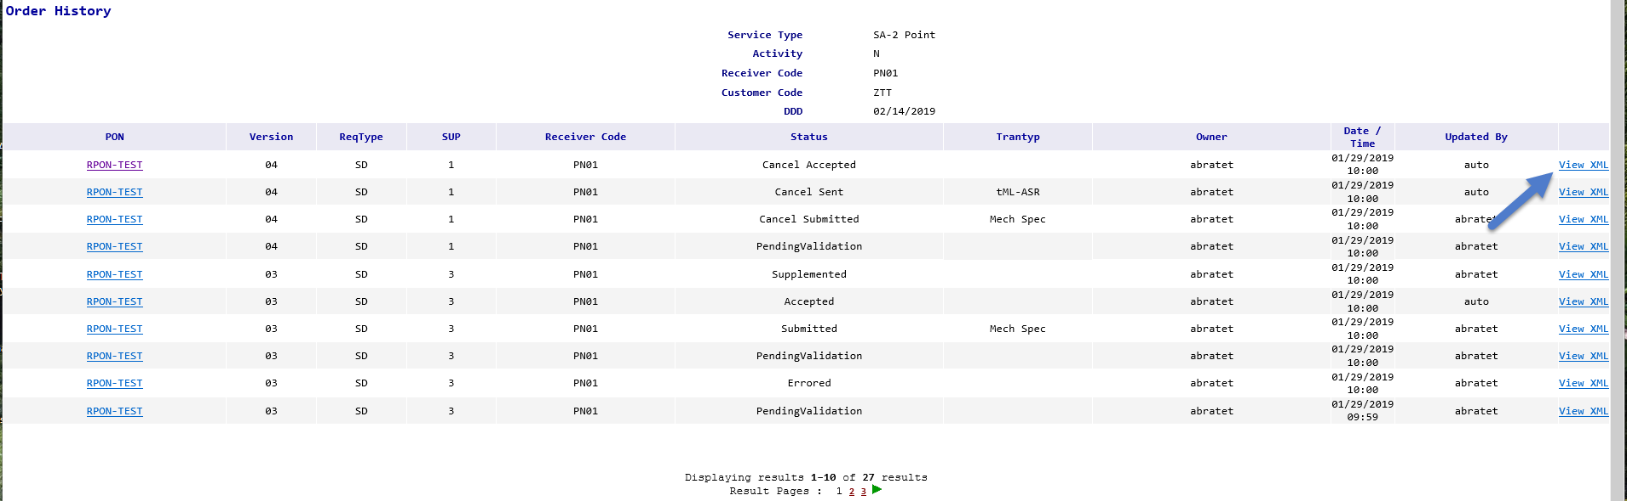
  9 | 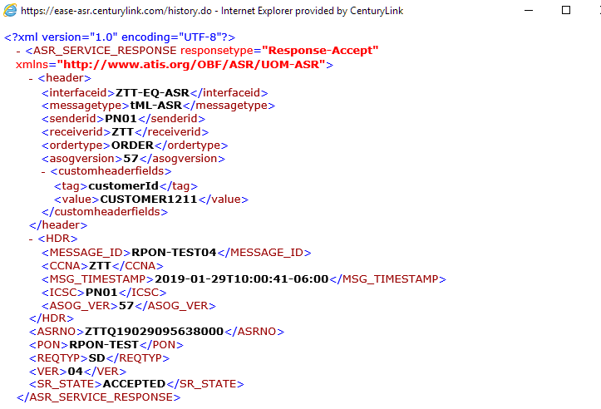
  10 | Users can exit the Order History Screen and return to the main EASE menu by clicking on the X on the top right of the screen.

Create Response | This option is only used by a CenturyLink employee to create a response (such as a jeopardy, clarification, completion, etc) to a customer. CenturyLink employees should reference internal documents regarding this process for additional details.

Resend | This option is used to re-transmit an Access Order in the event that the transmission of the Access Order is not received by CenturyLink. This version of the Access Order will correspond to the latest version containing a SENT status in the History Log.. This would only be used in cases where there has been a systematic failure to send/receive the order. the order must be in the following status: Sent, Resent, System, Errored, Accepted, or Rejected.  To request a Resend, please follow the following steps.
  Step | Action
  1 | Locate the PON in the Order List and click the associated radial button the far left-hand side of the PON name.  The radial button will now have a black dot in the middle, showing it has been selected.
  2 | From the Order Menu, move the cursor to the Resend option and click to select the option.  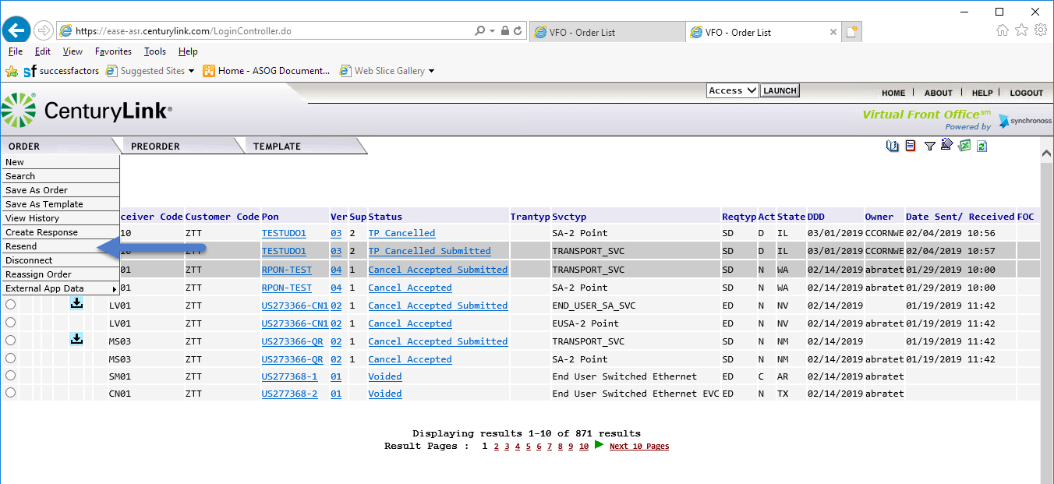
  3 | The latest order version will be resent to CenturyLink.  Please Note: If a user attempts to resend a previously accepted order, the system will return an error.

Disconnect | This option will allow a user to create a disconnect order from a previously completed order.  To create the disconnect order
  Step | Action
  1 | Locate the PON in the Order List and click the associated radial button the far left-hand side of the PON name.  The radial button will now have a black dot in the middle, showing it has been selected.
  2 | From the Order Menu, move the cursor to the Disconnect option and click to select the option.  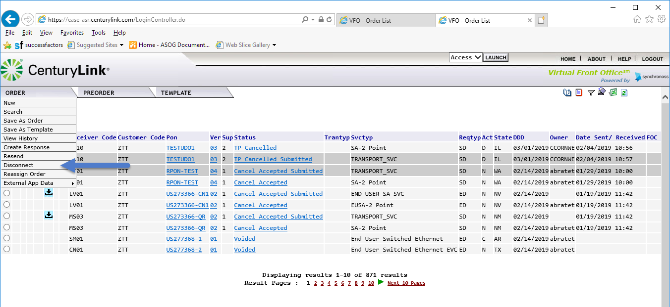
  3 | A new screen will be displayed allowing the user to create a new PON.  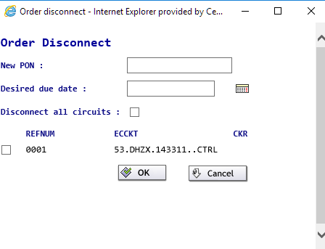
  4 | Users will need to enter:  - New PON:  - Desired due date:  Users can then choose to disconnect all the circuits associated with the order or select specific circuits by clicking the appropriate check boxes if more than one circuit is displayed.  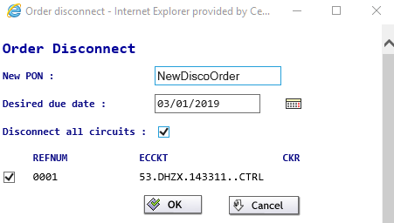
  5 | Click OK to create the new order. The user will be transferred into the newly created order.  
  6 | Click Cancel to cancel the request and return to the order menu.

Reassign Order | This option is only used by a CenturyLink employee to assign an order to a specific user. CenturyLink employees should reference internal documents regarding this process for additional details.

External APP Data Overview
Overview | CenturyLink supports several non-ASOG APPs to provide additional information to users. Additional information regarding each of the following options can be found below. After logging into the EASE application, users will be able to access the External App Data from the Order menu.  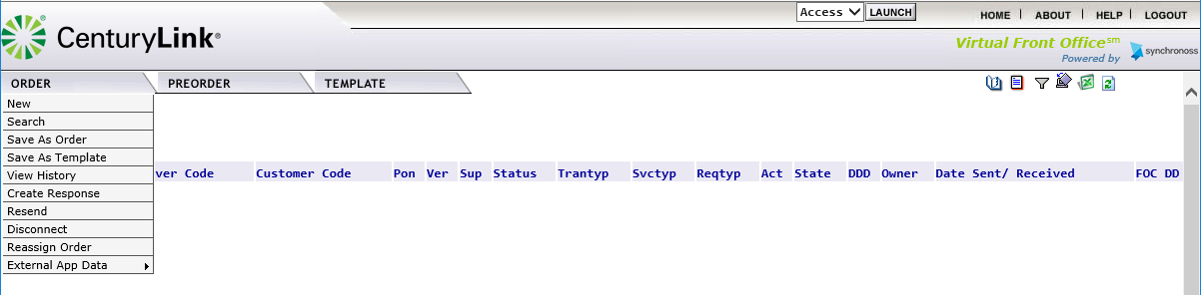  The External App Data supports the following tools:  - Archival GUI  - ASR Notes  - ASR Status Tool  - Ban Inquiry  - NC/NCI Inquiry  Although all tools are visible to users, accessing the data within some tools will be available to internal CenturyLink employees only. An overview of each of the tools will be provided below.

Archival GUI | EASE maintains a 2-year active history of PON (purchase order number) information. Accepted PONs that are older than 2-years will be archived. The archival GUI allows users to search for pons that have been archived in EASE. The archived information will only contain a subset of the original order information.
  Step | Action
  1 | From the Order tab, scroll to the External App Data tab. Move your cursor to the right and select the Archival GUI from the displayed menu.  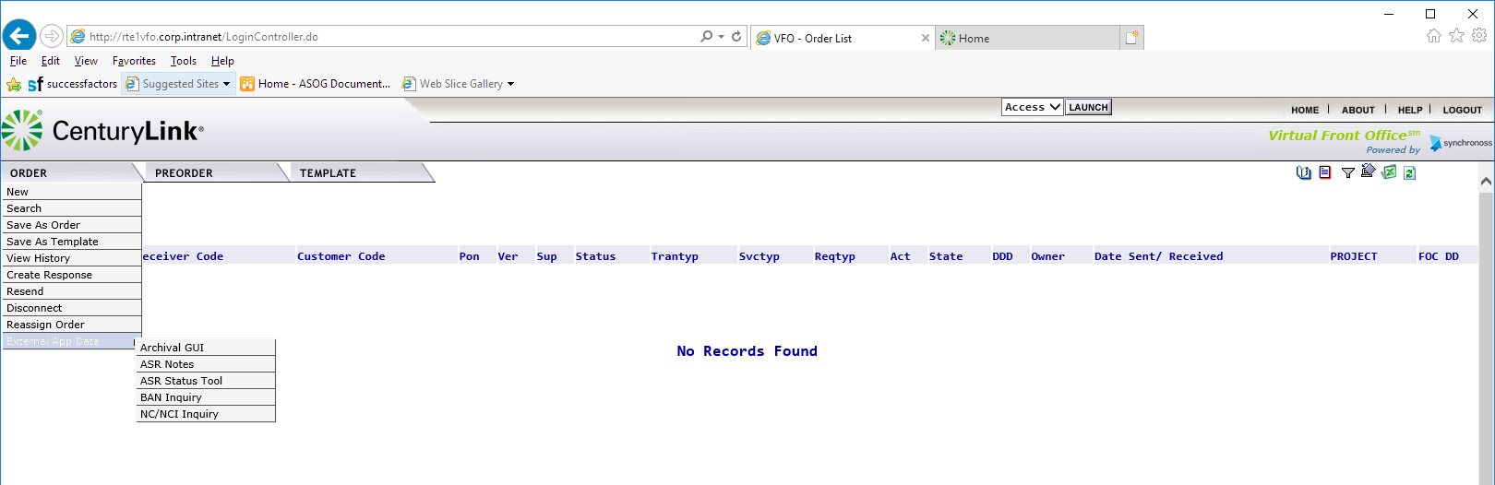
  2 | The Archival GUI will be displayed.  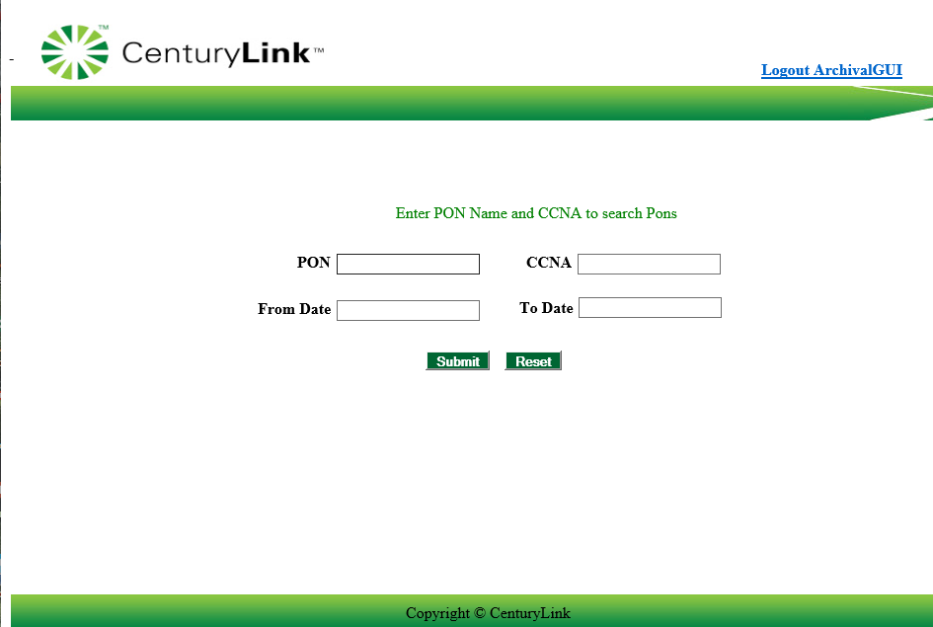
  3a | To search for a specific pon, enter the PON and CCNA.  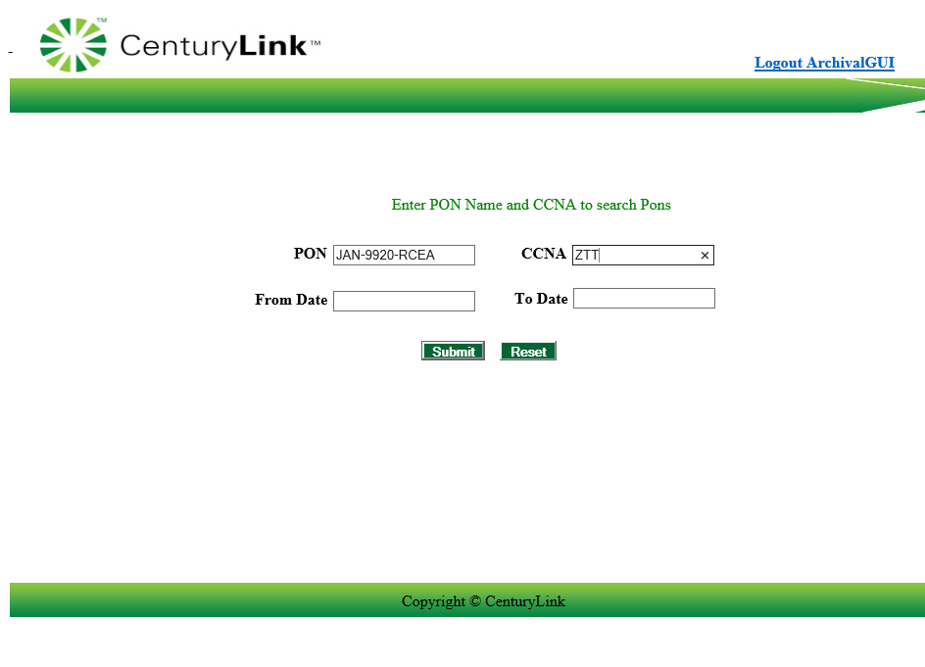
  3b | To search for a list of PONs, users can use a wildcard option by entering part of the PON information and then using the % key. The system will return all pons that meet the criteria entered.  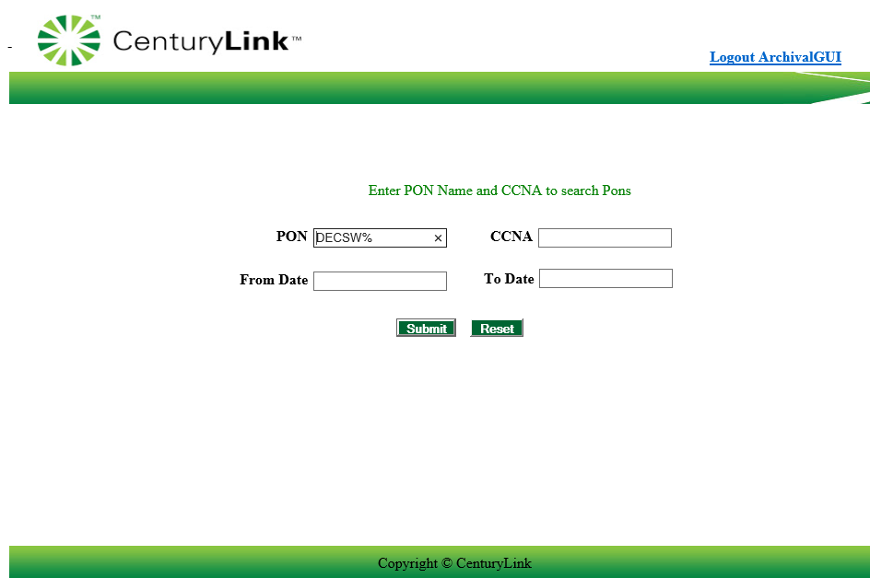
  3c | To search for a list of PONs within a certain date range, users can enter the From Date and To Date. This can be done by entering the date in the MM/DD/YYYY format or using the pop-up calendar to select a From and To Date.  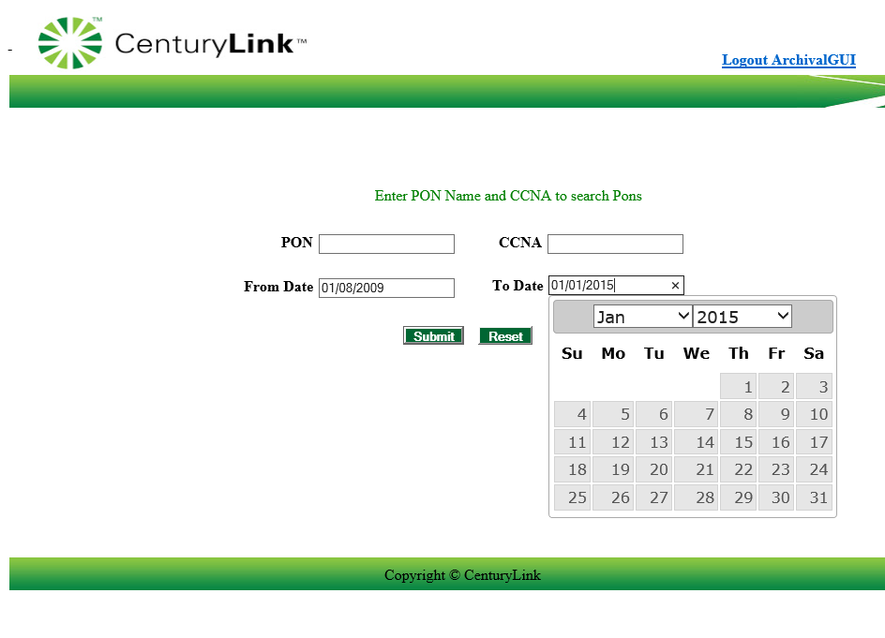  Please Note: this option requires both the From Date and To Date fields to be populated.
  4 | Click Submit to begin the Archival GUI Search or Reset to remove all field entry.
  5 | The system will return the archived information based on the criteria entered.  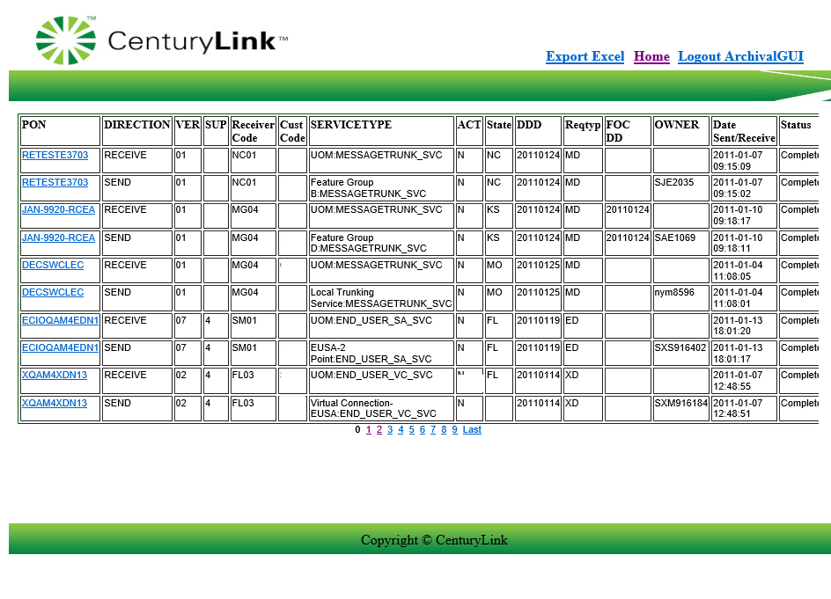  Please Note: users will have the ability to click on additional page numbers at the bottom of the screen to view additional results.
  6 | Users can click on the following hyperlinks within the Archival GUI. in the top right corner:
    Hyperlink | Resulting Action
    Export Excel | Allows the user to export the summarized PON information to Excel for further sorting.
    Home | Allows the user to return to the main Archival GUI screen.
    Logout ArchivalGUI | Allows the user to exit the External App. Users will be asked to close the screen.  

ASR Notes | ASR Notes can only be viewed by CenturyLink employees. External customers will receive an error when accessing this data.

ASR Status Tool | The ASR Status Tool can be used to obtain additional details regarding the ASR status and Provisioning details of the ASR.  To use the ASR Status Tool, use the following steps:
  Step | Action
  1 | From the Order tab, scroll to the External App Data tab. Move your cursor to the right and select the ASR Status Tool from the displayed menu.
  2 | The following screen will be displayed.  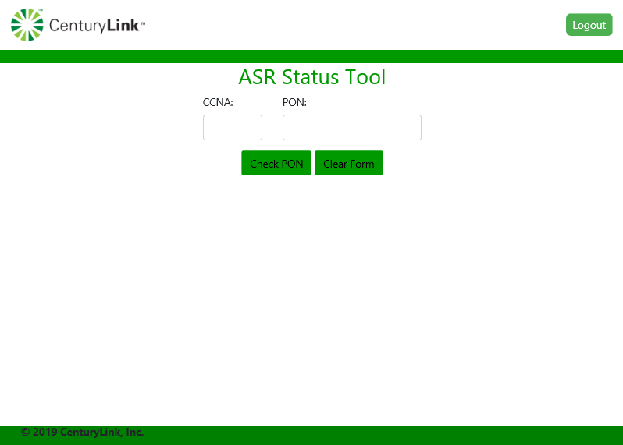
    Field | Description
    CCNA | Enter the CCNA associated with the PON
    PON | Enter the PON number to be retrieved
  3a | Enter the PON and CCNA information to be retrieved and click  Check PON.  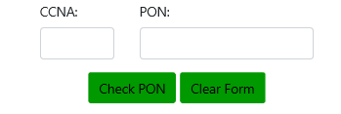
  4 | The system will return the most current information available for the PON including the Product, FOC’d Due Date, PON Status, Jeopardy Details and Additional HELD ORDER Details if applicable.  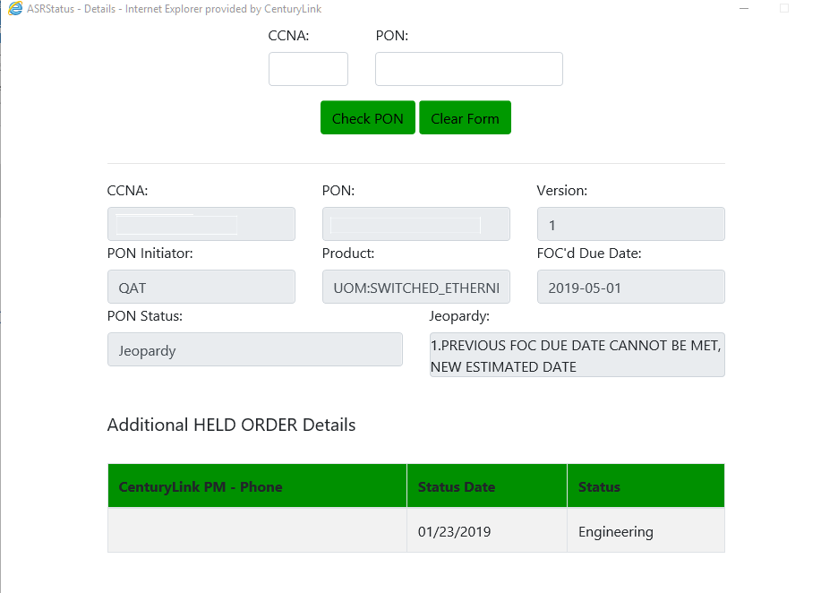
  5 | To clear the information on the ASR Status Tool, click on Clear Form.

BAN Inquiry | Due April …  The BAN Inquiry
  Step | Action
  1 | From the Order tab, scroll to the External App Data tab. Move your cursor to the right and select Ban Inquiry from the displayed menu.
  2 | The reference Table Maintenance Utility Screen will be displayed, showing three options to perform BAN inquiry.  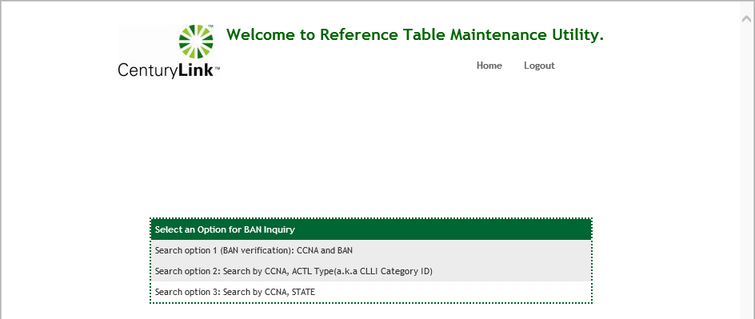
  3 | Users can click on the various Search options available.
  4a | To validate using a CCNA and BAN, click on Search option 1 (BAN verification): CCNA and BAN  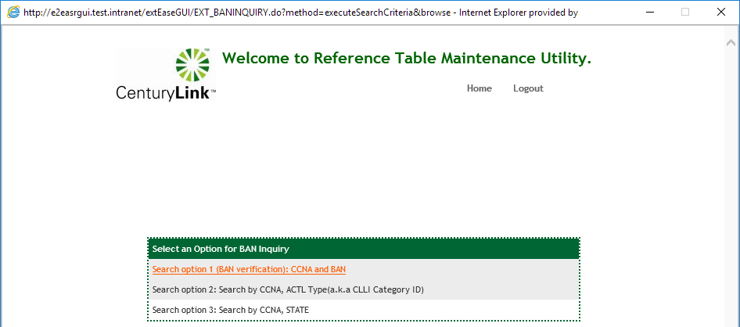

Search Option 1 – CCNA and BAN | Due April …  The BAN Inquiry
  Step | Action
  4a | To validate using a CCNA and BAN, click on Search option 1 (BAN verification): CCNA and BAN
   | 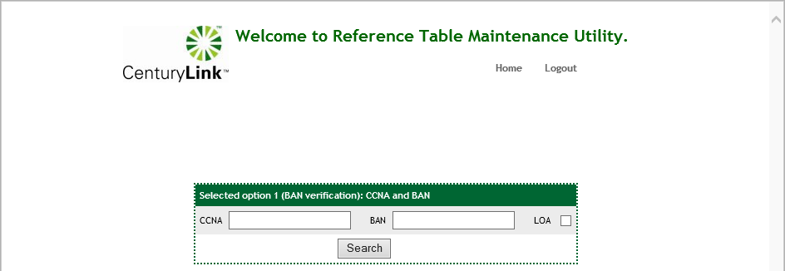

Search option 2 – CCNA, ACTL Type | Due April …  The BAN Inquiry
  Step | Action
  4a | To validate using a CCNA and BAN, click on Search option 1 (BAN verification): CCNA and BAN  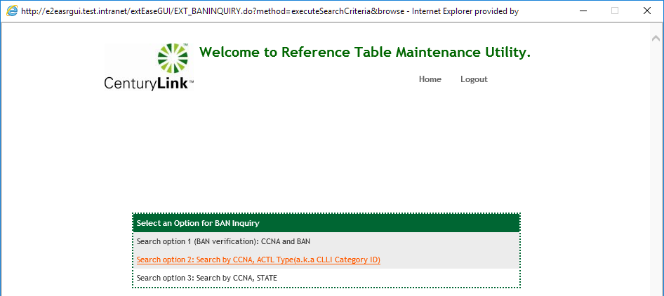
   | 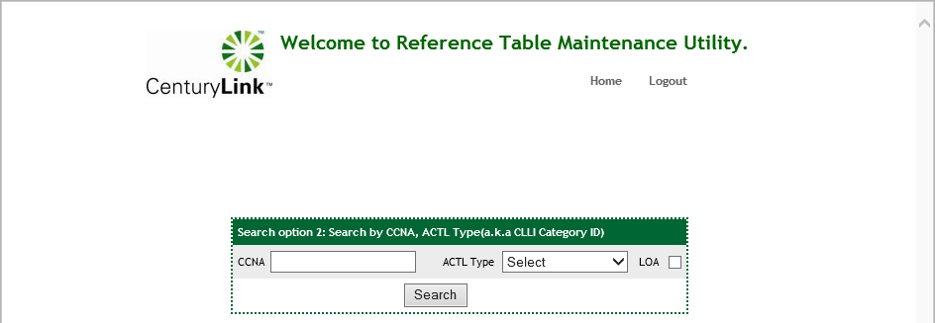

Search option 3 – CCNA, STATE | Due April …  The BAN Inquiry
  Step | Action
  4a | To validate using a CCNA and BAN, click on Search option 1 (BAN verification): CCNA and BAN  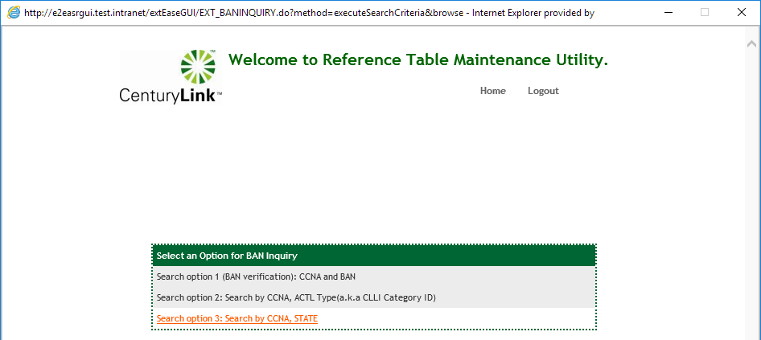
   | 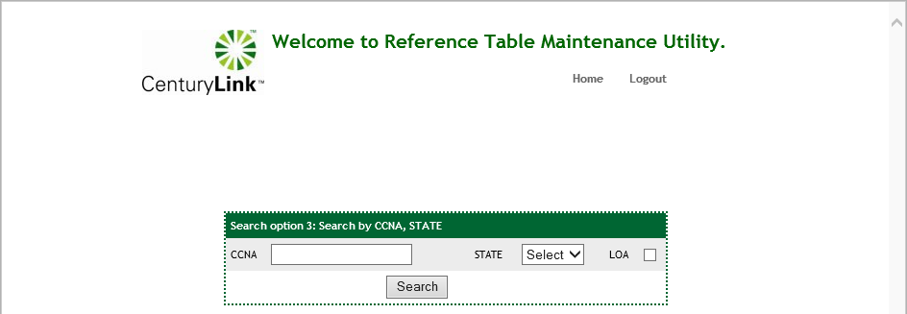

NC/NCI Inquiry | The NC/NCI Inquiry tool allows users to link to an internal reference table within EASE. This is a connection from within EASE VFO to the external Reference Table Maintenance Utility. The reference table contains the NC/NCI/SECNCI codes that are loaded with EASE.

Step | Action
1 | From the Order tab, scroll to the External App Data tab. Move your cursor to the right and select the Archival GUI from the displayed menu.  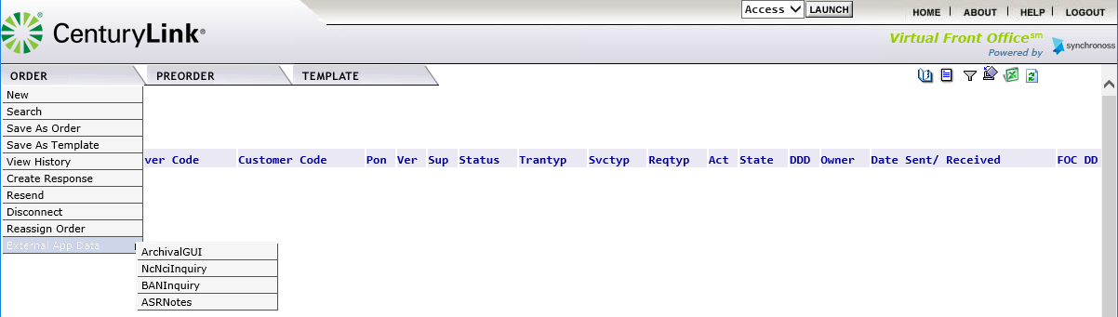
2 | The following screen will be displayed:  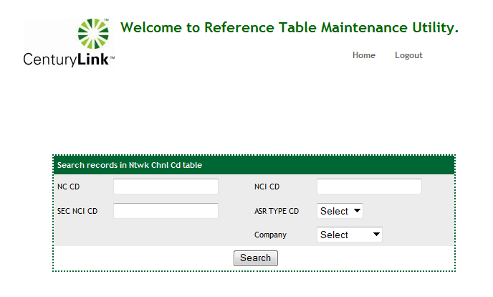
  Field | Description
  NC CD | Identifies Network Channel (NC)
  NCI CD | Identifies Network Channel Interface code (NCI)
  SEC NCI CD | Identifies secondary NCI code
  ASR TYPE CD | Identifies associated ASR Reqtype
  Company | Identifies the legacy CenturyLink company: CenturyLink or Qwest
3 | NC/NCI/SECNCI combinations are uniquely loaded by ASR Reqtype (ASR TYPE CD) and Company. Users can control the data returned thru the combination of fields entered.  Please note: Users are required to enter information using CAPS  Users can enter the appropriate information by tabbing thru the various fields.
  Field | Description
  NC CD | Required that Users must place at least 1 character in the NC Code
  NCI CD | Optional field that users can enter specific information
  SEC NCI CD | Optional field that users can enter specific information
  ASR TYPE CD | Optional field. Users can select a specific code by using the drop-down menu.
  Company | Optional field. Users can select a specific company by using the drop-down menu.
4 | Click on Search to initiate the request.
5 | Depending on the combination of information entered, users may be asked to redefine the search criteria. If this message is received, users can click the Back button at the bottom of the message to be returned to the inquiry screen.  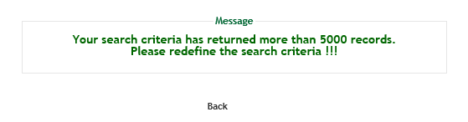
6 | The system will return the records that meet the search criteria provided. The display is limited to 5 records per page. Depending on the quantity of records returned, the user may see multiple pages of data available.  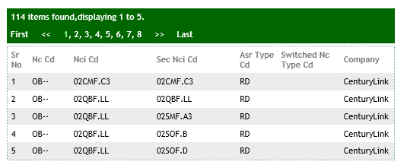
7 | Users can navigate thru the returned records by clicking a specific page number.  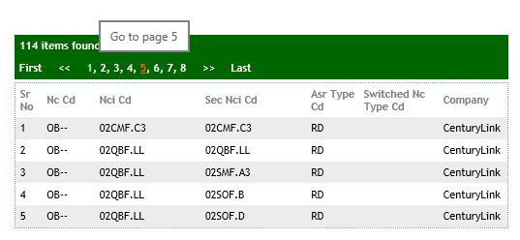
8 | To begin another search click on the Home button located at the top of the screen.  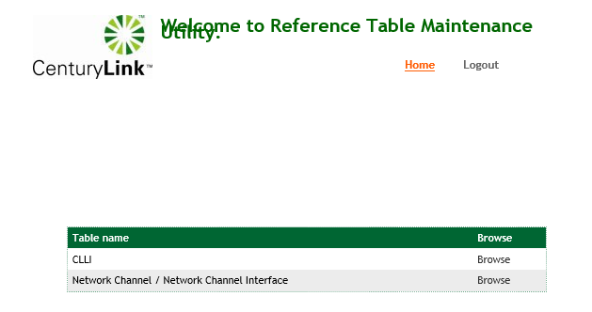
9 | Users will need to click Browse beside the Network Channel / Network Channel Interface to access the reference tables.  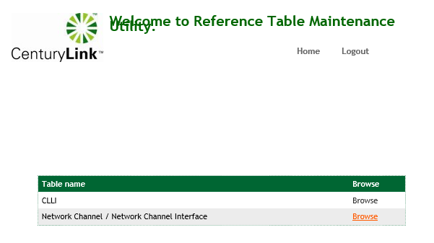
10 | To exit the reference table, users can click Logout in the top right-hand corner.  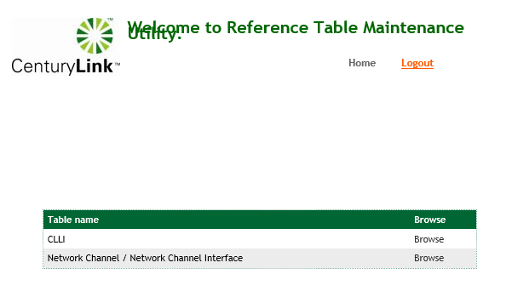
11 | Users will receive the message “You have successfully logged out !!!”. Users can click the Close button to return to the main EASE VFO menu  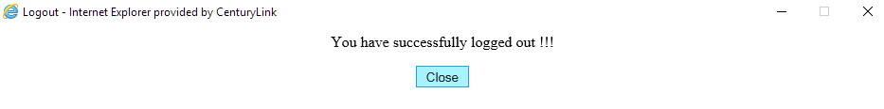

PREORDER Tab

Overview | The Pre-Order tab provides the user with the ability to check and view information outside of an order. This section will provide details for starting a new preorder, searching for a saved pre-order query, along with the details of the types of pre-orders that can be performed.

To start a Pre-order inquiry | The following steps can be used to begin a pre-order inquiry.
  Step | Action
  1 | Upon successful login, select the Pre-Order Tab from the menu bar. The options available are New and Search.  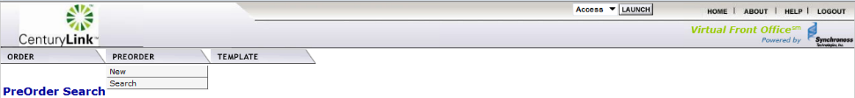
  2 | When you select ‘New’, the PreOrder Initiation screen will be displayed. The Message Id field will be auto-populated by the system with a sequence number.  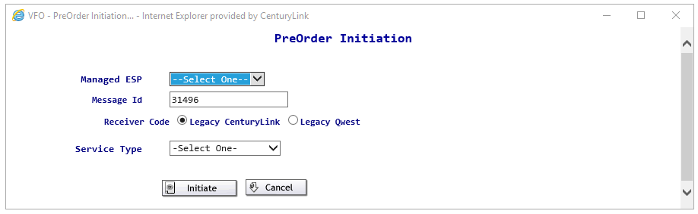
  3 | To begin the New PreOrder inquiry,  - Use the drop-down arrow to select the appropriate managed ESP  - Select the appropriate Receiver Code to select radial button for Legacy CenturyLink or Legacy Qwest.  - Use the drop-down arrow to select the appropriate Service Type  - Click on the initiate button to start the inquiry.  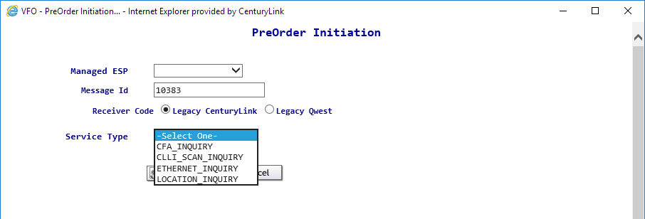
  Additional information regarding each specific PreOrder Inquiry is provided below.

EASE CFA Inquiry
Starting the CFA Inquiry | The following steps will describe specific instructions for performing an EASE CFA Inquiry and will be done after starting the EASE Pre-Order Inquiry process.
  Step | Action
  1 | To begin the Pre-Order Inquiry by selecting the CFA_Inquiry option.
  2 | The CFA_INQUIRY screen will be displayed  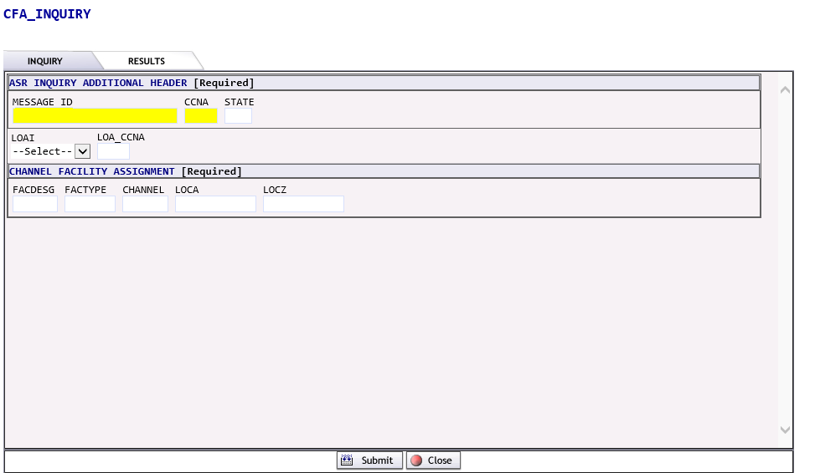
  3 | The CFA_INQUIRY screen will be displayed  The ASR INQUIRY ADDITIONAL HEADER section is a required section. A lot of the fields provided are mandatory and must be provided.  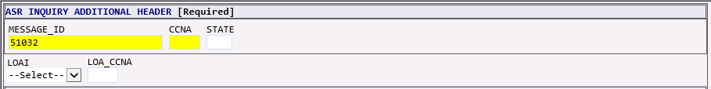  The CHANNEL FACILITY ASSIGNMENT section is a required section. Information provided will be used to determine the amount of information provided in the inquiry results.
    Required fields:
    MESSAGE_ID | Will be prepopulated from the initiation screen
    CCNA | Enter the CCNA field, using all CAPS
    STATE | Enter the correct 2-digit state abbreviation for the inquiry
    Optional fields: these fields are only required when viewing higher facilities belonging to another customer
    LOAI | Select “Y” if you have a LOA from another customer/carrier.
    LOA_CCNA | Enter the CCNA associated with the higher-level facility
    Field detail:
    FACDESG | Identifies the facility designator
    FACTYPE | Identifies the facility type
    CHANNEL | Identifies the channel.  Note: to obtain the entire range of a facility, enter the full range. i.e.: a T1 would be an entry of 1-24, a T3 would be an entry of 1-28
    LOCA | Identifies the A location of the CFA
    LOCZ | Identifies the Z location of the CFA
  4 | Click the SUBMIT button to initiate or CLOSE button to exit from the inquiry
  5 | If the SUBMIT button has been clicked the user will see a message that the inquiry has executed, and the system is waiting for a PreOrder Response ……  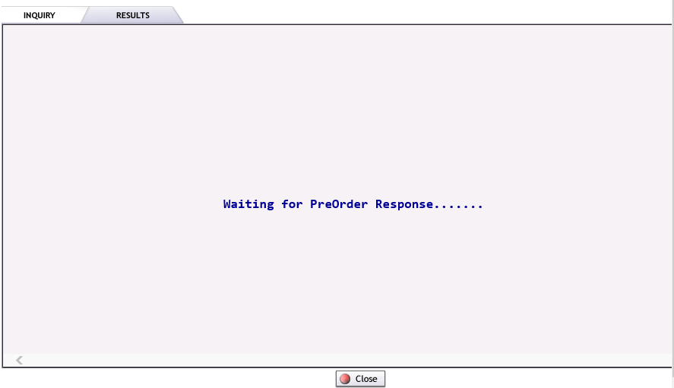  Please note: If the CLOSE button is selected from this screen, the inquiry will be stopped.
  6 | Upon completion of the Pre-Order, the system will execute the request and provide a response upon submission.  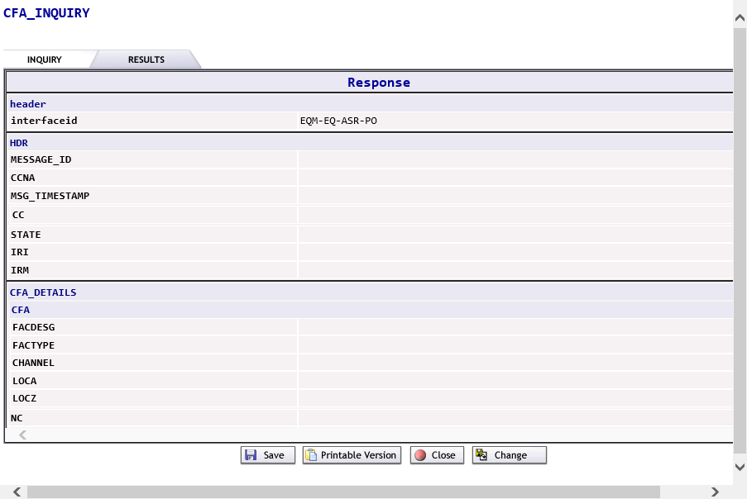

Viewing the results | Upon successful completion of the inquiry, the user will see the following results
  Step | Action
  1 | 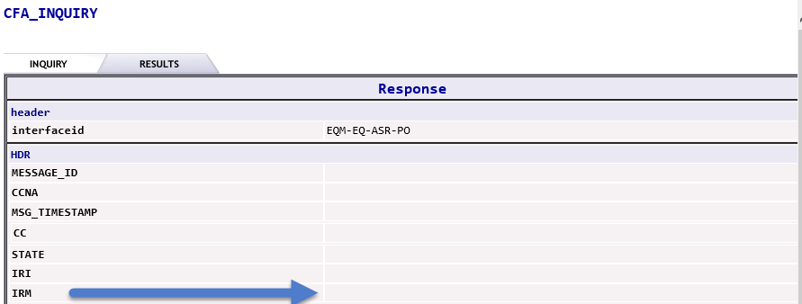  The results of the inquiry will be displayed in the IRM field.  Possible options are:  The user will see the detailed facility information in the CFA Details section.  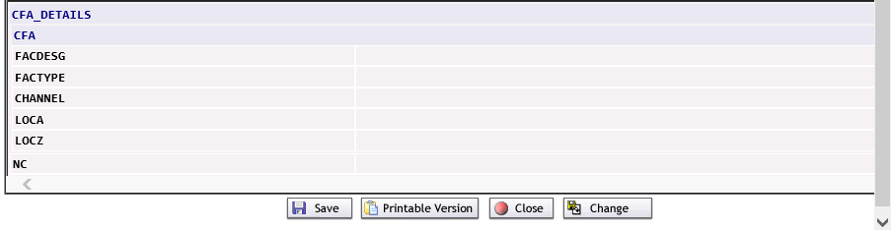  If the inquiry was for multiple channels, users can view additional information by clicking on the arrow buttons or entering the channel two and from numbers in the top RIGHT hand corner. Please note: only 2 channels will be displayed on a given screen.  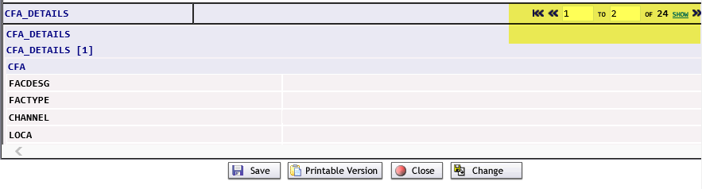
    CFA Validated | The facility was able to be validated and additional information regarding the facility will be displayed in the CFA_details section.
    Busy | The CFA information entered has been executed and the channel is busy.
    Circuit ID not eligible for this Co-Provider | The facility belongs to a different CCNA in the managed ESP. The user will have the option to click the CHANGE button, provide a different CCNA and submit the request again.
    VACANT | The CFA information entered has been executed and the slot is vacant and available for use.
    Requested Information Not Found | The CFA information is not found using the information provided.
    CFA Validation Error | The CFA information entered is not valid
  2 | At times, inquires can receive a message that the inquiry has timed out. Users have the option to click the CHANGE button and resubmit the inquiry.  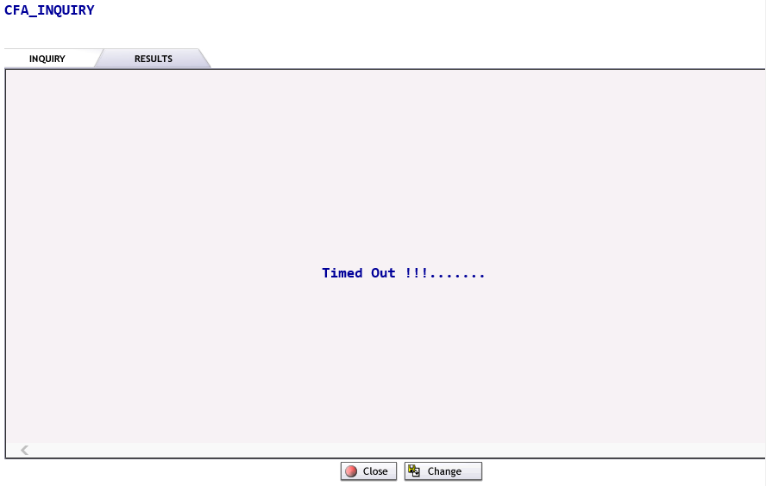
  3 | Users can Save, Print, Close or Change the information on the inquiry by pressing the appropriate button.

EASE CLLI_SCAN Inquiry

Starting the CLLI Scan Inquiry | The following steps will describe specific instructions for performing an EASE CLLI_SCAN Inquiry and will be done after starting the EASE Pre-Order Inquiry process.
  Step | Action
  1 | Begin the Pre-Order Inquiry by selecting the CLLI_SCAN Inquiry option.
  2 | The CLLI_SCAN screen will be displayed  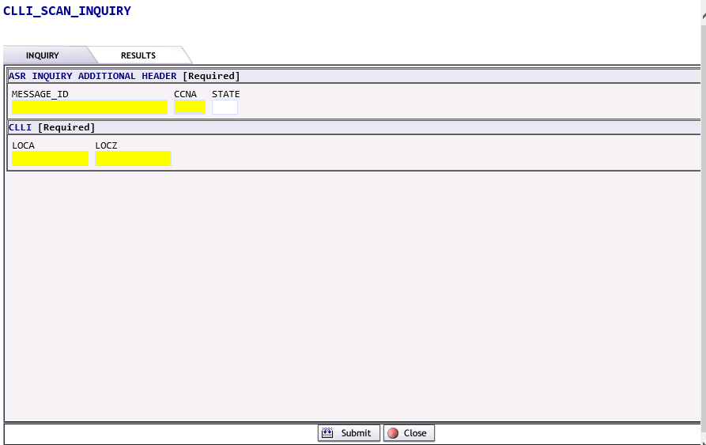  The ASR INQUIRY ADDITIONAL HEADER section is a required section. A lot of the fields provided are mandatory and must be provided.  The CLLI section is a required section. Information provided will be used to determine the amount of information provided in the inquiry results.  * CLLI codes must be entered in alphabetical order
    Required fields:
    MESSAGE_ID | Will be prepopulated from the initiation screen
    CCNA | Enter the CCNA field, using all CAPS
    STATE | Enter the correct 2-digit state abbreviation for the inquiry
    Field detail:
    LOCA | Identifies the A* location of the CFA
    LOCZ | Identifies the Z* location of the CFA
  3 | Click the SUBMIT button to initiate or CLOSE button to exit from the inquiry
  4 | If the SUBMIT button has been clicked the user will see a message that the inquiry has executed, and the system is waiting for a PreOrder Response ……  Please note: If the CLOSE button is selected from this screen, the inquiry will be stopped.
  5 | Upon completion of the Pre-Order, the system will execute the request and provide a response upon submission.  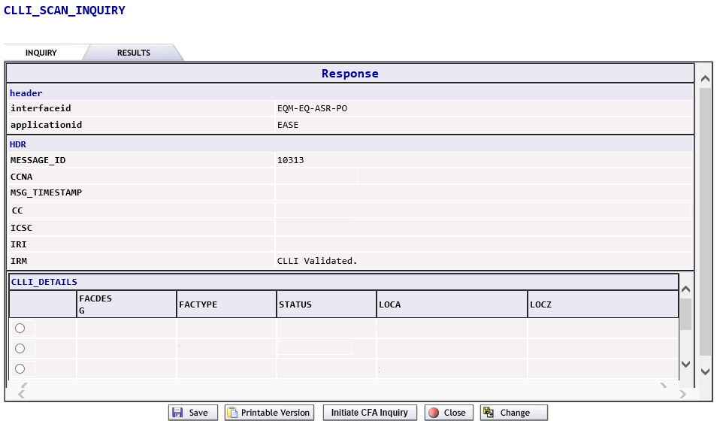

Viewing the Results
  Step | Action
  1 | 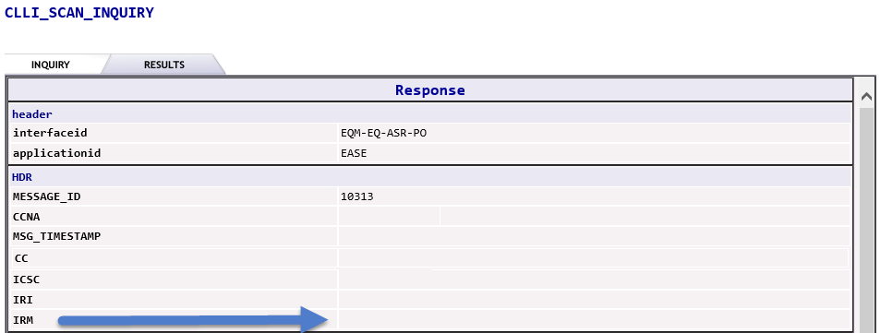  The results of the inquiry will be displayed in the IRM field.  Possible options are:  The user will see the detailed facility information in the CLLI DETAILS section.  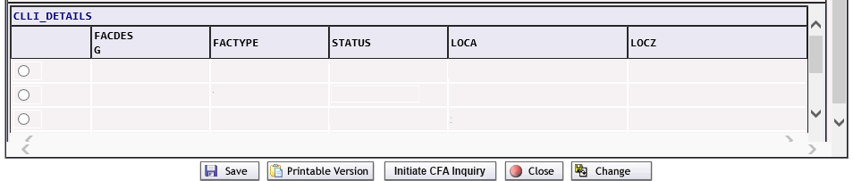  Users can view additional information by using the right-hand slider bars.
    CLLI Validated. | The CLLI codes provided were able to be validated and additional detail will be in the CLLI_DETAILS section.
    Host error has occurred:CIV095E-FIND FAILED NO DATA TO DISPLAY | This may be caused when the CLLI codes are not associated to the CCNA or the CLLI codes cannot be validated.
  2 | At times, inquires can receive a message that the inquiry has timed out. Users have the option to click the CHANGE button and resubmit the inquiry.
  3 | Users can Save, Print, Initiate CFA Inquiry, Close or Change the information on the inquiry by pressing the appropriate button.  To Initiate a CFA Inquiry, users will also need to select a specific row by clicking the appropriate radial button on the left-hand side.

EASE Ethernet Inquiry

Starting the Ethernet Inquiry | The following steps will describe specific instructions for performing an EASE ETHERNET Inquiry and will be done after starting the EASE Pre-Order Inquiry process.
  Step | Action
  1 | Begin the Pre-Order Inquiry by selecting the ETHERNET Inquiry option.
  2 | The ETHERNET_INQUIRY screen will be displayed  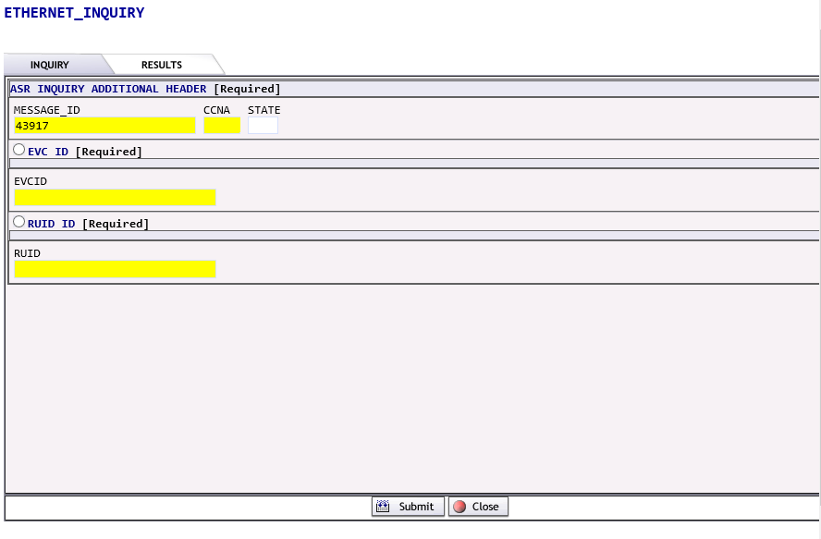  The ASR INQUIRY ADDITIONAL HEADER section is a required section. A lot of the fields provided are mandatory and must be provided.  Users are required to click on the appropriate radial button to select either the EVC ID or RUID ID section to obtain additional information on switched ethernet services. Users cannot select both the EVC ID and RUID ID.  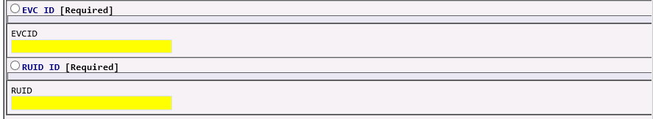
    Required fields:
    MESSAGE_ID | Will be prepopulated from the initiation screen
    CCNA | Enter the CCNA field, using all CAPS
    STATE | Enter the correct 2-digit state abbreviation for the inquiry
    Field detail:
    EVCID | Identifies the EVC ID of the active/in-service ethernet service.
    RUID | Identifies the RUID (Related UNI ID) of the active/in-service ethernet service.
  3 | Click the SUBMIT button to initiate or CLOSE button to exit from the inquiry
  4 | If the SUBMIT button has been clicked the user will see a message that the inquiry has executed, and the system is waiting for a PreOrder Response ……  Please note: If the CLOSE button is selected from this screen, the inquiry will be stopped.
  5 | Upon completion of the Pre-Order, the system will execute the request and provide a response upon submission.  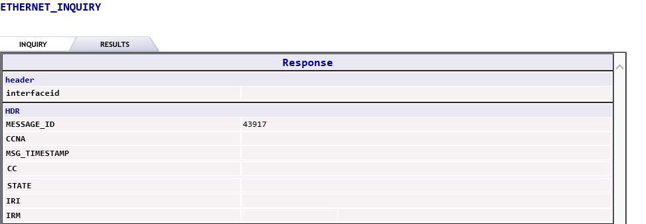  The results of the inquiry will be displayed in the IRM field.  Possible options are:
    SUCCESS | The information provided were able to be validated and additional detail will be in the EVC_INFO or RUID_INFO section.
    NO DATA FOUND | The information provided was not able to be validated.

Viewing the EVC_ID results | An EVC Inquiry will provide the following fielded results  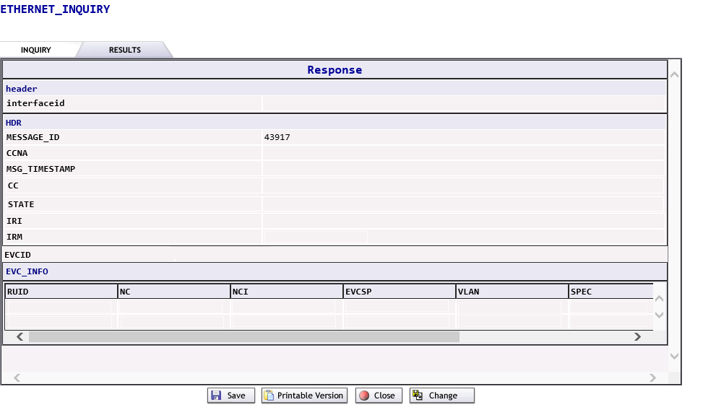  Users can scroll to the left and right to view additional information for the inquiry.  An EVC_ID inquiry will provide the following fielded results per associated RUID.
  EVCID | The EVC used for the inquiry will be displayed
  EVC_INFO | This section contains details associated to the EVC
  RUID | Related RUID (Related UNI)
  NC | The NC (Network Code) code
  NCI | The NCI (Network Chanel Interface) code
  EVCSP | The EVCSP (Ethernet Virtual Circuit Service Point) code
  VLAN | If applicable, the VLAN (Virtual Local Area Network)  If additional VLANs are applicable, the rows will be repeated.
  SPEC | If applicable, the SPEC (Service and Produce Enhancement Code)
  LOS | The LOS (Level of Service)
  BDW | The BDW (Bandwidth)
  Step | Action
  1 | At times, inquires can receive a message that the inquiry has timed out. Users have the option to click the CHANGE button and resubmit the inquiry.
  2 | Users can Save, Print, Close or Change the information on the inquiry by pressing the appropriate button.  If a user chooses to change the inquiry, the user will need to reselect the appropriate radial button for the EVC or RUID in order to change the information.

Viewing the RUID results | A RUID Inquiry will provide the following fielded results.  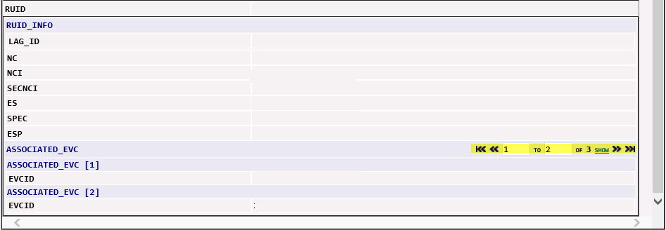
  RUID | The RUID used for the inquiry will be displayed
  RUID_INFO | This section contains details for the RUID
  LAG_ID | If applicable the LAG (Link Aggregation Group) ID
  NC | The NC (Network Channel) Code
  NCI | The NCI (Network Channel Interface) Code
  SECNCI | The SECNCI (Secondary NCI) Code
  ES | The ES (Egress Scheduler) Code
  SPEC | The SPEC (Service and Produce Enhancement Code)
  ESP | The ESP (Ethernet Service Point) Code
  Associated_EVC | If more than 1 EVC is associated to a RUID, users can view additional information by clicking on the arrow buttons or entering the channel two and from numbers in the top RIGHT hand corner.  Please note: only details for 2 associated EVCs will be displayed on a given screen.
  Associated_EVC [#] | Assigned Number to the EVC
  EVCID | The associated EVCID
  Step | Action
  1 | At times, inquires can receive a message that the inquiry has timed out. Users have the option to click the CHANGE button and resubmit the inquiry.
  2 | Users can Save, Print, Close or Change the information on the inquiry by pressing the appropriate button.  Please Note: If a user chooses to change the inquiry, the user will need to reselect the appropriate radial button for the EVC or RUID in order to change the information.

EASE Location Inquiry

Starting the Location Inquiry | The following steps will describe specific instructions for performing an EASE Location Inquiry and will be done after starting the EASE Pre-Order Inquiry process.
  Step | Action
  1 | Begin the Pre-Order Inquiry by selecting the LOCATION Inquiry option.
  2 | The LOCATION_INQUIRY screen will be displayed  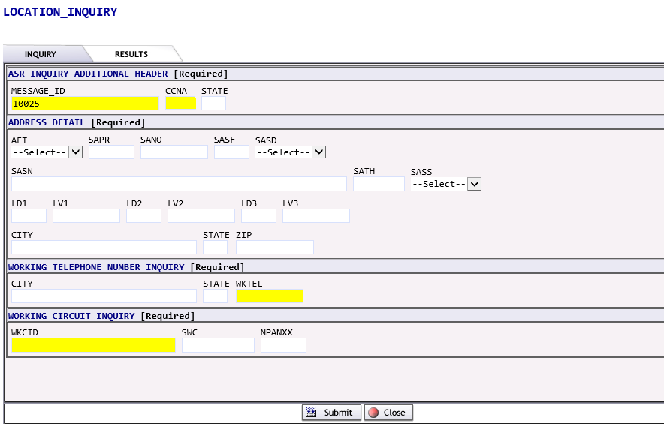  The ASR INQUIRY ADDITIONAL HEADER section is a required section. A lot of the fields provided are mandatory and must be provided.  Users will see three options for performing a location inquiry displayed.
    Required fields:
    MESSAGE_ID | Will be prepopulated from the initiation screen
    CCNA | Enter the CCNA field, using all CAPS
    STATE | Enter the correct 2-digit state abbreviation for the inquiry
    ADDRESS_DETAIL | Allows the user to perform validation based on a specific address. This option is also available within the SALI section of the service order.
    WORKING TELEPHONE NUMBER INQUIRY | This option is not supported by CenturyLink at this time
    WORKING CIRCUIT INQUIRY | This option is not supported by CenturyLink at this time
  2a | Performing a LOCATION inquiry based on Address Detail  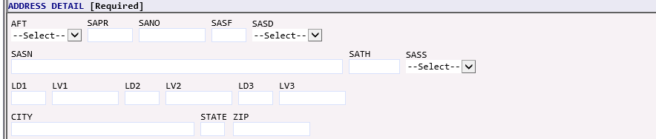
    AFT | AFT identifies the format of the address being supplied. Valid entries:  A = Rural Route and/or box number  B = Unnumbered  C = Provider Assigned house number  D = Descriptive  E = Provisioning Address
    SAPR | SAPR identifies the prefix for the address number of the service address
    SANO | SANO identifies the number of the service address
    SASF | SASF identifies the suffix for the address number of the service address
    SASD | SASD identifies the street directional prefix for the service address. Use the drop-down to select a valid entry  E = East  W= West  N = North  S = South  NE = Northeast  NW = Northwest  SE = Southeast  SW=Southwest
    SASN | SASN identifies the street name of the service address
    SATH | SATH identifies the thoroughfare portion of the service address, such as LN (lane) or BLVD (boulevard)
    SASS | SASS identifies the street directional suffix for the service address. Use the drop down to select one of the Valid entries shown below.  E = East  W= West  N = North  S = South  NE = Northeast  NW = Northwest  SE = Southeast  SW = Southwest  NOTE: This is not the same as DIR and the two cannot be used interchangeably in the address
    LD1,  LD2,  LD3 | The LD1, LD2, LD3 identifies additional specific complex address information related to the address. The supported abbreviations have been determined based on the US Postal Service Publication 28. Valid entries include:  - UNIT  - ROOM  - APT  - RM  - STE  - FL  - FLR  - BLDG  - COMP
    LV1,  LV2,  LV3 | LV1, LV2, LV3 identifies the value associated with the location designator
    CITY | City identifies the city, village, or township
    STATE | State identifies the abbreviation for the state or province
    ZIP | Zip identifies the ZIP or postal code
  2b | Performing a LOCATION inquiry using WORKING TELEPHONE NUMBER INQUIRY  At this time, CenturyLink does not support this inquiry
  2c | Performing a LOCATION inquiry using WORKING CIRCUIT INQUIRY
    WKCID | Identifies the SERIAL working circuit ID.  The WKCID must be paired with the SWC or NPANXX to return results.
    SWC | Identifies the serving wire center CLLI Code (8 or 11 characters) associated with this request.
    NPA/NXX | Identifies the NPA NXX associated with the location inquiry. This is entered as 6 numeric characters.
  3 | Click the SUBMIT button to initiate or CLOSE button to exit from the inquiry
  4 | If the SUBMIT button has been clicked the user will see a message that the inquiry has executed, and the system is waiting for a PreOrder Response ……  Please note: If the CLOSE button is selected from this screen, the inquiry will be stopped.
  5 | Upon completion of the Pre-Order, the system will execute the request and provide a response upon submission.  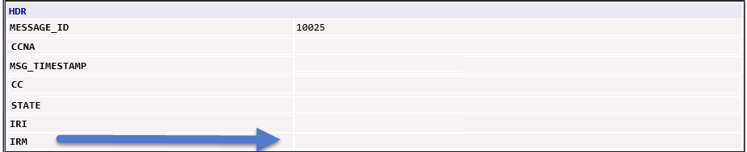  The results of the inquiry will be displayed in the IRM field.  Possible options are:
    Exact Match | The information provided was an exact match to the address databases.
    Alternatives Exist | The information provided more than one address that is similar to the request. The first 20 responses will be returned.  If the inquiry is performed within the service order, users will have the ability to use the radial button on the left-hand side to select the address and transfer it to the SALI section.
    No match found for | The information provided was not able to be validated. Users will have the ability to click CHANGE, alter the inquiry and resubmit.

Viewing the results from an address inquiry | 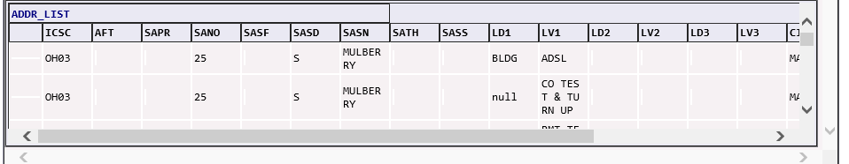  Users can use the scroll bar at the bottom of the screen to access the various fields returned in the response.  Please note: When a response contains more than 1 match, the system will only return the top 20 matches to the address. Users will be able to use the scroll bars on the right-hand side to view the available responses.
  ADDR_LIST | The following fields will be returned in the response
  ICSC | The CenturyLink ICSC associated with the address
  AFT | AFT identifies the format of the address being supplied.
  SAPR | SAPR identifies the prefix for the address number of the service address
  SANO | SANO identifies the number of the service address
  SASF | SASF identifies the suffix for the address number of the service address
  SASD | SASD identifies the street directional prefix for the service address.
  SASN | SASN identifies the street name of the service address
  SATH | SATH identifies the thoroughfare portion of the service address, such as LN (lane) or BLVD (boulevard)
  SASS | SASS identifies the street directional suffix for the service address.
  LD1,  LD2,  LD3 | The LD1, LD2, LD3 identifies additional complex address information specific information related to the address.
  LV1,  LV2,  LV3 | LV1, LV2, LV3 identifies the value associated with the location designator
  CITY | Identifies the city, village, or township
  STATE | Identifies the 2-digit abbreviation for the state or province
  ZIP | Identifies the ZIP or postal code
  Step | Action
  1 | At times, inquires can receive a message that the inquiry has timed out. Users have the option to click the CHANGE button and resubmit the inquiry.
  2 | Users can Save, Print, Close or Change the information on the inquiry by pressing the appropriate button.

Viewing the results from a Working Telephone Number Inquiry | This inquiry is not supported by CenturyLink at this time

Viewing the results from a Working Circuit Inquiry | INSERT INFORMATION HERE
  Step | Action
  1 | At times, inquires can receive a message that the inquiry has timed out. Users have the option to click the CHANGE button and resubmit the inquiry.
  2 | Users can Save, Print, Close or Change the information on the inquiry by pressing the appropriate button.

EASE PREORDER Search Function

The following steps will describe specific instructions for searching for performing an EASE Location Inquiry. Users can search previously saved PreOrder inquiries. Inquiries saved by a specific user will automatically be displayed at the bottom of the screen.

Step | Action
1 | Select SEARCH under the PREORDER menu tab.
2 | The PreOrder Search Screen will be displayed.  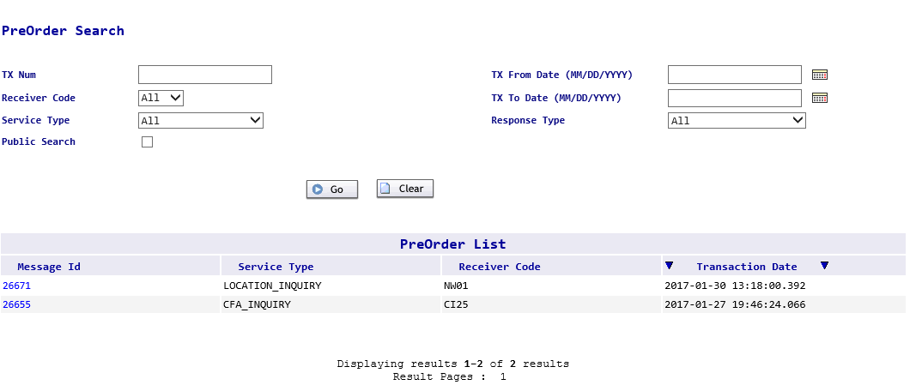
3 | To view any previously saved PreOrder inquiry for a specific ESP, users can enter information in the following fields.
  PreOrder Search
  TX Num | Enter the Message ID from the saved PreOrder response. Wildcard searches can be performed using the % symbol.
  Receiver Code | Select the appropriate ICSC from the drop-down menu. The default selection will be All.
  Service Type | Select the appropriate PreOrder Inquiry type from the drop-down menu. The default selection will be All.
  Public Search | When checked, all saved PreOrder inquiries for the ESP will be returned.
  TX From Date (MM/DD/YY) | Enter the beginning date range for the search or click the calendar icon on the right to select a date.
  TX To Date (MM/DD/YY) | Enter the ending date range for the search or click the calendar icon on the right to select a date.
  Response Type | Select the appropriate Response Type from the drop-down menu. The default selection will be All.
4 | Click Go to initiate the search or Clear to erase the search criteria and return the fields to the system default values.
5 | The PreOrder List will display PreOrders initiated by a specific user.  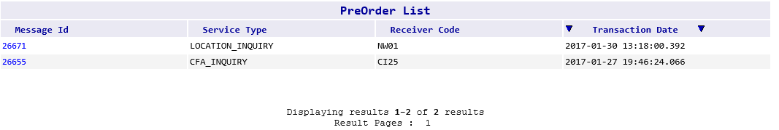
6 | Clicking on the Message ID will open the details regarding the saved search. Users will be able to see the PreOrder Inquiry as well as the associated response.  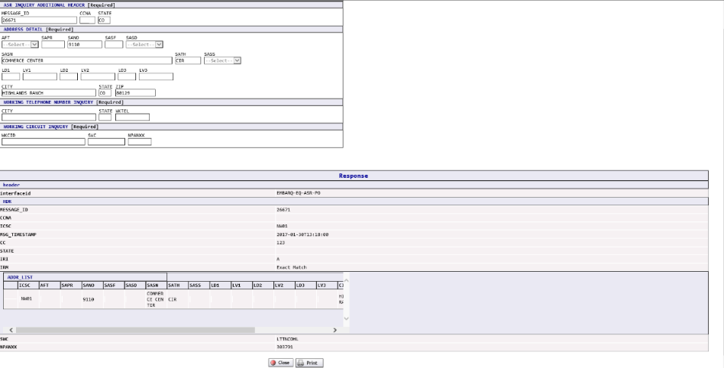
7 | Users can Close or Print the displayed information by pressing the appropriate button.

TEMPLATE Tab

Overview | The Template tab allows users to create templates in EASE VFO for future order entry. A template allows the user to quickly create orders that contain the same information. For that reason, it is best to keep the information in a template very basic. The template is created using the same ASOG version, Order Activity and Type of order.  In the template tab, users can create a NEW template or SEARCH for an existing template.  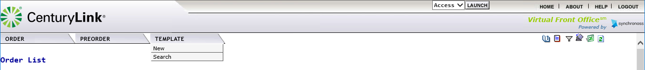

Creating a NEW template | The following steps can be used to create a new template.
  Step | Action
  1 | Select NEW from the Template Tab drop down menu.
  2 | Users will be taken to the Template Initiation Screen  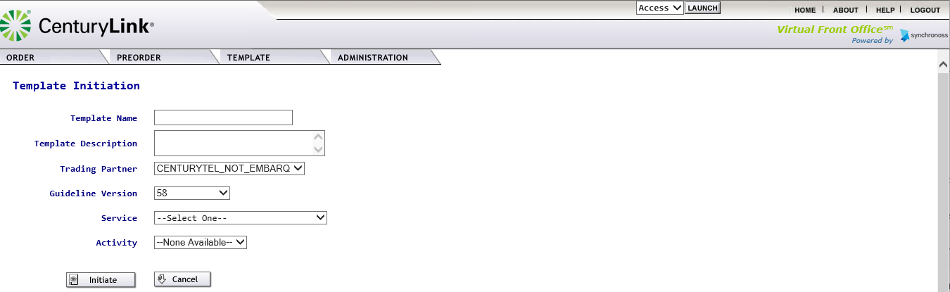
  3 | Users will enter the information in the following fields
    Field | Description
    Template Name | Enter a unique template name up to 20 characters long
    Template Description | Additional details regarding the template can be entered
    Trading Partner | It is recommended that this field not be altered.
    Guideline Version | This will default to the most current ASOG version in EASE. It is recommended that this field not be altered.
    Service | Select the Service Type from the drop- down menu.  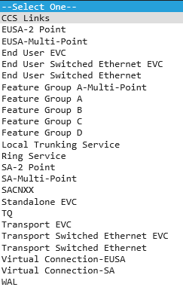
    Activity | Select the Activity from the drop-down menu. The values displayed identify the activity types permitted per ordering guidelines.
      Activity | Used for
      C | Change Service
      D | Disconnect
      M | Inside Move
      N | New Service
      R | Records Only
      T | Outside Move
  4a | Click Initiate to begin the template creation  
  4b | Click Cancel to cancel the request and be returned to the EASE main menu.
  5 | If the template is initiated, users will be taken to the Template Screens where they have the ability to enter information in each of the associated order screens.  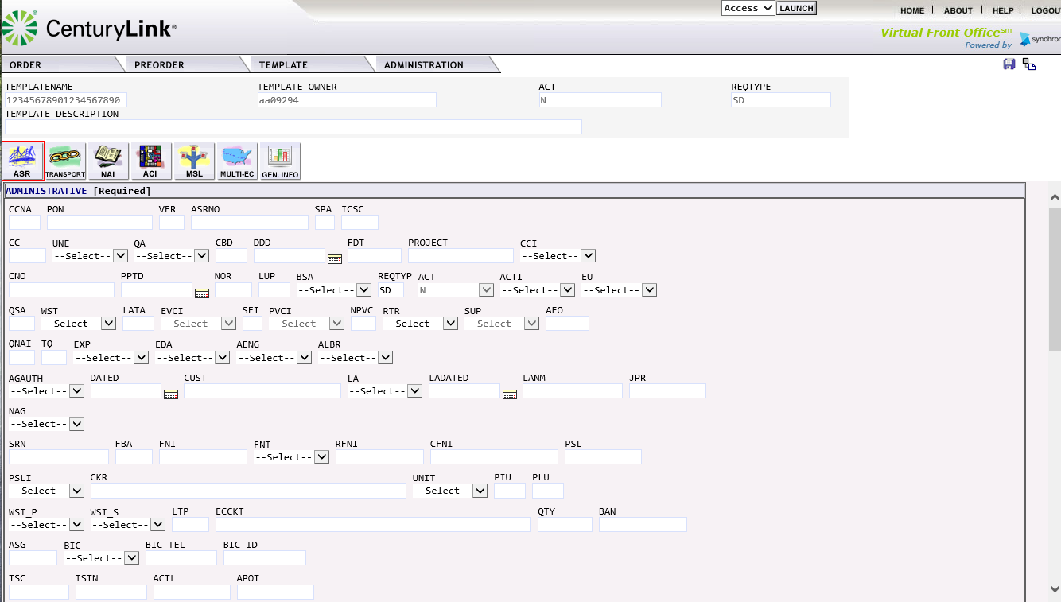
  6 | Users can move between the order sections by clicking on the various ICONs for each of the order pages.
  7 | When the template is finished, click the save icon ( )located in the top right-hand corner to save the template for future use.
  8 | Users will see a message displayed under the order tab – Record Successfully Saved.  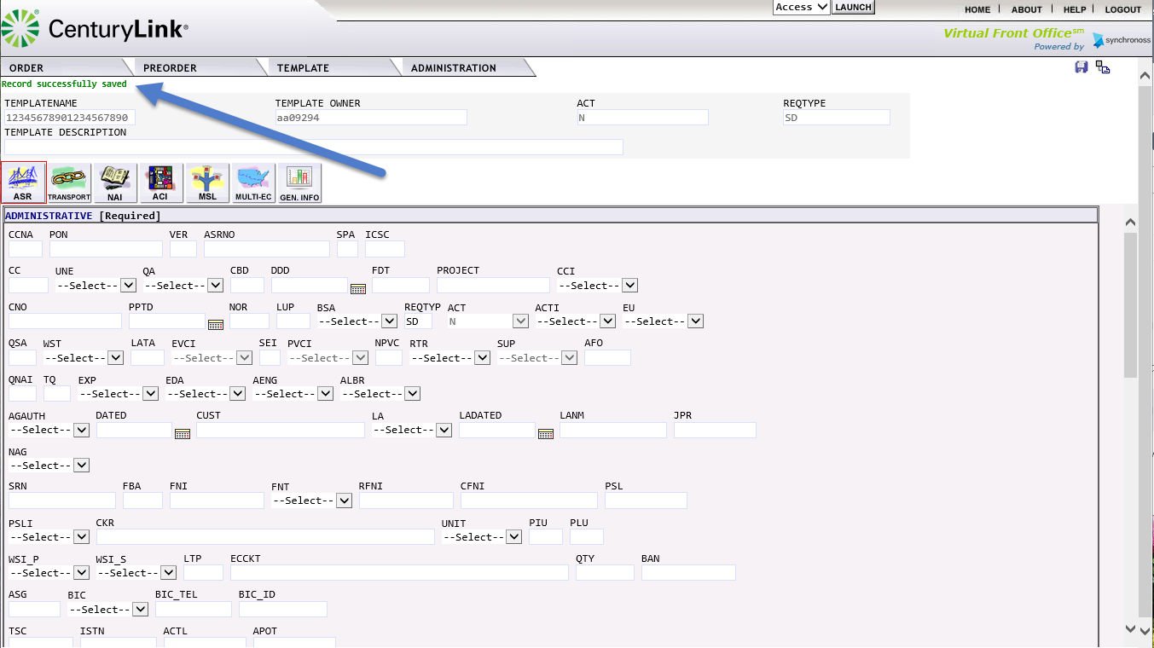
  9 | To return to the Template Tab Main menu, click on the return to list icon () located in the top right-hand corner.

Using SEARCH in the Template Tab | The following steps can be used to Search for a template Name.
  Step | Action
  1 | Select Search from the Template Tab drop down menu.
  2 | Users will be taken to the Template List Screen.  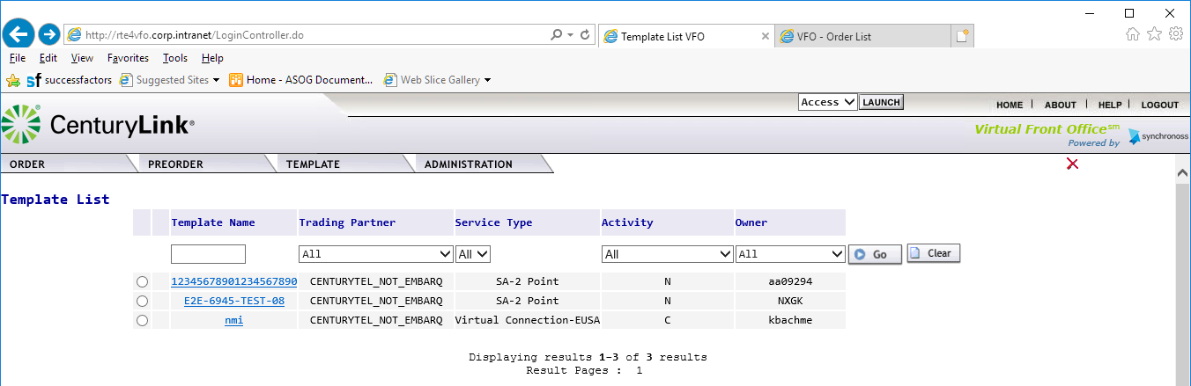

Viewing the Template List | A list of all saved templates can be viewed in the Template List.  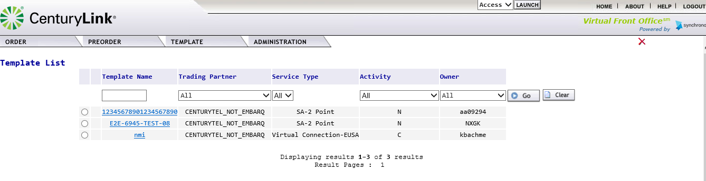  Users can sort the saved templates by using the column drop down options. Note: To reset the Template List, click on the CLEAR button

Selecting a Template | To open a specific template, users should use the following steps.
  Step | Action
  1 | Click on Template Name.
  2 | The template will be opened. Users have the ability at this point to make and save changes to the template.

Deleting a Template | To delete a specific template, users should follow the following steps.
  Step | Action
  1 | Click the radial button to the left of the template name that is to be deleted.  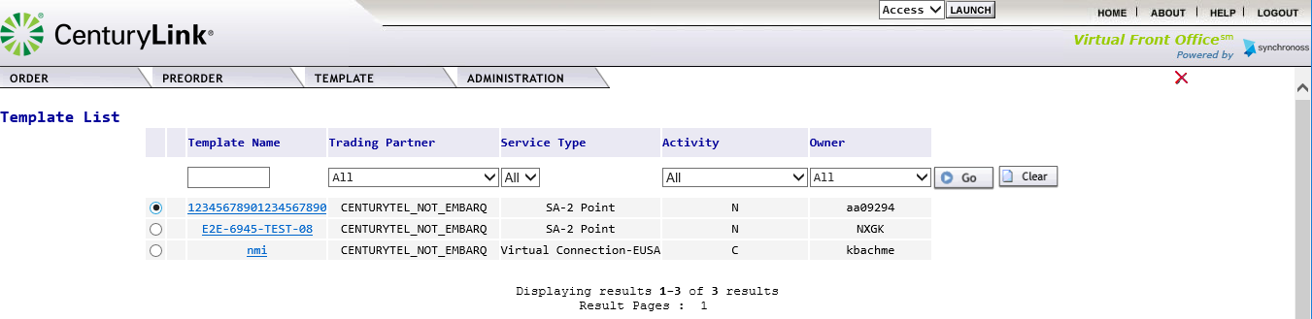
  2 | Click on the red X located in the top right-hand corner of the screen.  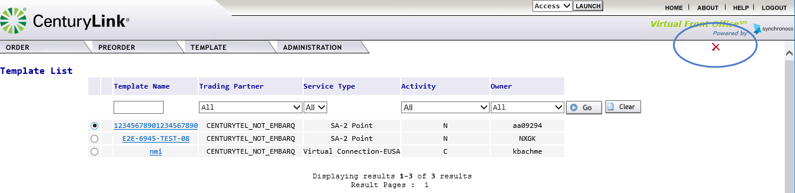
  3 | Users will receive a pop-up screen to confirm the deletion of the record.  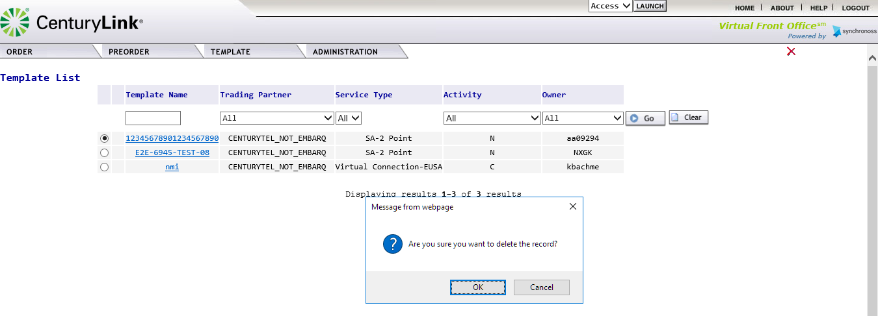
  4 | Click OK to delete the record  
  5 | Click Cancel to exit the delete request and return to the Template List.

Creating an Order in EASE VFO
Overview | This section is creating an ASR in EASE VFO. Because of the requirements for each ASR type and activity, this section is not meant to represent all edits and field entries.

EASE Helpdesk contact information | The EASE helpdesk can be contacted  - Telephone at: 888-796-9102 option 2  - via email at: Helpdesk.EASE@CenturyLink.com

Additional Resources | The following additional resources are also available:  - The ASR Order page URL: http://www.centurylink.com/wholesale/systems/ossconsolid.html  - EASE Training: http://training.centurylink.com/EASE  - Address Validation Utility, Virtual Front Office, and Reference Table Maintenance: http://EASE.centurylink.com/  - The ASOG document is available from the OBF Document Catalog at ATIS.org.

Beginning an Order in VFO | The following steps should be used to create a manual order within EASE VFO
  Step | Action
  1 | From the Order Tab, Select NEW to begin the order creation.  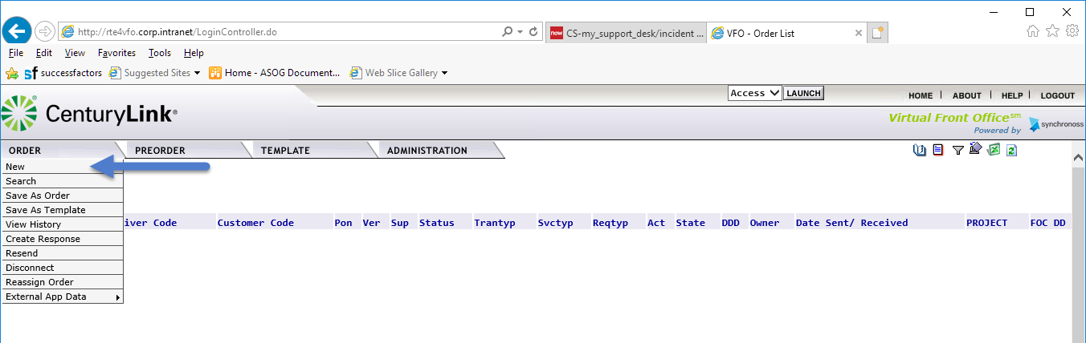
  2 | Users will be taken to the Order Initiation to set the initial order requirements.  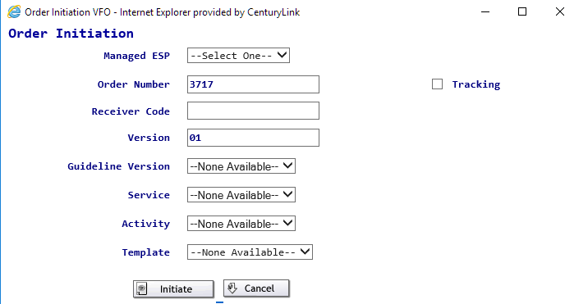
    Field | Definition
    Managed ESP | Identifies the managed customer group. Use the drop-down menu to select the managed customer group.
    Order Number | This will become the PON. Users can keep the system generated number or enter a unique 16 alpha-numeric name.  Please note: PON names cannot be re-used within a 2-year window.
    Receiver Code | Identifies the ICSC that the order will be sent to. For Meetpoint orders, this will be the ASC-EC (controlling ICSC). Users should begin typing the ICSC. The system will provide combinations. Users can then click on the appropriate ICSC.  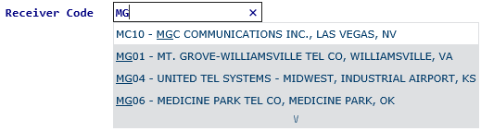
    Version | This will always be defaulted to 01. It is recommended that this value not be altered.
    The following field values will be altered after the user has populated the first 4 fields.
    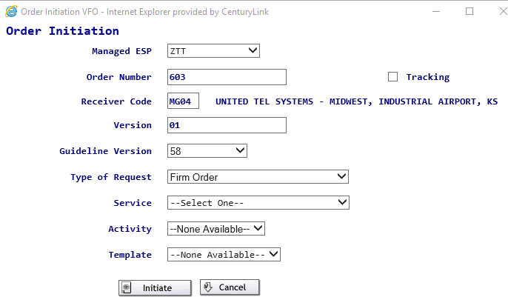
    Guideline Version | This field will default to the most current ASOG version in the EASE environment. This field should not be altered.
    Type of Request | This field will default to the value of Firm Order. This field should not be altered, as CenturyLink does not support 4 step process.
    Service | Select the Service from the drop-down menu. These values will define the type of service being ordered as well as the associated ASR forms. The Services are further defined in Appendix 2 of this guide.
    Activity | Select the Activity from the drop-down menu. The values displayed identify the activity types permitted per ordering guidelines.
      Activity | Used for
      C | Change Service
      D | Disconnect
      M | Inside Move
      N | New Service
      R | Records Only
      T | Outside Move
    Template | Select the Template from the drop-down menu if applicable. This menu will only display a template name if one is available.
  3a | Click on Initiate to create the order  Please note: Once the order has been initiated, the above values cannot be altered.
  3b | Click on Cancel to cancel the request and be returned to the EASE main menu.
  4 | A new window will be opened for the newly created order based on the fields selected.  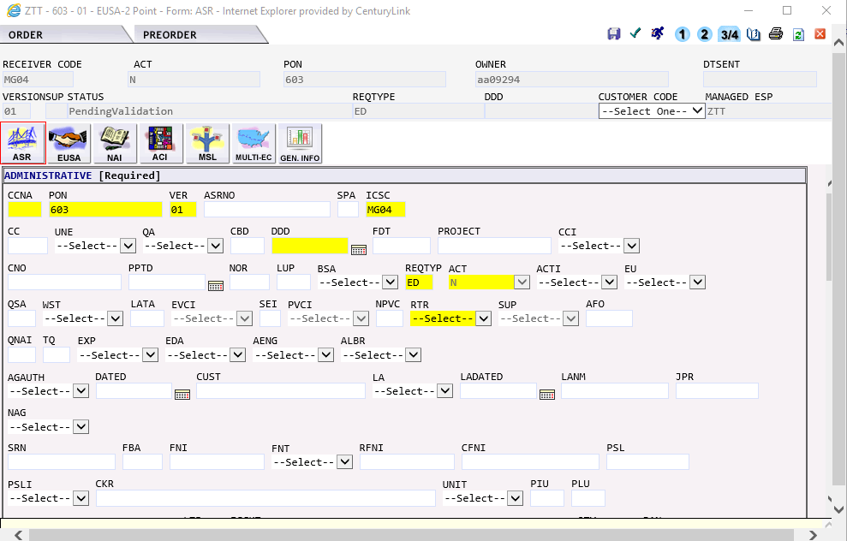

Navigating the Order Screen | The order screen is broken down into 5 basic areas:  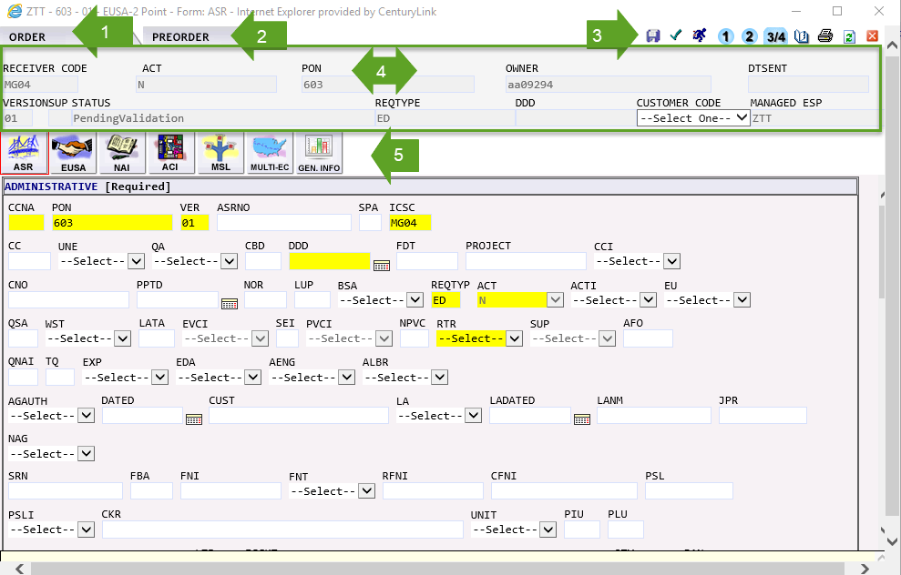  Each of these sections will be further defined below.
  Section |  | Function
  1 | ORDER Tab | This menu will provide various actions that can be performed while working with the order.
  2 | PREORDER tab | This menu will allow the user to perform PREORDER validations
  3 | Order ICONs | This section provides quick links to various order activities.
  4 | Order Header Information | This section defines the order header. The fields contained in the information defined on the Order Initiation screen.  Customer Code: The user must select the appropriate CCNA from drop-down menu. Only CCNAs associated to the customer group are available for selection.
  5 | Associated ASR Forms | EASE will display the associated ASR forms based on the Service Type selected on the Order Initiation Screen.  Please note: The Gen. Info tab is a vendor supported tab that is not used by CenturyLink.

ORDER Tab | The ORDER tab defines various activities that can occur within an order. In some cases, the same activity is available thru an ICON on the top right-hand side. Users can use the order tab or the ICON to perform the requested action.  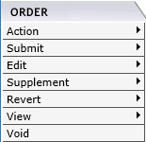
  Order Action | Defined activity
  Action | Provides the ability for a user to
    Action | Definition
    Save Order | System will save all field entries on the order.
    Save As Order | Allows the user to save the order under a different PON name. User will be taken back to the order Initiation Screen where additional fields can be altered.
    Save As Template | This allows the user to create a template from the order entry information.
    Validate | Allows the user to validate the order information.
  Submit | Provides the ability for the user to
    Action | Definition
    Validate and Submit | Validate the information entered on the ASR. If no errors are present, the order will be submitted to CenturyLink.
    Submit without Validate | This option is available to CenturyLink Administrators. This will allow an order with non-fatal errors to be submitted/accepted.
  Edit | Provides the ability for the user to
    Action | Definition
    Resend | Resend a record that has failed due to system interface issues.
    Create Response | This option is only available for CenturyLink users to provide a customer response.
    Update General Info | This is a vendor supplied tool for internal order statistics. This is not used by CenturyLink.
    Apply Template | Allow the user to apply fielded template information to the order in progress.
    Inactivate Order | This reverts the order to inactive and stops the ordering process.
  Supplement | Provides the ability for the user to
    Action | Definition | EASE will alter the SUP field to
    Cancel | Cancel the ASR | 1
    DDD Change | Modify the DDD field | 2
    Others | Modify the accepted ASR  *PRE-FOC  *POST-FOC | 4  3
  Revert | Allows the user to revert the order to a previous state/version
    Action | Definition
    Revert to Last Saved | Revert the order to the last saved version. This is only available while working in the current order state.
    Revert to Last Submitted | Revert the order to the previously submitted version of the ASR.
  View | Allows the user to view various information regarding the order:
    Action | Definition
    View History | View all History associated to the order, including all versions and order status information.
    View Error List | View all Errors associated with the current non-submitted version of the order. Users will have the ability to click on the error message to navigate to the field in error where possible.
    View Printable Version | View the PDF version of the order. This option will initiate a separate print-friendly screen. Users will have the ability to print or save the order information.
  Void | Void the order information. This option can only be used on orders that have not been submitted to CenturyLink. The PON name associated with the voided pon cannot be reused during the 2-year window.

PREORDER Tab | The PREORDER tab provides the user with the ability to check and view information outside of an order. Within the order itself, users can only initiate NEW preorder inquiries.  Detailed information regarding each of the pre-order inquiries can be found in the PREORDER Tab Section of this guide.

Order ICONs | The upper right-hand corner of the VFO Order Screen has 11 action icons to select.
  ICON | Definition
   | Save the Order
   | Validate the Order
   | Validate and Submit the Order
   | Validate and Submit with Errors.
   | Cancel the Order. EASE will systematically enter a SUP value of 1.
   | Supp the DDD on the Order. EASE will systematically enter a SUP value of 2.
   | Sup the ASR information on the order. EASE will systematically determine if the SUP value will be 3 (Post FOC) or 4 (Pre FOC)
   | View Order History
   | Print the Order
   | Refresh the Page
   | Exit the order without saving the information. Any unsaved changes will be lost.

Order Header Information | The Order Header Information identifies the order control information. Information created during the Order Initiation is transferred over into this section and is grayed out, prohibiting any change to the information.  Additional fields are populated based on user or system processing.
  Field | Additional information
  DTSENT | Date/Time Sent. This field will be populated with the Date/Time the order was accepted by CenturyLink
  STATUS | This is the current status of the order. Additional information regarding the status can be found in Appendix 1.
  DDD | This is the Desired Due Date for the order request.
  CUSTOMER CODE | This is the CCNA for the order request. Once this value is assigned, this cannot be changed.

Associated ASR forms | Depending on the Service selected, all associated ASR forms will be displayed. Users can navigate to each form by clicking on the associated ICON. Information regarding the form can be found in the Access Service Order Guidelines (ASOG).
  ICON | ASOG form
   | ASR ADMIN Form – this is the default screen displayed for every ASR.
  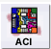 | Additional Circuit Information Form
   | Additional Ring Information Form
   | End Office Detail Form
   | End User Access Form
  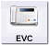 | EVC Form
  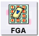 | Feature Group A Form
   | Multi Service Legs Form
  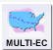 | Multi-EC Form
  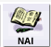 | Network Assignment Information Form
   | Ring Services Form
  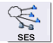 | Switched Ethernet Services Form
   | Translations Questionnaire Form
   | Transport Form
   | Trunking Form
  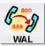 | WATS Access Line Form
  ICON | Vendor Specific Form
   | General Information – this is not utilized by CenturyLink.

Navigating within the Created Order | Once the order is created, any ASR form that could be generated with the Service selected is displayed for the user. The first screen visible for the user will be the ASR form. This is the main ADMIN form available for every order type. Users will notice that some of the fields have been highlighted in yellow. The fields selected for highlighting is a vendor choice. There should not be any assumption made that the field would be required or prohibited for the created order.  Users will have the ability to click on the various forms to easily move within the form.  To move within a specific form, users can use the TAB key to move between the fields. Users can also take their cursor and click on a field to move directly to a specific field.

Entering the field data | Entry in the EASE VFO fields can be submitted in one of three formats:
  Method | Used For
  Keystroke | Direct entry into a field. Users should use UPPERCASE for all field entry.
  Drop-Down menu | EASE VFO will provide a valid list of possible entries. Users should select one of the options displayed.
  Calendar Selection | Users have the option in date formatted fields to use the calendar () ICON to select a specific date. When the ICON is clicked, a calendar will be displayed allowing the user to select a specific date.  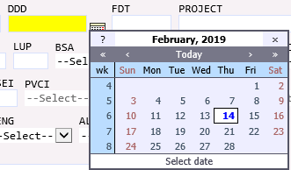  Upon selecting a specific date, the date will be formatted to the field format expected.

Viewing the Field Help Text | Help text is available for each field once in an order in EASE VFO. As a user navigates thru the various field, formatted field help text is displayed in a pale-yellow box at the bottom of the screen. This text provides a brief field definition, field format and an example of the field entry.  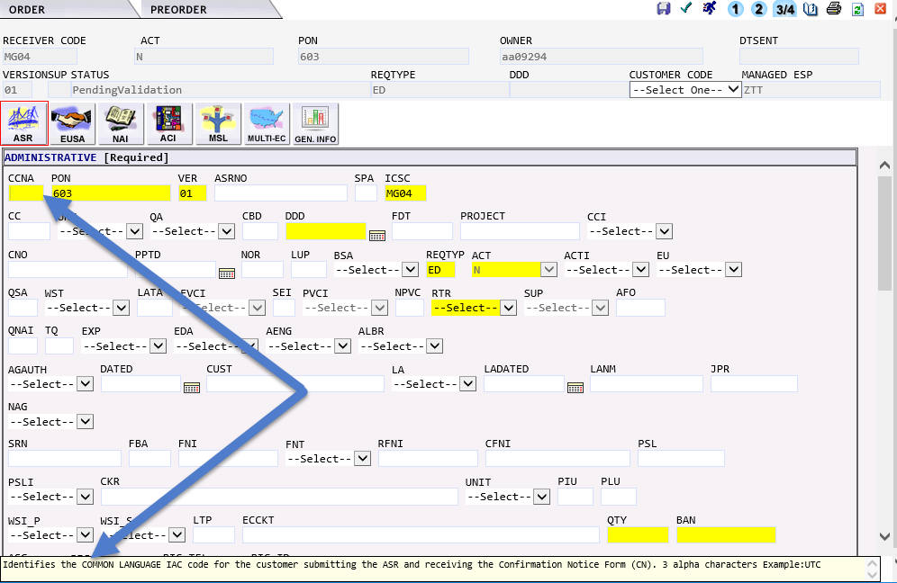

Validating the order | Clicking the validate button will allow the user to validate the order entries. This can be done at any time during the order entry and display all initial errors regarding to the ASR field entry.

Viewing the order errors | After an order has been validated, EASE VFO will display an associated order errors in a new pop-up window.  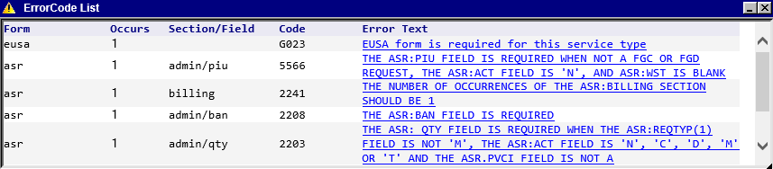
  Column | Description
  Form | Identifies the specific form where the field/error occurs
  Occurs | How many times this error occurred during a specific validation
  Section/Field | The Field/Section the error is located in
  Code | The associated error code.
    Error Starts with | Will be
    RTE….. | Industry Standard edit
    G….. | Industry Standard edit
    #### | Industry Standard edit
    EQ…. | CenturyLink specific edit for field entry
    CTLV | CenturyLink JMS error
  Error Text | This contains the error message.

Resolving the errors | Each error will have a blue hyperlink displaying the Error Text. Users can click on this hyperlink and expect one of two options to occur:  In either instance, once the error has been viewed, the blue hypertext will be change to purple.  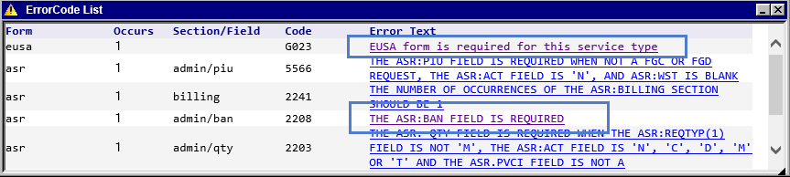  Users can use the scroll bar on the far-right hand side to scroll thru all the returned errors.  Please note: Users may receive additional errors as additional fields are entered and information corrected/ removed.
   | What will occur
  Manually navigate to the field | The user will receive a pop-up box stating that they must manually search for the first occurrence of the field.  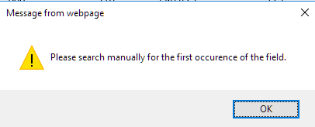
  Jump to the field in error | The user will be directed to the field in error on the screen. The field in error will be highlighted in RED and the cursor will be automatically directed to the first character in the field.  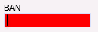

Validate within the order | Some fields within EASE VFO to validate the entered information. When available, users will see Validate as a hyperlink beside the field or following a section name.  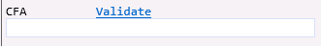  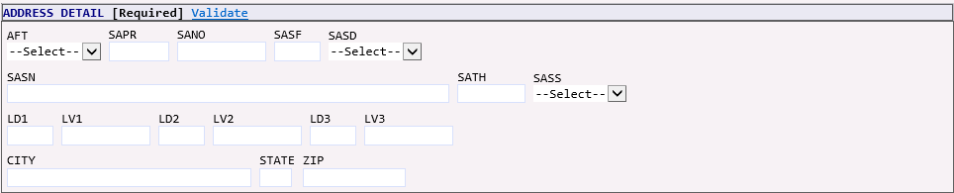  After entering the information in the field or section, users can click on the Validate hyperlink. EASE VFO will automatically initiate the appropriate PREORDER inquiry.  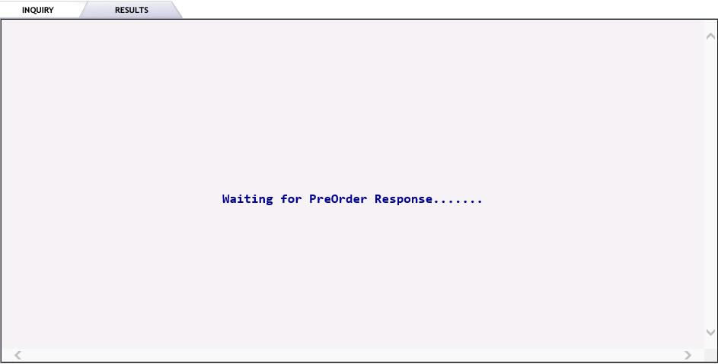  When the inquiry is complete, users will see the results for the inquiry.  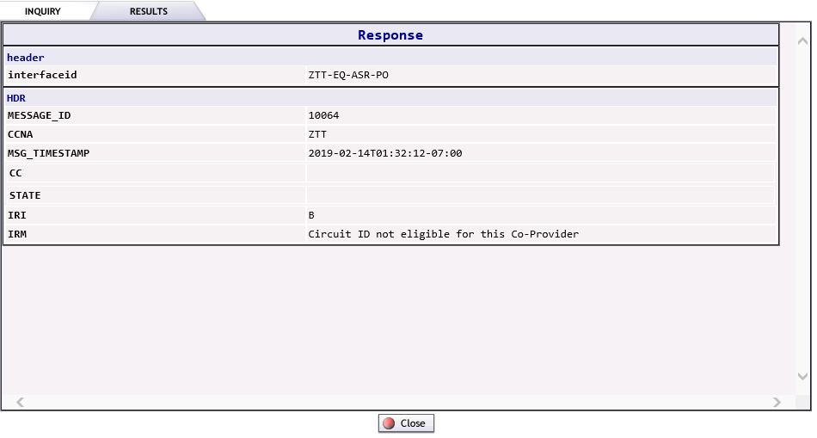  Depending on the inquiry / response, users may have the option to close the inquiry or transfer the validated information directly back into the pending order.

Submitting the Order | Once all errors on the order have been resolved, the order status will be altered to validated.  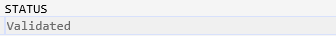  To submit the pon, users can choose a submit option from the order tab or click on the SUBMIT ICON. The system will revalidate the order and submit the order to CenturyLink. If no errors exist, users will see the order STATUS field changed to Submitted.  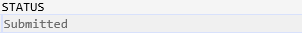

Appendix 1 - Order Status

The matrix below defines the various Order Status values, definition and user action for each status.

Status | Definition | Send/Rcv or Receive | User Action
Accepted | The Access Provider (Trading Partner) has received the order and sent a positive acknowledgement for the order. Exchange Path has updated the status, stored the message in the Exchange Path database, and sent a notification message to VFO to update the status. The ASR has passed fatal validations and will begin the order processing process. | Send/Rcv | Order will begin CenturyLink provisioning process.
Accepted | The Access Provider (Trading Partner) has received the order and it has passed fatal validations. | Receive | The response goes to Accept Submitted, so it can be transmitted to the order originator.
Accepted Sent | The Accepted response has been transmitted to the ASR originator. | Receive | The user can create and submit.
Accepted Submitted | The Accepted response is sitting in queue waiting to be transmitted to the ASR Originator. | Receive | Once the Accepted status has been transmitted, the status is changed to Accepted Sent.
Accepted System Errored | The Accepted response could not be transmitted to the ASR originator. | Receive | Once the system errors have been resolved, the Accept response can be Submitted again.
Cancel Accepted | The AP has returned a positive acknowledgement of canceling an ASR. Exchange Path has updated the status, stored the message in the Exchange Path Database, and sent a notification message to VFO. | Sent/Rcv | No Action
Cancel Received | The Cancel request has been received by the AP. | Send/Rcv | No Action
Cancel Rejected | The AP has returned a negative rejection acknowledgment for a cancellation. | Send/Rcv | View the reject reason and take the recommended action.
Cancel Resent | The Cancel request has been resent. | Send/Rcv | No Action
Cancel Sent | A Cancel request has been sent to the AP. | Send/Rcv | No Action
Cancel Submitted | The Cancel request has been sent to Exchange Path (behind the scenes EASE interface) for validation and subsequent processing. | Send/Rcv | No Action
Cancel Tracked | An order that is for tracking only has been cancelled. | Send/Rcv | No Action
Cancelled | The order has been supplemented with a cancel request. | Send/Rcv | No Action
Clarification Submitted | The Clarification response is sitting in queue, waiting to be transmitted to the ASR originator. | Receive | Once the Clarification response has been transmitted, the status is sent to Clarification Sent.
Clarification | The AP has initiated a Clarification message. Exchange Path has updated the status, stored the message in the Exchange Path Database, and sent a message to VFO to update the status. | Send/Rcv | Review the Clarification and take the recommended action.
Clarification Cleared Invalidated | The Trading Partner has returned a Clarification Cleared message for the Access Order and Exchange Path has sent a notification message to VFO to update the status. | Send/Rcv | No Action
Clarification Cleared Invalidated | The AP has initiated a Clarification Cleared message for the order, but the Clarification was not validated. | Send/Rcv | No Action
Clarification Cleared Saved | The Clarification Cleared has been cancelled and a response notification has been created and saved by the user in VFO | Receive | A Clarification Cleared response is submitted by the user.
Clarification Cleared Sent | The Clarification Cleared response has been transmitted to the ASR originator. | Receive | The user can create and submit any of the subsequent statuses.
Clarification Cleared Submitted | The Clarification Cleared response is sitting in que waiting to be Transmitted to the ASR originator. | Receive | One the Clarification Cleared response has been transmitted, the status is changed to Clarification Cleared Sent.
Clarification Cleared System Errored | The Clarification Cleared response could not be transmitted to the ASR originator. | Receive | Once the system errors have been resolved, the Clarification Cleared response can be submitted again.
Clarification Invalidated | The AP has initiated a Clarification message for the order, but the clarification was not validated. | Send/Rcv | Review the Clarification and take the recommended action.
Clarification Sent | The Clarification response has been transmitted to the ASR originator. | Receive | Review the Clarification and take the recommended action.
Clarification System Errored | The Clarification response could not be transmitted to the ASR originator. | Receive | Once the system errors have been resolved, the Clarification cleared response can be submitted again.
Clarification Validated | The Clarification has been initiated and validated, but not sent or submitted. (It is viewable online, but will not be sent back via e-mail, fax, or batch.) | Receive | Submit the Clarification.
Clarification Saved | There are issues/questions about an ASR and a Clarification response has been created and saved by the user in VFO. | Receive | The Clarification response is submitted by the user. Review the Clarification and take the recommended action.
Complete Sent | The Completed response has been transmitted to the ASR originator. | Receive | No further updates are allowed once the order is a Completed Sent status.
Completed | The VFO user has manually updated the ASR status to Completed or the AP has initiated a Completed message. | Send/Rcv | Review Response
Completed Invalidated | The AP has initiated a completion message, but the completion was not validated by the internal EP system. | Receive | No Action
Completed Submitted | The Completed response is sitting in queue, waiting to be transmitted to the ASR originator. | Receive | Once the Completed response has been transmitted, the status is changed to Completed Sent.
Completed System Errored | The Completed response could not be transmitted to the ASR originator. | Receive | Once the system errors have been resolved, the Completion response can be submitted again.
Completion Saved | The ASR has been Completed and a response has been created and Saved by the user in VFO | Receive | The Completed response is submitted by the user.
Confirmed | The AP has returned a Confirmation message for the order. Exchange Path has updated the status, stored the message in the EP database, and sent a notification message to VFO to update the status. | Send/Rcv | Review Response
Confirmed Saved | The Confirmation response has been created and saved by the user in VFO. | Receive | The Confirmed response is submitted by the user.
Confirmed Sent | Indicated that the Confirmed response has been transmitted to the ASR originator | Receive | User can create and submit any of the subsequent statuses.
Confirmed Submitted | The Confirmed response is sitting in queue, waiting to be transmitted to the ASR originator. | Receive | Once the Confirmed response has been transmitted, the status is changed to Confirmed Sent.
Confirmed System Errored | The Confirmation response could not be transmitted to the ASR originator. | Receive | Once the system errors have been resolved, the Confirmed response can be submitted again.
Design Order Confirmed | The AP has returned a Design Order Confirmation message for the order. Exchange Path has sent a notification message to VFO to update the status. | Send/Rcv | Review Response
Design Order Confirmed Saved | The DOC response has been created and saved by the user in VFO. | Receive | The DOC response is submitted by the user.
Design Order Confirmed Sent | The DOC response has been transmitted to the ASR originator. | Receive | The user can create and submit any of the subsequent statuses.
Design Order Confirmed Submitted | The DOC response is sitting in queue waiting to be transmitted to the ASR originator. | Receive | Once the DOC response has been transmitted, the status is changed to Design Order Confirmed Sent.
Design Order Confirmed System Errored | The DOC response could not be transmitted to the ASR originator. | Receive | Once the system errors have been resolved, the DOC response can be submitted again.
DLR Saved | The DLR response has been created and saved by the user in VFO. | Receive | The DLR response is submitted by the user.
DLR Sent | The DLR response has been transmitted to the ASR originator. | Sent | The user can create and submit any of the subsequent statuses.
DLR Submitted | The DLR response is sitting in queue, waiting to be transmitted to the ASR | Receive | Review Response
DLR System Errored | The DLR response could not be transmitted to the ASR originator. | Receive | Once the system errors have been resolved, the DLR response can be submitted again.
DLR/Design | The AP has returned a DLR for the order. Exchange Path has updated the status, stored the message in the EP database, and sent a notification message to VFO to update the status. | Send/Rcv | Review Response
Errored | The ASR has failed the validation process. Exchange Path has updated the Request Status, stored the ASR, and sent an Error Notification to VFO. | Receive | Correct the error and validate again.
Jeopardy | Jeopardy status indicates that there are situations that may jeopardize critical dates of the ASR. | Send/Rcv | Review the Jeopardy and take the recommended action.
Jeopardy Invalidated | The Jeopardy was initiated and not validated. (It is viewable online, but will not be sent back via e-mail, fax, or batch. | Receive | Validate and submit the Jeopardy response.
Jeopardy Saved | The FOC date is in jeopardy and a response has been created and saved by the user in VFO. | Receive | The Jeopardy response is submitted by the user. Review the Jeopardy and take the recommended action.
Jeopardy Saved | The FOC date is in Jeopardy and a response has been created and saved by the user in VFO. | Receive | The Jeopardy response is submitted by the user.
Jeopardy Sent | The Jeopardy response has been transmitted to the ASR originator. | Receive | The user can create and submit any of the subsequent statuses.
Jeopardy Submitted | The Jeopardy response is sitting in queue waiting to be transmitted to the ASR originator. | Receive | Once the Jeopardy response has been transmitted, the status is changed to Jeopardy Sent.
Jeopardy System Errored | The Jeopardy response could not be transmitted to the ASR originator. | Receive | Once the system errors have been resolved, the Jeopardy response can be submitted again.
Jeopardy with Errors | Indicates there are situations that may jeopardize critical dates of the ASR and there are errors with the request. | Send/Rcv | Review the Jeopardy and take the recommended action.
Jeopardy with Errors Invalidated | The Jeopardy was initiated, not validated, and contains errors. | Send/Rcv | Validate and submit the Jeopardy response.
Jeopardy with Errors Saved | The FOC date is in Jeopardy due to errors on the ASR and a response has been created and saved by the user in VFO. | Receive | The Jeopardy with Errors response is submitted by the user.
Jeopardy with Errors Sent | The Jeopardy with Errors response has been transmitted to the ASR originator. | Receive | The user can create and submit any of the subsequent statuses.
Jeopardy with Errors Submitted | The Jeopardy with Errors response is sitting in queue waiting to be Transmitted to the ASR originator. | Receive | Once the Jeopardy with Errors response has been transmitted, the status is changed to Jeopardy with Errors Sent.
Jeopardy with Errors System Errored | The Jeopardy with Errors Response could not be transmitted to the ASR originator | Receive | Once the system errors have been responded, the Jeopardy with errors response can be submitted again.
Pending Completion | The Exchange Path Monitor process determines that a Completion Notice has not been received in the time allotted and issues a notification message to VFO to update the status | Send/Rcv | Contact the AP to find out the cause of the delay in response.
Pending Confirmation | The Exchange Path Monitor process determines that the Firm Order Confirmation (FOC) has not been received in the time allotted and issues a notification message to VFO to update the status. | Send/Rcv | Contact the AP to find out the cause of the delay in response.
Pending Design | The Exchange Path Monitor process determines the DLR or Design information has not been received in the time allotted and a notification message is sent to VFO to update the status. | Send/Rcv | Contact the AP to find out the cause of the delay in response.
Pending Response | The Exchange Path Monitor process determines a Response has not been received in the time allotted and a notification message is sent to VFO to update the status. | Send/Rcv | Contact the AP to find out the cause of the delay in response.
Pending Validation | An initial request or a change to a request (other than Cancel) has been created, but the request has not been sent to Exchange Path for validation or submission to the AP. After selecting Submit or Validate, the resulting response from Exchange Path will be Validated or Errored. | Send/Rcv | Finish entering the order and submit.
Received | This status appears when service requests are sent to VFO for processing. This indicates the customer’s request has been received. | Send/Rcv | The Accept response is generated by the system if fatal validations are passed.
Rejected | The AP has returned a negative (rejection) acknowledgment. Exchange Path has updated the status, stored the message in the Exchange Path Database, and sent a notification message to VFO to update the status. | Send/Rcv | Review the response and take the recommended action.
Resent | Another copy of the last submitted version of the ASR is sent to the AP. | Send/Rcv | No Action
Sent | The order is sent to the AP, the status is updated, and a notification message is sent to VFO to update the status. | Send/Rcv | No Action
Sent Failed | An attempt to send the order to the AP fails. | Receive | Try to send the order again.
Submitted | This status indicates that an initial request or a change to a request has been sent to the AP for validation and subsequent processing—status does not apply to a cancel request. | Send/Rcv | No Action
Supplement Received | The customer has sent a supplement to the previously received service request. | Send/Rcv | The Accept response is generated by the system if fatal validations are passed.
Supplemented | The order has been supplemented. | Receive | No Action
System Errored | VFO has received a system error message from Exchange Path. | Send/Rcv | Read the error message, correct it, and submit the order again.
TP Cancelled | The Access Provider has cancelled the customer’s order due to no response to a Clarification/Notification Request. | Send/Rcv | Create a new order if one is still needed.
TP Cancelled Invalidated | The AP (also known as the Trading Partner (TP)) has cancelled the customer’s ASR due to no response to a Clarification/Notification Request (internal EP did not validate cancellation). | Receive | Create a new order if one is still needed.
TP Cancelled Saved | The ASR is being cancelled by the Access Provider because Clarifications have not been resolved and a response has been created and saved by the user in VFO | Receive | The TP Cancelled response is submitted by the user.
TP Cancelled Sent | The TP Cancelled response has been transmitted to the ASR originator. | Receive | The user can create and submit any of the subsequent statuses.
TP Cancelled Submitted | The TP Cancelled response is sitting in queue waiting to be transmitted to the ASR originator. | Receive | Once the TP Cancelled has been transmitted, the status is changed to TP Cancelled Sent.
TP Cancelled Submitted | The TP Cancelled response is sitting in queue waiting to be transmitted to the ASR originator. | Receive | Once the TP Cancelled response has been transmitted, the status is changed to TP Cancelled Sent.
TP Cancelled System Errored | The TP Cancelled response could not be transmitted to the ASR originator. | Receive | Once the system errors have been resolved, the TP Cancelled response can be submitted again.
TP Errored | The Trading Partner has returned one or more error messages for the order. Exchange Path has updated the status, stored the message in the Exchange Path Database, and sent a notification message to VFO to update the status. | Send/Rcv | Review the response and take the recommended action.
TP Errored Saved | The ASR has validation errors and a response has been created and saved by the user in VFO. | Receive | The TP Errored response is submitted by the user.
TP Errored Sent | The TP Errored response has been transmitted to the ASR Originator. | Receive | The user can create and submit any of the subsequent statuses.
TP Errored Submitted | The TP Errored response is sitting in queue waiting to be transmitted to the ASR originator. | Receive | Once the TP Errored response has been transmitted, the status changes to TP Errored Sent.
TP Errored System Errored | The TP Errored response could not be transmitted to the ASR originator. | Receive | Once the system errors have been resolved, the TP Errored response can be submitted again.
Tracked | The order was initiated as a “Tracking Only” request and is not be transmitted to the AP. This is used when the order was sent manually outside of VFO and user wants to track the order progress manually in VFO. | Send/Rcv | No Action
Validated | This indicates that an order has been successfully validated and there are no errors. | Send/Rcv | No Action
Voided | An order that was never submitted can be voided to indicate that the order should not be transmitted to the AP. | Send/Rcv | No Action

Appendix 2 - Order Types

The Order Type matrix below provides the Service Type, CenturyLink product, Request/Order Type, EASE VFO Form, and Notes.

Service Type | CenturyLink Product | Request/Order Type | EASE VFO Forms | Notes
CCS Links | SS7 Links | LD/Switched | TQ  Trunking
EUSA-2 Point | - DS0  - DS1  - DS3  - Program Audio  - Program Video  - LC EVPL UNI | ED/Specials/PLT | EUSA  SES (EVPL) | End-user address to End-user address (only one address with EVPL)
EUSA-Multi-Point | - DS0  - DS1  - DS3 | ED/Specials/PLT | EUSA  MSL
End User EVC | UNI/EVC Combo | ED/LC EVPL | SES  EVC | LC EVPL Combo order with address
End User Switched Ethernet EVC | UNI/EVC Combo | ED/LQ MOE | SES  EVC | Combo order with address
End User Switched Ethernet | UNI | ED/LQ MOE | SES | UNI with one address
Feature Group A-Multi-Point | N/A | N/A | N/A | Per Tariff - CenturyLink offering is point-to-point only
Feature Group A | - Trunks  - Combos | AD/Switched | FGA

Service Type | CenturyLink Product | Request/Order Type | EASE VFO Forms | Notes
Feature Group B | - Trunks  - Combos | MD/Switched | Trunking  TQ  EOD
Feature Group C | - Trunks  - Combos | MD/Switched | Trunking  TQ  EOD | Not used by CenturyLink
Feature Group D | - Trunks  - Combos | MD/Switched | Trunking  TQ  EOD
Local Trunking Service | - Trunks  - Combos  - LIS and WIS Trunks  - LIS and WIS Combo  - LIS and WIS 911 Trunks  - LIS and WIS 911 Combo  - Paging  - Type 1 | MD/Switched | Trunking  TQ  EOD
Ring Service | - LC SONET  - LC SOCR | RD/LC Rings | Ring | Not offered as meet-point

Service Type | CenturyLink Product | Request/Order Type | EASE VFO Forms | Notes
SA-2 Point | - DS0  - DS1  - DS3  - LC MASC  - Collocation scenarios  - LC NetPoint  - Program Audio  - Program Video  - LC OptiPoint  - LQ OWS  - LQ GeoMax  - LQ SHNS  - Ethernet Transport  - LC EVPL UNI | SD/Specials/PLT | Transport  NAI (Daisy Chain) | - ACTL to end-user or ACTL to central office  - LC EVPL UNI has not SECLOC
SA-Multi-Point | - DS0  - DS1  - DS3 | SD/Specials | Transport  MSL
SACNXX | 500, 900 Service | MD/Switched | Trunking  TQ  EOD
Standalone EVC | EVC | SD/LC EVPL and LQ MOE | EVC
TQ | Translations Only | MD/Switched | TQ
Transport EVC | UNI/EVC Combo | SD/LC EVPL | Transport  EVC | ACTL and no SECLOC
Transport Switched Ethernet EVC | UNI/EVC Combo | SD/LQ MOE | SES  EVC | ACTL and no SECLOC
Transport Switched Ethernet | UNI | SD/LQ MOE | SES | ACTL and no SELOC

Service Type | CenturyLink Product | Request/Order Type | EASE VFO Forms | Notes
Virtual Connection EUSA | - Frame Relay  - ATM  - DSL over ATM  - Resale Frame Relay | XD/Broadband | EUSA  VC
Virtual Connection-SA | - Frame Relay  - ATM  - DSL over ATM | VD/Broadband | Transport  VC
WAL | WATS | WD/WATS | WAL

Appendix 3 – EASE UOM Implementation Guidelines

Initial Communication | The initial communications phase will be considered complete with an agreement to either move forward with an implementation or to suspend or halt progress due to limitations on the CLEC/IXC/WSP side. This agreement and rationale will be documented in the meeting minutes by the project manager. Additional team meetings will be held as agreed upon.

Project Plan Development / Negotiation | An Implementation/Migration Project Plan represents the milestones and responsibilities of all parties throughout the planned EASE implementation process. These milestones will be mutually agreed upon. Regularly scheduled conference calls will be conducted as needed to review progress, answer questions, and identify and communicate resolution of issues. The assigned project manager will be responsible for maintaining and monitoring progress within the Project Plan. A mutual negotiation and approval process will be used to manage changes to schedules as recommended or required by either party. All parties will give sufficient advance notice to the other party to allow adequate analysis of the impact of any proposed schedule changes.  The inability of either party to meet any of the milestones contained in the Implementation Project Plan/Industry Upgrade Test Plan on the date(s) identified may result in the need to renegotiate a revised Project Plan/Test Plan. All revised plans will be developed based on the availability of resources from within the respective organizations and may contain dates that are substantially different from those described in the original plan.  The development of, and agreement to, a formal Implementation/Migration Project Plan is the pre-requisite to continuing to the remaining Implementation Process activities.

Project Plan Development / Negotiation Activities | The following activities will occur during the Project Plan development and approval process:  - CenturyLink IPM will provide a draft project plan for the customer’s review.  - Project plan will contain all of the milestones that are required for either a new implementation of a ASOG release, or a migration of an existing customer to the next ASOG industry release.  - The customer will review the proposed project plan and ask any questions about the content of the plan  - The IPM will work with the customer to incorporate changes to the project plan and reissue, if necessary, for a final review and approval.  - The customer will review the final project plan proposal and approve it when there is mutual agreement with the plan. This will be the final approved project plan for the implementation/migration.

Requirements Review | A critical factor in a successful implementation is a thorough understanding by the CLEC/IXC/WSP of EASE. The requirements review phase of implementation will provide the CLEC/IXC/WSP with an opportunity to develop a clear understanding of these requirements. This review is critical to the customer who must:  - Develop and define the business processes and procedures necessary to support the use of their ASR interface for transactions.  - Develop the appropriate documentation (i.e., Methods and Procedures) necessary to support the use of EASE by CLEC/IXC/WSP personnel.  - Perform any necessary database gap analysis for the purpose of ensuring that all data fields that carry the ASR information can be successfully populated.  - Identify appropriate data values.  - Select Pre-Order transactions to support the intended products to be ordered through the Gateway.  - NOTE: CenturyLink strongly recommends the use of Pre-Order transactions to assist CLECs/IXCs/WSPs in achieving Order content accuracy, reducing rejection rates, and improving Service Order flow-through. Pre-Order transactions can be submitted via EASE. Information on the use of EASE is documented on the CenturyLink Wholesale website at: http://www.centurylink.com/wholesale/systems/ossconsolid.html.

Requirements Review Activities | While it is the CLEC/IXC/WSP’s responsibility to perform a thorough review of all CenturyLink requirements, CenturyLink will provide support to clarify issues and answer questions regarding EASE business rules, requirements, and the Implementation Process. CenturyLink recommends the following process to ensure that the CLEC/IXC/WSP has a thorough understanding of the answers to each question:  - The CLEC/IXC/WSP reviews CenturyLink requirements as documented in the CenturyLink Specific Business Rules document and other documents listed in the “CenturyLink Document Overview” section of this document.  - Questions arising from the CLEC/IXC/WSP’s review of ASR requirements will be captured on a Question Log by the CLEC/IXC/WSP.  - The Question Log, with questions populated by the CLEC/IXC/WSP, will be submitted to CenturyLink.  - CenturyLink will either provide a response to the question or identify those questions requiring further investigation and research.  - CenturyLink will provide answers to outstanding questions and the CLEC/IXC/WSP will update the log to reflect their understanding of the answers provided.  - CenturyLink will review the answers entered by the CLEC/IXC/WSP in the log after which the CLEC/IXC/WSP may indicate that a question may be closed if it has been adequately answered.  If this process becomes cumbersome to a CLEC/IXC/WSP, the process can be negotiated to allow the customer and CenturyLink to work together most efficiently while maintaining their ability to thoroughly understand the answers to the questions.  The Requirements Review phase of the implementation will be considered complete when the CLEC/IXC/WSP determines that they have adequately reviewed all of CenturyLink’s requirements documentation and have a thorough understanding of them. This understanding will be critical to the effective development of the customer’s interface with CenturyLink.  The CLEC/IXC/WSP may decide to continue use of the Question Log throughout the implementation.

Establishing Connectivity Testing Activities for EASE VFO | CenturyLink UOM XML Pre-Order tools are available on the public internet through a secured (SSL) connection. Security is provided by the industry-standard Basic authentication method (Base-64 encoded).  For a CLEC/IXC/WSP to gain access to the CenturyLink UOM XML Pre-Order tools, a user account needs to be created, including a negotiated user name and password combination. After a CenturyLink administrator creates the user account, the CenturyLink UOM Pre-Order tools become immediately available.  The Implementation Manager will work with the CLEC/IXC/WSP to agree upon the user name and password that will be used for Pre-Order access. The Implementation Manager will also work with the appropriate internal organizations to create the user account in the Pre-Order system and then test access with the CLEC/IXC/WSP.  The Connectivity Phase will be considered complete when continuity tested between the end to end applications. This does not guarantee that specific order/pre-order transactions can be transmitted successfully from the customer to CenturyLink. It simply establishes that connectivity is proved between the two companies.

Implementation/Industry Upgrade Testing Process | The Implementation/Industry Upgrade Testing process is as follows:  - CenturyLink and the customer will agree on a test plan for the implementation/migration  - The CenturyLink test environment will be available for testing during posted times.  - The CLEC/IXC/WSP submits test transactions, according to the agreed-upon test plan.  - CenturyLink generates the responses dependent on the transaction passing the edits.  - A call may be scheduled (typically on an as needed basis) to provide an opportunity for CLEC/IXC/WSP and the CenturyLink testing representative to interact and discuss the testing results. Testing communication may also be done via email if unattended testing is selected.  The Test Phase will be considered complete when the CLEC/IXC/WSP has successfully tested the Test Plan scenarios in the test environment for new implementation and/or the Industry Upgrade cut-over has occurred.

Implementation/Industry Upgrade Testing Activities | - CenturyLink will notify the customers when the test window will be for Industry Upgrades. The CLEC/IXC/WSP will call CenturyLink to schedule their testing period within the overall test window.  - For new Implementations, the Project Plan will determine when testing will occur.  - The customer submits a proposed test plan which includes the number and types of ASRs which will be submitted for testing.  - Purchase Order Numbers (PON) and REQTYPs to be tested will be part of the plan as well as how many/which one will need a Firm Order Confirmation (FOC) upon completion.  - Proposed test plans may follow industry guidelines or be of the customer’s own creation. There are no minimum test requirements, however for a new implementation, it is suggested that all REQTYPs be tested that will be in production.  - The CLEC/IXC/WSP will notify the IPM when they begin sending in order files for testing.  - The IPM will track incoming files and notify the customer of the status of the test scenarios.  - When Business Processing Layer (BPL) errors occur, the IPM will notify the customer and provide any assistance to them to resolve the issue.  - All test scenarios submitted from the plan will receive successful acknowledgments from CenturyLink.  - The customer will request when they want to receive any FOCs from the test plan. The IPM will advise the customer when the FOC is ready and a new file will be required from the customer to trigger the FOC back to them.  - The customer may notify the IPM when an error they receive does not follow OBF standards. The IPM will research the error and if a bug is determined by the technical team, CenturyLink will determine when the bug will be fixed. CenturyLink will notify the CLEC/IXC/WSPs of any such bugs that do not get fixed during the test process.

Test Plan | Test Planning will begin approximately two weeks prior to the start date of testing where the following will be reviewed and determined:
  Plan Criteria | Definition
  Test Case Creation: | It is expected that test cases will be documented that are required for successful test execution of ASR UOM capability. These test cases will be used as the basis for a successful testing phase..
  Test Case Execution Window: | Test cases will be executed during a defined testing window. This will be a mutually agreed upon time period. For example. 8-12 AM CST or 1-5 PM CST. This will ensure all resources are available during the planned testing timeline.
  Testing Success Rate: | Goal for execution and pass rate should be mutually determined during Test Planning.
  Testing Communications | During planning, the method, timing and frequency of communications for testing should be determined by CenturyLink and the customer. Periodically, CenturyLink refreshes the test databases, which may require CenturyLink to provide new test data.
  Testing Resources | Testing resources need to be confirmed prior to the start of testing. All testing resources should be readily available via phone, email or IM during the testing window. This will ensure testing stays on schedule and resolution incurs no delay.
  Testing Phases | During planning, the testing phases will be reviewed. Testing Phases include Connectivity, Systems and User Testing. These are detailed in the Test Execution Phase.
  Testing Timeline | During planning, the testing timelines should be solidified and confirmed for each phase. Guidelines are provided in the overall schedule section of this document.

Test Case Review | A review of the Test Cases to be executed should be held at least one week prior to the start of testing. The participants would be the Test Case creators and execution contacts from both companies. Test cases should cover all scenarios that would be executed through the UOM interface.
  Type of Testing | Definition
  System Testing | System Testing will be completed by CenturyLink to ensure core components are functioning prior to connectivity test start.
  Connectivity Testing | Connectivity testing is the first step to completing preparation for User Testing. Connectivity testing will ensure we have the interface connectivity setup correctly and transactions can be sent between CenturyLink and your company. It is critical that we have access to the individuals who can support and troubleshoot the Connectivity Testing. This is often where the entire process becomes delayed if not handled in a timely manner
  User Testing | User testing will be the execution of the User Created test plan. CenturyLink will be required to confirm transactions are received and responses are sent. This testing will be completed during the defined Testing Window.

Deployment Planning | Deployment Planning will begin approximately three weeks prior to the actual implementation date where the following will be reviewed and determined:
  Area | Description
  Detailed Project Plan | A detailed Project Plan will be created outlining the tasks, resources and timeframes for each activity to be completed during the implementation window. Both CenturyLink and the customer will be required to create one.
  Backout Plan | Each deployment plan will include a backout plan in the event an issue arises during deployment and/or testing that requires us to backout the changes.
  Implement Window | The implementation window will consist of an agreed upon timeframe of which the UOM code will be deployed into production. This is typically done after hours to avoid impact to any daily activities.
  Shakeout Testing | Testing will occur once the deployment is complete to ensure the new interface is working as designed and did not negatively impact the non-UOM business activities.
  Shakeout Testing Data | Data required for shakeout testing needs to be planned ahead of time to ensure adequate data for execution against the new UOM interface.
  Escalation | The Escalation point during Deployment will be through the CTL IT Primary POC who will then engage the CTL Business Escalation point. It is expected that the customer will utilize a similar process.
  Code Lock | It is customary to lock code one week prior to the actual deployment date. This allows time to finish preparation for implementation and ensures no hasty last minute changes jeopardize the success of the activities.
  GO/NO GO | A joint GO/NO GO meeting will be held with both CenturyLink and the customer to review the testing results, deployment planning readiness and provide the final GO or NO GO decision to implement the new UOM interface. This will be held at least 2 days prior to, and no more than five days prior to the actual deployment start.

Deployment Execution | There will be two issues covered during the Deployment execution:  Deployment Execution Communication: A joint conference bridge will be established at the start of the deployment activities. This will allow for easy communication between CenturyLink and the customer. All status and issues will be reported to this bridge. The bridge can be provided by either company.  Deployment Approval: Upon approval of the deployment and Shakeout testing activities, all key parties will gather on the joint bridge to discuss the status of the deployment. At this time, a GO/NO go decision will be made to move ahead with the new UOM interface.

Post Implementation Review | In order to ensure there are no production issues post initial deployment, post implementation meetings will be setup daily by the IT Main point of contact the week following to address any issues that may arise.

Milestones
Event/Milestone | Activities
Initial Customer Engagement Meeting | - Review UOM Implementation Process  - Identify IT/Business leads from customer and complete contact information  - Assess customer readiness/resource availability  - Discuss Next Steps
Joint Technical Meeting | - Confirm contact information  - Develop high-level schedule  - Discuss connectivity testing strategy/ time required  - Discuss technical requirements:  - Preferred connectivity option  - Connectivity Information  - Customer and CenturyLink - provide IP addresses; source/destination URLs (test and production environments)  - Type of security required
Timeline Confirmation Meeting | - Confirm customer timeline for implementation
Environment Readiness | - Interface/connectivity changes complete for CenturyLink and customer
Test Execution | - Connectivity & Application Testing  - Comparable support/troubleshooting contacts from the customer side
Deployment Planning | - Determine Implementation Window  - Consists of mutually agreed upon timeframe for production deployment. Typically done after hours to avoid impact to any daily activities.  - Develop Implementation Plan (Customer & CenturyLink)  - Should outline tasks, resource and timeframes for each activity/tasks to be completed during the implementation window.  - Develop Backout Plan  - Implementation plan will include a backout plan in the event an issue arises during deployment  - Escalation  - Escalation point during deployment will be through the CenturyLink IT contact.
Deployment Execution | - Deployment Execution Communication:  - A joint conference bridge will be established at the beginning of the deployment activities, to allow easy communication between CenturyLink and the customer.  - Upon approval of the deployment and verification testing activities, both companies will provide sign-off.
Post-Implementation Support | - To minimize and/or ensure that there are no production issues following the deployment, the EASE IT contact will monitor the daily activities of the new customer, for a minimum of 1 week, and address any issues that might arise.

