LSR UOM Receive Web Service API Specification

Version 2.2
Document Number: LSOG-REC-WS-EA

Initial Issue Date: December 03, 2010
Date Last Revised: April 27, 2020

CENTURYLINK

COMMERCIALLY SENSITIVE
REPRODUCTION PROHIBITED
Copyright 2017-2018 Synchronoss Technologies, Inc.®
All rights reserved. All information and data contained in this document is CONFIDENTIAL and PROPRIETARY to Synchronoss Technologies, Inc. and its affiliates, and intended only for use of authorized user to whom this copy is assigned by Synchronoss Technologies, Inc. The user shall not copy, reproduce, transmit, distribute, disclose or use the information or data contained in it, or any portion of it, except as expressly permitted in writing by Synchronoss nor permit anyone else to do the same. The recipient shall be held fully liable for any wrongful disclosure or use of any of the information contained in this document by him, or his officers or employees or anyone else to whom he makes the information available. Synchronoss® and Synchronoss Technologies® are registered trademarks of Synchronoss Technologies, Inc.®
Exchange PathTM Interconnection Gateway are trademarks of Synchronoss Technologies, Inc.
All other names or marks may be trademarks of their respective owners.

Revision No. | Date | Prepared By | Description of Changes
2.1 | 02/22/2018 |  | Updated VER for LSOG14
2.2 | 04/27/2020 |  | Updated VER for LSOG19

Review Tracking:
Document Information
Project/Product:  LSR UOM Receive Web Service component | Release: | Feature/Subsystem/Other: ____________________________________________
Document Title: LSR UOM New Customer API – Ver 2.2 2Q19.doc |  | Document # LSOG-REC-WS-EA
Document Date: 04/27/2020
Date Document Distributed for Review:
Meeting Review Date (if applicable):
Reviewer Information

TABLE OF CONTENTS

1. Introduction 4
1.1 Referenced Documents: 4
1.2 System Requirements 4
1.3 Definitions 4
1.4 Assumptions and Constraints: 4
2. LSR UOM Receive Web Service Interface Architecture 5
3. WSDLs & LSR Flow 6
3.1 LSR Receive WSDLs 6
3.1.1 LSR Request Receive WSDL 6
3.1.2 LSR Response Send WSDL 6
3.1.3 LSR UOM Order Flow 7
3.1.4 LSR UOM Pre-Order Flow 8
3.1.5 LSR Order Receive - Positive Flow 9
3.1.6 LSR Order Receive – SOAP Fault 10
3.1.7 LSR Order Receive – Hard Error 11
3.1.8 LSR Order Receive – Soft Error 12
3.1.9 LSR Order Receive – Non-Fatal Error 13
3.1.10 LSR UOM Receive – Pre-Order Positive Flow 14
3.1.11 LSR UOM Receive – Pre-Order Negative Flow 15
4. Sample LSR tMLs 16
4.1 LSR UOM Order Request tML 16
4.1.1 ReqType: CB 16
4.1.2 ReqType: JB 18
4.2 LSR UOM Order Response tML 21
4.2.1 OK tML 21
4.2.2 SOAP Fault 22
4.2.3 Error Fatal Response tML (Hard Error) 23
4.2.4 Error Response tML (Soft Error) 24
4.2.5 Jeopardy Response tML 25
4.2.6 Clarification Response tML 26
4.2.7 Confirmation Response tML 27
4.2.8 Completion Response tML 29
4.3 LSR UOM Pre-Order Request / Response tML 30
4.3.1 DLI Pre-Order Request / Response tML 30
4.3.2 CSI Pre-Order Request / Response tML 35
4.3.3 AV Pre-Order Request / Response tML 41
5. SOAP Faults and Fault Messages 47
6. tMLHeader Details 48
7. LSOG 19 /UOM Schemas
8. WSDLs: Provided under Separate Cover 49

Introduction

Referenced Documents:
ATIS Documents for UOM LSR

ILEC customers have to purchase/procure above referenced documents from ATIS.

System Requirements
- Web Services over HTTP/HTTPS
- SOAP version 1.2
- WSDL 1.1

Definitions
XML – Extensible Markup language
LSR – Local Service Request
LSOG – Local Services Ordering Guideline
WSDL – Web Service Definition Language
RPC – Remote Procedure Call
HTTP – Hypertext Transfer protocol
SOAP – Simple Object Access Protocol
tML – Telecommunications Messaging Language

Assumptions and Constraints:
- The LSOG XML Schema used is derived from LSOG 19 ATIS defined XML Schema. .
- Using this LSR UOM receive Web Service component will not impact cross-visibility functionality in VFO. Without Web Services, transactions used to come through to Exchange Path directly. With Web Services, they would come via Web Services and finally to Exchange Path.
- This new LSR UOM receive Web Service component will support order as well as preorder requests and responses.

LSR UOM Receive Web Service Interface Architecture
LSR UOM Receive Web Service interfaces follows standard business-to-business integration mode between two trading partners.

ILEC LSR Receive Web Service

CLEC Customers (LSR Send and Response Receive)

FIREWALL

FIREWALL

- ILEC LSR Receive Web Services are implemented in RPC style as per the WSDL published. More details on the LSR WSDLs are provided in the following document.
- CLEC customers need to write to the LSR Request-Receive WSDL to send LSR requests to the ILEC.
- CLEC customers must implement RPC style Web Service as per the LSR Response-Send WSDL published by the ILEC to receive asynchronous LSR order response notifications.
- CLEC customers’ LSR send client needs to initiate tML request over HTTPS.
- ILEC LSR receive Web Service interface extracts the payload, forwards it to back end system and sends soap response back to the CLEC customers.

WSDLs & LSR Flow

3.1 LSR Receive WSDLs

3.1.1 LSR Request Receive WSDL

This Web Service must be implemented by the new LSR UOM Receive Web Service component, and the CLEC customer sending LSR UOMs must write to this Web Service using the LSRRequest-Receive.wsdl.

The processAsyncRequest is for Orders and the processSyncRequest is for Pre-Orders.

Note: The Web Service server will be deployed on the ILEC side and will be able to handle requests coming in and responses going to CLEC customers.

Operation and Message Names
processAsyncRequest – RPC over SOAP HTTP protocol
  - request
  - response
processSyncRequest – RPC over SOAP HTTP protocol
  - request
  - response

3.1.2 LSR Response Send WSDL

CLEC customers must implement this Web Service and the ILEC must write to this Web Service hosting the LSRResponse-Send.wsdl. This WSDL is only for Orders as there are no asynchronous responses in the case of Pre-Orders.
.

Operation and Message Name:
processAsyncResponse – RPC over SOAP HTTP protocol
  - response

3.1.3 LSR UOM Order Flow

CLEC customers must transmit LSR UOM Order tML as request parameter over the operation processAsyncRequest with a place holder for the response string parameter.

ILEC will validate the received UOM message for basic tML conformity and XML Schema validation.
- If it fails, a SOAP fault will be sent back on the response message of the processAsyncRequest web service call.
- If successful, OK tML will be sent as the synchronous response attribute of the processAsyncRequest web service call.

ILEC will then continue validating the XML against the Business Rules.
  - If business rules validation fails, ILEC sets the header element <businessrulevalidationresult> to the value FAILED in the LSOG 19 Request XML message. Populate the LSR_RESP/HDR and LSR_RESP/header with the same information as is being generated in LSR UOM Receive flow when a business rule error happens. If Error Analyzer classifies these as
    - All Hard Errors, will transmit the Fatal Error response (LSR_RESP/LR/ERROR_DETAIL populated) message via HTTP/HTTPS to ILEC customers. The error code and description in the ERROR_DETAIL section must convey the detailed rule error(s). The LSR_RESP/LR/LR_ADMIN/RT tag must contain “V”. The LSR_RESP@responsetype attribute must contain “ERROR-FATAL”.
    - All Soft Errors, will embed the error xml as CDATA value to the <businessrulevalidationresult> tag in header section of the LSOG 19 Request XML and send it to back end OSS. The error code and description in the ERROR_DETAIL section must convey the detailed rule error(s). The LSR_RESP/LR/LR_ADMIN/RT tag must contain “E”. The LSR_RESP@responsetype attribute must contain “ERROR”.
    - Neither Hard nor Soft, will transmit the Non-Fatal Error response (LSR_RESP/LR/ERROR_DETAIL populated) message via HTTP/HTTPS to ILEC customers. The error code and description in the ERROR_DETAIL section must convey the detailed rule error(s). The LSR_RESP/LR/LR_ADMIN/RT tag must contain “E”. The LSR_RESP@responsetype attribute must contain “ERROR”. ILEC will embed the error xml as CDATA value to the <businessrulevalidationresult> tag in header section of the LSOG 19 Request XML and send it to the back end OSS.
    - Some are Hard: ILEC will follow the Hard Error flow considering only those errors configured as Hard and ignoring any other validation errors.
    - None are Hard, some are Soft and some are neither Hard nor Soft: then ILEC will follow the “neither Hard nor Soft” flow.
  - If business rules validation is successful, ILEC sets the header element <businessrulevalidationresult> to the value PASSED in the XML message. ILEC will send the Accept Response tML to ILEC customers.

3.1.4 LSR UOM Pre-Order Flow

ILEC customers must transmit LSR UOM Pre-Order tML as request parameter over the operation processSyncRequest with a place holder for the response string parameter.

ILEC will validate the received UOM message for basic tML conformity and XML Schema validation.

If it fails, a SOAP fault will be sent back on the response message of the processSyncRequest operation.

If it succeeds, the request must be translated to XML and transmitted to the ILEC’s OSS, wait for synchronous response and send back that response over the same processSyncRequest operation as response back to the sender. Exchange Path must persist the request tML & XML as Source & Target in an outbound transaction. It must persist the response XML & tML as Source & Target in an inbound transaction.

3.1.5 LSR Order Receive - Positive Flow

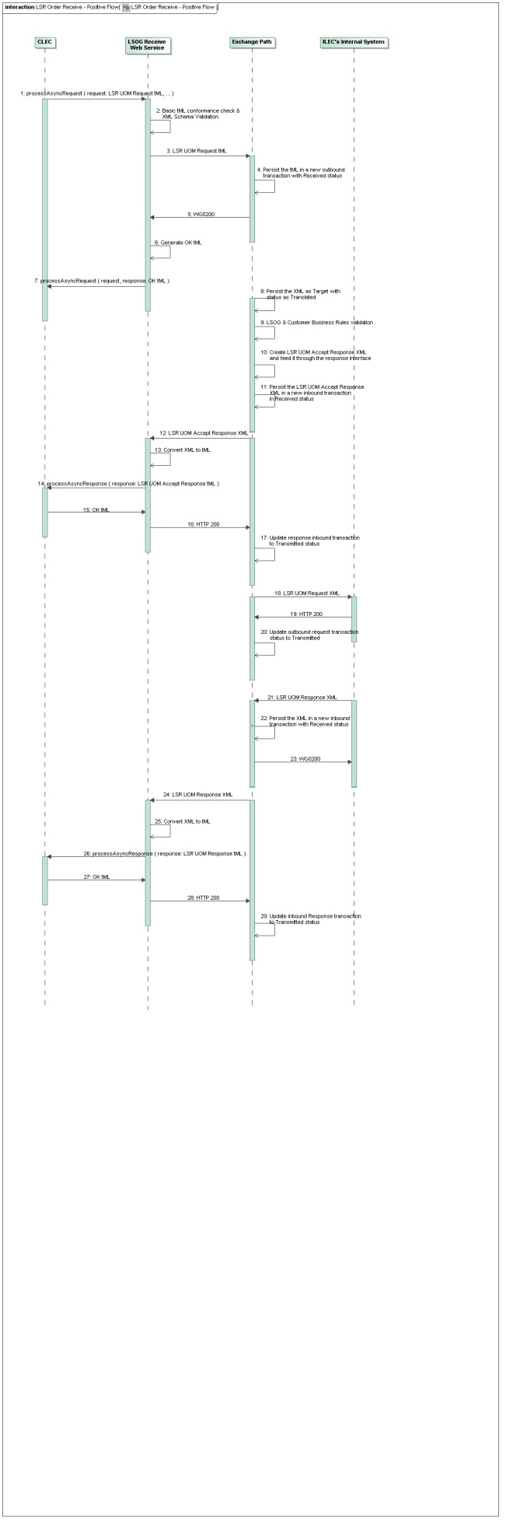

3.1.6 LSR Order Receive – SOAP Fault

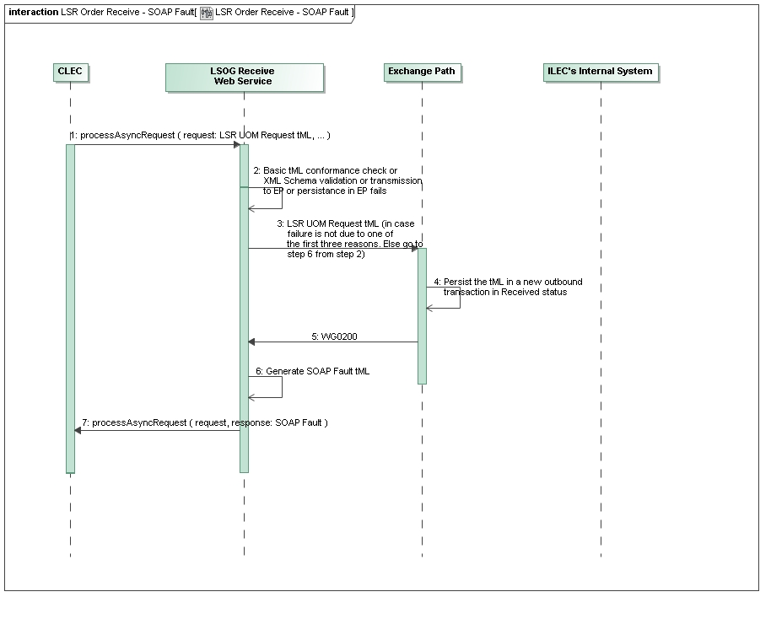

3.1.7 LSR Order Receive – Hard Error

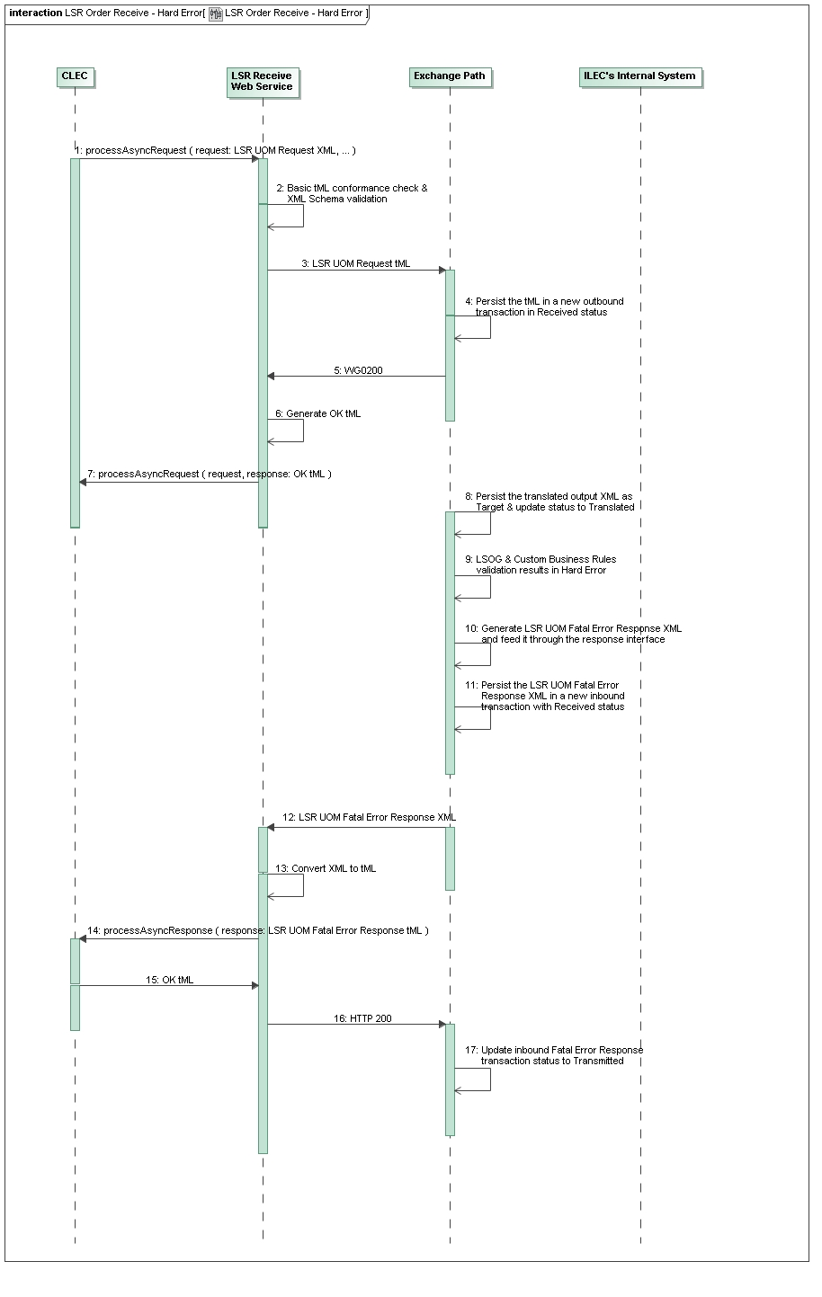

3.1.8 LSR Order Receive – Soft Error

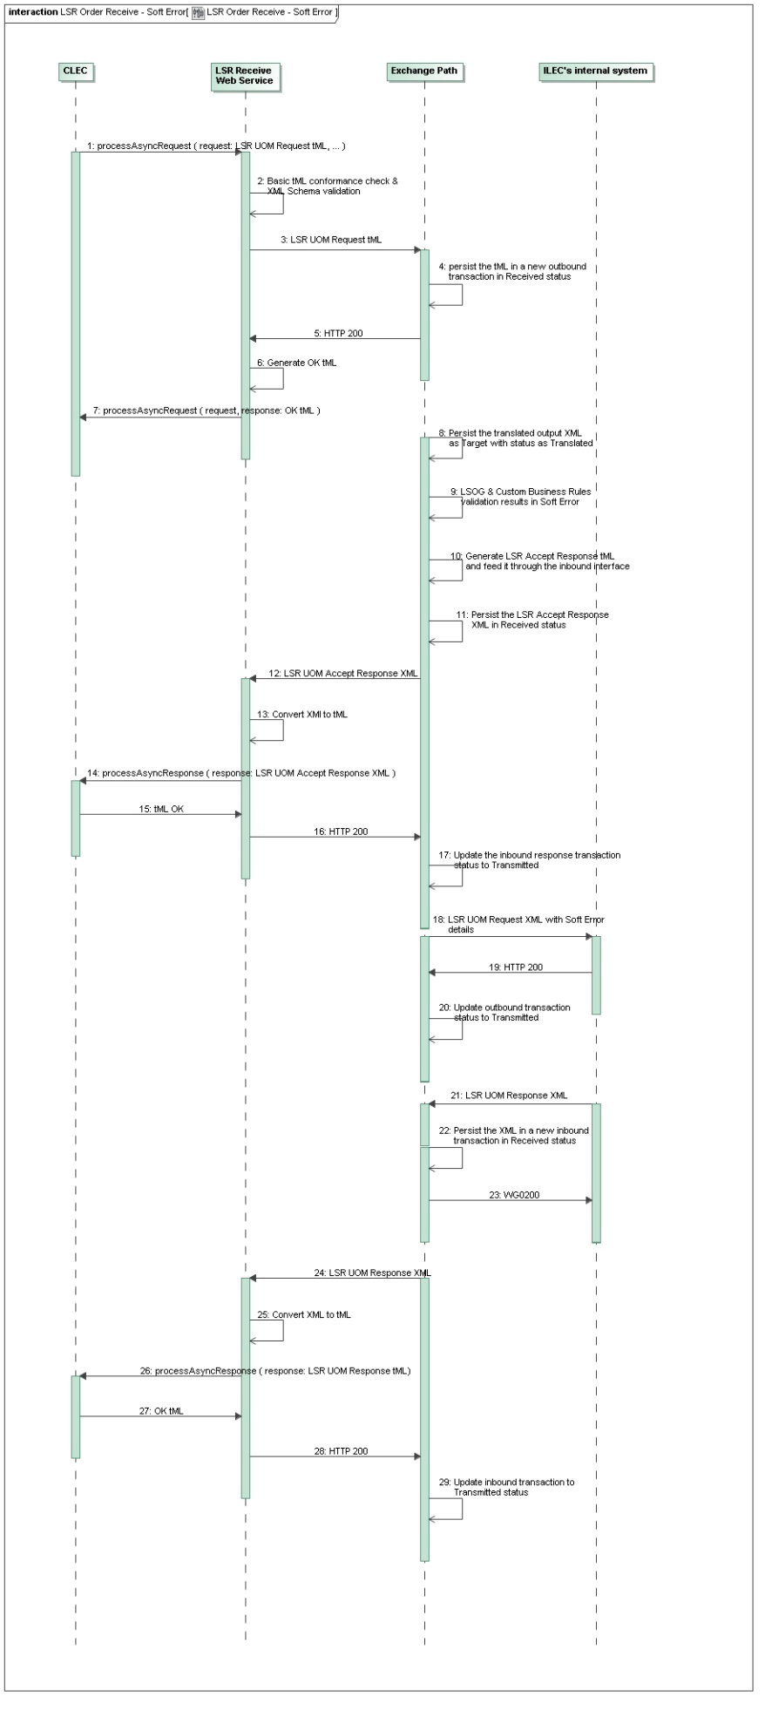

3.1.9 LSR Order Receive – Non-Fatal Error

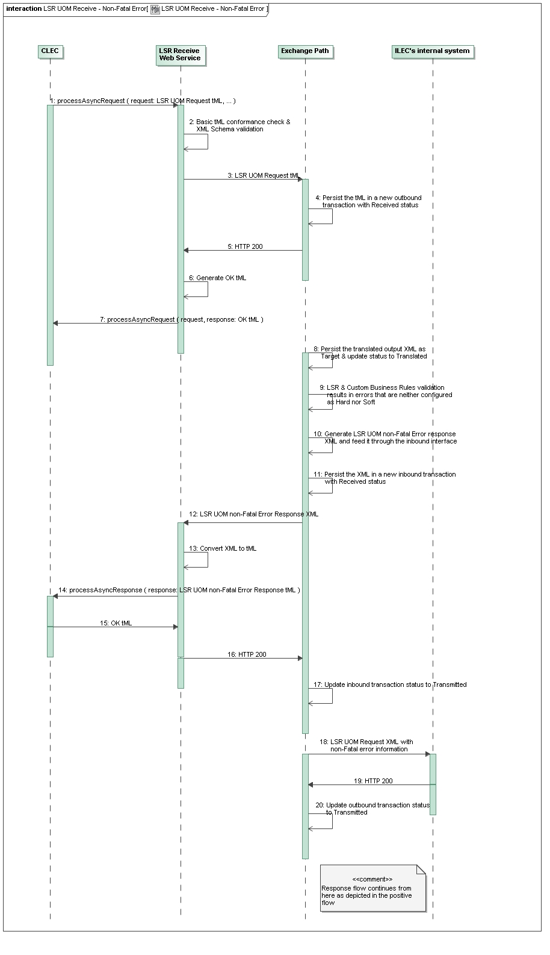

3.1.10 LSR UOM Receive – Pre-Order Positive Flow

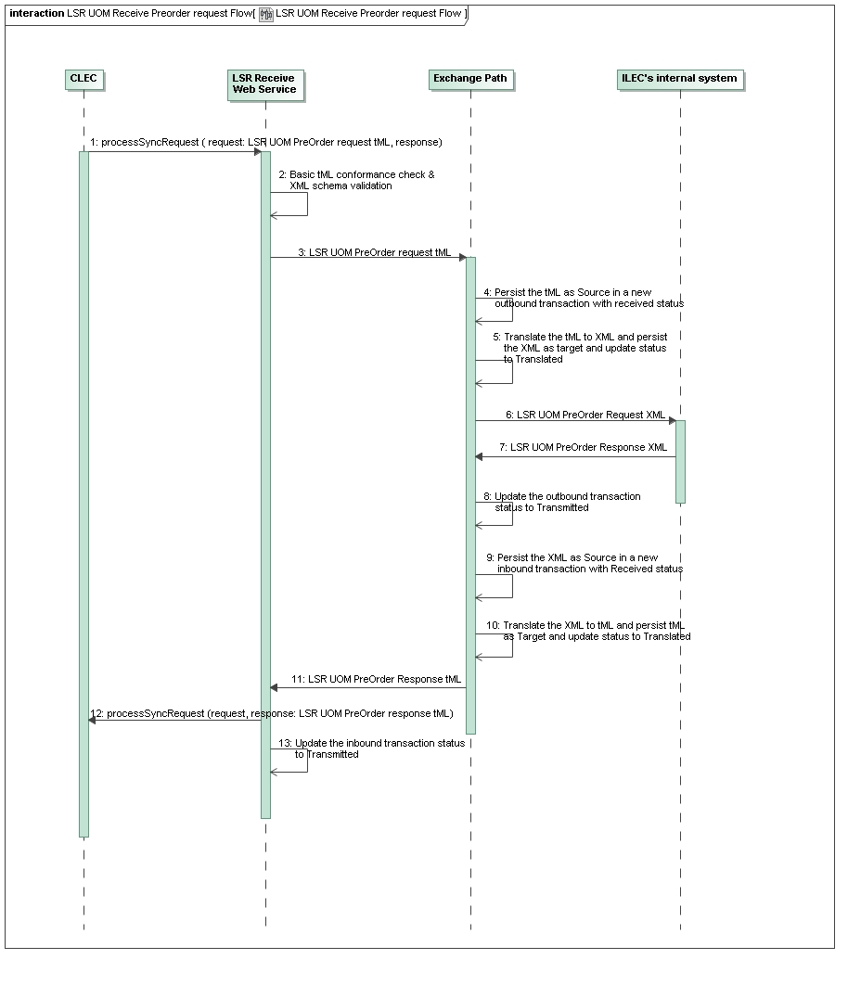

3.1.11 LSR UOM Receive – Pre-Order Negative Flow
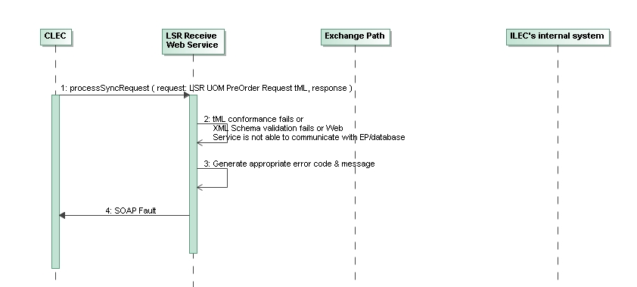

Sample LSR tMLs – The following samples are a guide for xml structure. The order xml and data is not meant to be a guide to build orders.

4.1 LSR UOM Order Request tML

4.1.1 ReqType: CB
<?xml version="1.0" encoding="UTF-8"?>

- <soapenv:Envelope xmlns:soapenv="http://schemas.xmlsoap.org/soap/envelope/" xmlns:xsd="http://www.w3.org/2001/XMLSchema" xmlns:xsi="http://www.w3.org/2001/XMLSchema-instance">

- <soapenv:Header>
<wsse:Security soapenv:mustUnderstand="0" soapenv:actor=""
xmlns:wsse="http://schemas.xmlsoap.org/ws/2002/07/secext">
<wsse:UsernameToken>
<wsse:Username>request_un</wsse:Username>
<wsse:Password>request_pwd</wsse:Password>
</wsse:UsernameToken>
</wsse:Security>

- <ns1:tMLHeader xmlns:ns1="http://tml.t1m1.org/tML.Transport.xsd">
<ns1:TransportID>1234EMBQ2018-02-28T09:12:09.758-05:0095</ns1:TransportID>
<ns1:CorrelationID>88484</ns1:CorrelationID>
<ns1:ApplicationType>LSROR</ns1:ApplicationType>
<ns1:From>1234</ns1:From>
<ns1:To>EMBQ</ns1:To>
<ns1:SendTimestamp>2018-02-28T09:12:09.758-05:00</ns1:SendTimestamp>
<ns1:RetryCount>0</ns1:RetryCount>
</ns1:tMLHeader>
</soapenv:Header>

- <soapenv:Body>

- <processAsyncRequest xmlns="java:lsr.webservice.wisor.com">
<string xmlns="">
<![CDATA[

<LSR_ORD_REQ xmlns="http://www.synchronoss.com/lsr/ctl_order" xmlns:sncrBase="http://www.synchronoss.com/base/SNCR_BASE">

<HDR>
<MESSAGE_ID>203572695</MESSAGE_ID>
<CCNA>ABC</CCNA>
<TPID>EMBQ</TPID>
<MSG_TIMESTAMP>2018-02-28T09:12:09.602-05:00</MSG_TIMESTAMP>
<PON>203572695</PON>
<VER>01</VER>
<ATN>7777777777</ATN>
<LSOG_VER>19</LSOG_VER>
</HDR>

<LSR>

<LSR_ADMIN>
<LOCQTY>1</LOCQTY>
<AN>4444444444</AN>
<ATN>6666666666</ATN>
<SC>MO</SC>
<DTSENT>201802280912</DTSENT>
<REQTYP>CB</REQTYP>
<ACT>V</ACT>
<RTR>C</RTR>
<CCNA>ABC</CCNA>
<CC>1234</CC>

<AUTHORIZATION>
<NNSP>8824</NNSP>
<TOS>1---</TOS>
<DDD>20180315</DDD>
<NPDI>C</NPDI>

<AUTH_INFO_GRP>
<AGAUTH>Y</AGAUTH>
</AUTH_INFO_GRP>
</AUTHORIZATION>
</LSR_ADMIN>

<CONTACT>
<INIT>STI Callcenter</INIT>
<INIT_TEL_NO>6666666666</INIT_TEL_NO>
<IMPCON>STI Callcenter</IMPCON>
<IMPCON_TEL_NO>6666666666</IMPCON_TEL_NO>
</CONTACT>
</LSR>

<EU>

<LOC_ACCESS>
<LOCNUM>1</LOCNUM>
<NAME>ABC COMPANY</NAME>

<LOC_ACCESS_INFO>
<EUMI>N</EUMI>
<ELT>B</ELT>
</LOC_ACCESS_INFO>

<SVC_ADDR_GRP>
<SANO>123</SANO>
<SASD>S</SASD>
<SASN>Highway 1</SASN>
<CITY>GOWER</CITY>
<STATE>MO</STATE>
<ZIP>64454</ZIP>
</SVC_ADDR_GRP>
</LOC_ACCESS>
</EU>

<NP>

<NP_ADMIN>
<NPQTY>2</NPQTY>
</NP_ADMIN>

<NP_SVC_DET>
<PORTED_NBR>8888888888</PORTED_NBR>
<NPT>D</NPT>
<LOCNUM>1</LOCNUM>
<LNUM>00001</LNUM>
<LNA>V</LNA>
</NP_SVC_DET>

<NP_SVC_DET>
<PORTED_NBR>8888888888</PORTED_NBR>
<NPT>D</NPT>
<LOCNUM>1</LOCNUM>
<LNUM>00002</LNUM>
<LNA>V</LNA>
</NP_SVC_DET>
</NP>
</LSR_ORD_REQ>
]]></string>
</processAsyncRequest>
</soapenv:Body>
</soapenv:Envelope>

4.1.2 ReqType: JB
<?xml version="1.0" encoding="UTF-8"?>

- <soapenv:Envelope xmlns:soapenv="http://schemas.xmlsoap.org/soap/envelope/" xmlns:xsd="http://www.w3.org/2001/XMLSchema" xmlns:xsi="http://www.w3.org/2001/XMLSchema-instance">

- <soapenv:Header>
<wsse:Security soapenv:mustUnderstand="0" soapenv:actor=""
xmlns:wsse="http://schemas.xmlsoap.org/ws/2002/07/secext">
<wsse:UsernameToken>
<wsse:Username>request_un</wsse:Username>
<wsse:Password>request_pwd</wsse:Password>
</wsse:UsernameToken>
</wsse:Security>

- <ns1:tMLHeader xmlns:ns1="http://tml.t1m1.org/tML.Transport.xsd">
<ns1:TransportID>1234EMBQ2018-02-28T09:12:09.758-05:0095</ns1:TransportID>
<ns1:CorrelationID>88484</ns1:CorrelationID>
<ns1:ApplicationType>LSROR</ns1:ApplicationType>
<ns1:From>1234</ns1:From>
<ns1:To>EMBQ</ns1:To>
<ns1:SendTimestamp>2018-02-28T09:12:09.758-05:00</ns1:SendTimestamp>
<ns1:RetryCount>0</ns1:RetryCount>
</ns1:tMLHeader>
</soapenv:Header>

- <soapenv:Body>

- <processAsyncRequest xmlns="java:lsr.webservice.wisor.com">
<string xmlns="">
<![CDATA[

<?xml version="1.0" encoding="UTF-8"?>

<LSR_ORD_REQ xmlns="http://www.synchronoss.com/lsr/ctl_order" xmlns:sncrBase="http://www.synchronoss.com/base/SNCR_BASE">

<HDR>
<MESSAGE_ID>RERE979798</MESSAGE_ID>
<CCNA>ABC</CCNA>
<TPID>EMBQ</TPID>
<MSG_TIMESTAMP>2018-02-28T09:42:18</MSG_TIMESTAMP>
<PON>23423423424</PON>
<VER>01</VER>
<ATN>7777777777</ATN>
<LSOG_VER>19</LSOG_VER>
</HDR>

<LSR>

<LSR_ADMIN>
<LOCQTY>001</LOCQTY>
<ATN>7777777777</ATN>
<SC>UOM</SC>
<DTSENT>201802280942</DTSENT>
<REQTYP>JB</REQTYP>
<ACT>D</ACT>
<AFO>Y Y</AFO>
<RTR>E</RTR>
<CCNA>ABC</CCNA>
<CC>1234</CC>

<AUTHORIZATION>
<TOS>1---</TOS>
<DDD>20180228</DDD>
</AUTHORIZATION>
</LSR_ADMIN>

<LSR_BILL>
<BAN1>EFL22222</BAN1>
</LSR_BILL>

<CONTACT>
<INIT>RHONDA KING</INIT>
<INIT_TEL_NO>8888888888</INIT_TEL_NO>
<INIT_EMAIL>provisioning@JC.com</INIT_EMAIL>
<INIT_FAX_NO>8888888888</INIT_FAX_NO>
<IMPCON>Rhonda KING</IMPCON>
<IMPCON_TEL_NO>8888888888</IMPCON_TEL_NO>
<ALT_IMPCON>John Blu</ALT_IMPCON>
<ALT_IMP_TEL_NO>8888888888</ALT_IMP_TEL_NO>
</CONTACT>
</LSR>

<EU>

<LOC_ACCESS>
<LOCNUM>001</LOCNUM>
<NAME>HJK Inc</NAME>

<LOC_ACCESS_INFO>
<LCON>HJK</LCON>
<TEL_NO>9999999999</TEL_NO>
</LOC_ACCESS_INFO>

<SVC_ADDR_GRP>
<SANO>320</SANO>
<SASN>Hot</SASN>
<SATH>ST</SATH>
<SASS>S</SASS>
<CITY>FulSON</CITY>
<STATE>NC</STATE>
<ZIP>27893</ZIP>
</SVC_ADDR_GRP>
</LOC_ACCESS>
</EU>

<DL>

<LISTING_INFO>

<LISTING_CNTRL>
<LACT>D</LACT>
<ALI>0</ALI>
<RTY>LML</RTY>
<STYC>SL</STYC>
<DOI>0</DOI>
<DLNUM>0001</DLNUM>
</LISTING_CNTRL>

<LISTING_IND>
<DIRNAME>FULSON COUNTY AREAWIDE</DIRNAME>
</LISTING_IND>

<LISTING_INSTRUCTION>
<LTN>9999999999</LTN>

<LIST_NAME_GRP>
<LNLN>HJK</LNLN>
</LIST_NAME_GRP>

<LIST_ADDR_GRP>
<LANO>320</LANO>
<LASN>Hot</LASN>
<LATH>St</LATH>
<LASS>S</LASS>
<LALOC>Fulson</LALOC>
<LAST>NC</LAST>
<LAZC>27893</LAZC>
</LIST_ADDR_GRP>
</LISTING_INSTRUCTION>
</LISTING_INFO>

<DELIVERY_ADDR_INFO>
<DIRQTY>01</DIRQTY>
</DELIVERY_ADDR_INFO>
</DL>
</LSR_ORD_REQ>
]]></string>
</processAsyncRequest>
</soapenv:Body>
</soapenv:Envelope>

4.2 LSR UOM Order Response tML

4.2.1 OK tML

CenturyLink OK back to CLEC on ORDER REQUESTS
<?xml version="1.0" encoding="UTF-8"?>

- <soapenv:Envelope xmlns:soapenv="http://schemas.xmlsoap.org/soap/envelope/" xmlns:xsd="http://www.w3.org/2001/XMLSchema" xmlns:xsi="http://www.w3.org/2001/XMLSchema-instance">

- <soapenv:Header>

- <ns1:tMLHeader xmlns:ns1="http://tml.t1m1.org/tML.Transport.xsd">
<ns1:TransportID>EMBQ2018-02-28T08:12:10.510-06:00588</ns1:TransportID>
<ns1:CorrelationID>88484</ns1:CorrelationID>
<ns1:ApplicationType>LSROR</ns1:ApplicationType>
<ns1:From>EMBQ</ns1:From>
<ns1:To>1234</ns1:To>
<ns1:SendTimestamp>2018-02-28T08:12:10.510-06:00</ns1:SendTimestamp>
<ns1:RetryCount>0</ns1:RetryCount>
</ns1:tMLHeader>
</soapenv:Header>

- <soapenv:Body>

- <processAsyncRequestResponse xmlns="java:lsr.webservice.wisor.com">
<response xmlns="">OK</response>
</processAsyncRequestResponse>
</soapenv:Body>
</soapenv:Envelope>

CLEC OK back to CenturyLink on ORDER RESPONSES
<?xml version="1.0" encoding="UTF-8"?>

- <soap:Envelope xmlns:soap="http://schemas.xmlsoap.org/soap/envelope/">

- <soap:Header>

- <tml:tMLHeader xmlns:tml="http://tml.t1m1.org/tML.Transport.xsd">
<tml:TransportID>1234-20180228T100835317</tml:TransportID>
<tml:From>1234</tml:From>
<tml:To>EMBQ</tml:To>
<tml:SendTimestamp>2018-02-28T10:08:35.317-05:00</tml:SendTimestamp>
<tml:RetryCount>1</tml:RetryCount>
<tml:ApplicationType>LSROR</tml:ApplicationType>
<tml:ApplicationVersion>1.0</tml:ApplicationVersion>
</tml:tMLHeader>
</soap:Header>

- <soap:Body>

- <processAsyncResponseResponse xmlns="java:webservice.lsr.customer.wisor.com">
<result>OK</result>
</processAsyncResponseResponse>
</soap:Body>
</soap:Envelope>

4.2.2 SOAP Fault

<?xml version="1.0" encoding="UTF-8"?>

- <soapenv:Envelope xmlns:soapenv="http://schemas.xmlsoap.org/soap/envelope/" xmlns:xsd="http://www.w3.org/2001/XMLSchema" xmlns:xsi="http://www.w3.org/2001/XMLSchema-instance">

- <soapenv:Body>

- <soapenv:Fault>
<faultcode>WSLSRTMLSEND005</faultcode>
<faultstring>XML Schema validation failed. Please make corrections to the request and retry again. - javax.xml.rpc.soap.SOAPFaultException: XML Schema validation failed. Please make corrections to the request and retry again. - (1)cvc-maxLength-valid: Value '2018-01-11 13:38:24' with length = '19' is not facet-valid with respect to maxLength '12' for type 'DT_SENT_12_Type'. (2)cvc-type.3.1.3: The value '2018-01-11 13:38:24' of element 'DT_SENT' is not valid.</faultstring>

- <detail>
<ns1:hostname xmlns:ns1="http://xml.apache.org/axis/">abc.srvr.net</ns1:hostname>
</detail>
</soapenv:Fault>
</soapenv:Body>
</soapenv:Envelope>

4.2.3 Error Fatal Response tML (Hard Error)

<?xml version="1.0" encoding="UTF-8" ?>
- <soapenv:Envelope xmlns:soapenv="http://schemas.xmlsoap.org/soap/envelope/" xmlns:xsd="http://www.w3.org/2001/XMLSchema" xmlns:xsi="http://www.w3.org/2001/XMLSchema-instance">
- <soapenv:Header>
- <ns1:tMLHeader xmlns:ns1="http://tml.t1m1.org/tML.Transport.xsd">
<ns1:TransportID>EMBQ8XYZ2012-09-07T08:22:12.795-05:00223</ns1:TransportID>
<ns1:CorrelationID>134702413279848</ns1:CorrelationID>
<ns1:ApplicationType>LSROR</ns1:ApplicationType>
<ns1:ApplicationVersion>1.0</ns1:ApplicationVersion>
<ns1:From>EMBQ</ns1:From>
<ns1:To>8XYZ</ns1:To>
<ns1:SendTimestamp>2012-09-07T08:22:12.795-05:00</ns1:SendTimestamp>
<ns1:RetryCount>0</ns1:RetryCount>
</ns1:tMLHeader>
</soapenv:Header>
- <soapenv:Body>
- <processAsyncResponse xmlns="java:webservice.lsr.customer.wisor.com">
- <string xmlns="">
- <![CDATA[
<?xml version="1.0" encoding="UTF-8"?>
<LSR_RESP xmlns="http://www.synchronoss.com/lsr/ctl_order" xmlns:sncrBase="http://www.synchronoss.com/base/SNCR_BASE">
<HDR>
<MESSAGE_ID>201209071419929</MESSAGE_ID>
<CCNA>XYZ</CCNA>
<TPID>EMBQ</TPID>
<MSG_TIMESTAMP>2012-09-07T09:22:04.153-04:00</MSG_TIMESTAMP>
<PON>35239068060907D1</PON>
<VER>01</VER>
<LSOG_VER>10</LSOG_VER>
</HDR>
<LR>
<LR_ADMIN>
<RT>V</RT>
</LR_ADMIN>
<ERROR_DETAIL>
<ERROR_CODE>EQLW15</ERROR_CODE>
<ERROR_MESSAGE>TRANSACTION NOT AUTHORIZED - LTN NOT OWNED BY CLEC</ERROR_MESSAGE>
</ERROR_DETAIL>
</LR>
</LSR_RESP>
]]>
</string>
</processAsyncResponse>
</soapenv:Body>
</soapenv:Envelope>

4.2.4 Error Response tML (Soft Error)

<?xml version="1.0" encoding="UTF-8" ?>
- <soapenv:Envelope xmlns:soapenv="http://schemas.xmlsoap.org/soap/envelope/" xmlns:xsd="http://www.w3.org/2001/XMLSchema" xmlns:xsi="http://www.w3.org/2001/XMLSchema-instance">
- <soapenv:Header>
<ns1:tMLHeader xmlns:ns1=""http://tml.t1m1.org/tML.Transport.xsd"">
<ns1:TransportID>EMBQ8XYZ2012-09-24T14:04:30.732-05:00658</ns1:TransportID>
<ns1:CorrelationID>134851347073537</ns1:CorrelationID>
<ns1:ApplicationType>LSROR</ns1:ApplicationType>
<ns1:ApplicationVersion>1.0</ns1:ApplicationVersion>
<ns1:From>EMBQ</ns1:From>
<ns1:To>8XYZ</ns1:To>
<ns1:SendTimestamp>2012-09-24T14:04:30.732-05:00</ns1:SendTimestamp>
<ns1:RetryCount>0</ns1:RetryCount>
</ns1:tMLHeader>
</soapenv:Header>
- <soapenv:Body>
- <processAsyncResponse xmlns="java:webservice.lsr.customer.wisor.com">
- <string xmlns="">
- <![CDATA[
<?xml version="1.0" encoding="UTF-8"?>
<LSR_RESP xmlns="http://www.synchronoss.com/lsr/ctl_order" xmlns:sncrBase="http://www.synchronoss.com/base/SNCR_BASE">
<HDR >
<MESSAGE_ID >21410733978</MESSAGE_ID>
<CCNA >XYZ</CCNA>
<TPID >EMBQ</TPID>
<MSG_TIMESTAMP >2012-09-24T14:04:26-05:00</MSG_TIMESTAMP>
<PON >21410733978</PON>
<VER >01</VER>
</HDR>
<LR >
<REMARKS >PENDING ORDER THAT HAS TO BE COMPLETED OR CANCELLED BEFORE PORT CAN BE PROCESSED</REMARKS>
<LR_ADMIN >
<INIT >DLC</INIT>
<REP >NEAC</REP>
<REP_TEL_NO >7777777777</REP_TEL_NO>
<RT >E</RT>
<RCODE >1C</RCODE>
<RDET >CUSTOMER NOT READY</RDET>
</LR_ADMIN>
</LR>
</LSR_RESP>
]]>
</string>
</processAsyncResponse>
</soapenv:Body>
</soapenv:Envelope>"

4.2.5 Jeopardy Response tML

<?xml version="1.0" encoding="UTF-8" ?>
- <soapenv:Envelope xmlns:soapenv="http://schemas.xmlsoap.org/soap/envelope/" xmlns:xsd="http://www.w3.org/2001/XMLSchema" xmlns:xsi="http://www.w3.org/2001/XMLSchema-instance">
- <soapenv:Header>
<ns1:tMLHeader xmlns:ns1=""http://tml.t1m1.org/tML.Transport.xsd"">
<ns1:TransportID>EMBQ9XYZ2012-09-24T13:39:14.291-05:00438</ns1:TransportID>
<ns1:CorrelationID>134851195429347</ns1:CorrelationID>
<ns1:ApplicationType>LSROR</ns1:ApplicationType>
<ns1:ApplicationVersion>1.0</ns1:ApplicationVersion>
<ns1:From>EMBQ</ns1:From>
<ns1:To>9XYZ</ns1:To>
<ns1:SendTimestamp>2012-09-24T13:39:14.291-05:00</ns1:SendTimestamp>
<ns1:RetryCount>0</ns1:RetryCount>
</ns1:tMLHeader>
</soapenv:Header>
<soapenv:Body>
- <processAsyncResponse xmlns="java:webservice.lsr.customer.wisor.com">
- <string xmlns="">
- <![CDATA[
<?xml version="1.0" encoding="UTF-8"?>
<LSR_RESP xmlns="http://www.synchronoss.com/lsr/ctl_order" xmlns:sncrBase="http://www.synchronoss.com/base/SNCR_BASE">

<HDR>
<MESSAGE_ID >47653924947</MESSAGE_ID>
<CCNA>XYZ</CCNA>
<TPID>EMBQ</TPID>
<MSG_TIMESTAMP >2012-09-24T13:39:01-05:00</MSG_TIMESTAMP>
<PON>47653924947</PON>
<VER>01</VER>
<AN>99999999</AN>
</HDR>
<LR >
<REMARKS >Port failed due to pending move order on account. order 1113845577 canceled.</REMARKS>
<LR_ADMIN ><INIT >Company LNP</INIT>
<REP>NEAC</REP>
<REP_TEL_NO >4444444444</REP_TEL_NO>
<RT >J</RT>
<RCODE >1C</RCODE>
<RDET>LOCAL SERVICE PROVIDER NOT READY</RDET>
</LR_ADMIN>
</LR>
</LSR_RESP>
]]>
</string>
/processAsyncResponse>
</soapenv:Body>
</soapenv:Envelope>"

4.2.6 Clarification Response tML

<?xml version="1.0" encoding="UTF-8" ?>
- <soapenv:Envelope xmlns:soapenv="http://schemas.xmlsoap.org/soap/envelope/" xmlns:xsd="http://www.w3.org/2001/XMLSchema" xmlns:xsi="http://www.w3.org/2001/XMLSchema-instance">
- <soapenv:Header>
<ns1:tMLHeader xmlns:ns1=""http://tml.t1m1.org/tML.Transport.xsd"">
<ns1:TransportID>EMBQ9XYZ2012-09-17T15:39:26.901-05:0090</ns1:TransportID>
<ns1:CorrelationID>134791436690499</ns1:CorrelationID>
<ns1:ApplicationType>LSROR</ns1:ApplicationType>
<ns1:ApplicationVersion>1.0</ns1:ApplicationVersion>
<ns1:From>EMBQ</ns1:From>
<ns1:To>9XYZ</ns1:To>
<ns1:SendTimestamp>2012-09-17T15:39:26.901-05:00</ns1:SendTimestamp>
<ns1:RetryCount>0</ns1:RetryCount></ns1:tMLHeader>
</ns1:tMLHeader>
</soapenv:Header>
<soapenv:Body>
- <processAsyncResponse xmlns="java:webservice.lsr.customer.wisor.com">
- <string xmlns="">
- <![CDATA[
<?xml version="1.0" encoding="UTF-8"?>
<LSR_RESP xmlns="http://www.synchronoss.com/lsr/ctl_order" xmlns:sncrBase="http://www.synchronoss.com/base/SNCR_BASE">
<HDR >
<MESSAGE_ID >70268554910913D1</MESSAGE_ID>
<CCNA >XYZ</CCNA>
<TPID >EMBQ</TPID>
<MSG_TIMESTAMP >2012-09-17T15:39:15-05:00</MSG_TIMESTAMP>
<PON >70268554910913D1</PON>
<VER >01</VER>
</HDR>
<LR >
<REMARKS >directory disconnect 1112619977</REMARKS>
<LR_ADMIN >
<INIT >ocdirectory</INIT>
<REP >NEAC</REP>
<REP_TEL_NO >7777777777</REP_TEL_NO>
<RT >F</RT>
<DD >20120917</DD>
</LR_ADMIN>
</LR>
</LSR_RESP>
]]>
</string></processAsyncResponse>
</soapenv:Body>
</soapenv:Envelope>"

4.2.7 Confirmation Response tML
<?xml version="1.0" encoding="UTF-8"?>

- <soapenv:Envelope xmlns:soapenv="http://schemas.xmlsoap.org/soap/envelope/" xmlns:xsd="http://www.w3.org/2001/XMLSchema" xmlns:xsi="http://www.w3.org/2001/XMLSchema-instance">

- <soapenv:Header>

- <wsse:Security xmlns:wsse="http://schemas.xmlsoap.org/ws/2002/07/secext" soapenv:actor="" soapenv:mustUnderstand="0">

- <wsse:UsernameToken>
<wsse:Username>Lsruid</wsse:Username>
<wsse:Password>lsrpw1231</wsse:Password>
</wsse:UsernameToken>
</wsse:Security>

- <ns1:tMLHeader xmlns:ns1="http://tml.t1m1.org/tML.Transport.xsd">
<ns1:TransportID>EMBQ2018-02-28T08:12:33.060-06:00635</ns1:TransportID>
<ns1:CorrelationID>151982715306143</ns1:CorrelationID>
<ns1:ApplicationType>LSROR,LSRPO</ns1:ApplicationType>
<ns1:ApplicationVersion>1.0</ns1:ApplicationVersion>
<ns1:From>EMBQ</ns1:From>
<ns1:To>1234</ns1:To>
<ns1:SendTimestamp>2018-02-28T08:12:33.060-06:00</ns1:SendTimestamp>
<ns1:RetryCount>0</ns1:RetryCount>
</ns1:tMLHeader>
</soapenv:Header>

- <soapenv:Body>

- <processAsyncResponse xmlns="java:webservice.lsr.customer.wisor.com">
<string xmlns="">
- <![CDATA[
<?xml version="1.0" encoding="UTF-8"?>
<LSR_RESP xmlns="http://www.synchronoss.com/lsr/ctl_order" xmlns:sncrBase="http://www.synchronoss.com/base/SNCR_BASE">
<HDR>
<MESSAGE_ID>203572695</MESSAGE_ID>
<CCNA>ABC</CCNA>
<TPID>EMBQ</TPID>
<MSG_TIMESTAMP>2018-02-28 08:12:32</MSG_TIMESTAMP>
<PON>203572111</PON>
<VER>01</VER>
<AN>2222222222</AN>
<LSOG_VER>19</LSOG_VER>
</HDR>
<LR>
<LR_ADMIN>
<ORD>1484429222,REMARKS2</ORD>
<INIT>STI Callcenter</INIT>
<REP>STI Callcenter</REP>
<REP_TEL_NO>6666666666</REP_TEL_NO>
<RT>C</RT>
<DD>20180315</DD>
<EC_VER>1</EC_VER>
</LR_ADMIN>
<CIRCUIT_DET>
<LNUM>0001</LNUM>
<TNS>5555555555</TNS>
</CIRCUIT_DET>
<CIRCUIT_DET>
<LNUM>0002</LNUM>
<TNS>8888888888</TNS>
</CIRCUIT_DET>
<REMARKS_INFO>
<REMARKS1>CUSTOMER DESIRED DUE DATE IS: 20180315</REMARKS1>
<REMARKS2>1484429333</REMARKS2></REMARKS_INFO>
</LR>
</LSR_RESP>
]]>
</string>
</processAsyncResponse>
</soapenv:Body>
</soapenv:Envelope>

4.2.8 Completion Response tML

<?xml version="1.0" encoding="UTF-8"?>

- <soapenv:Envelope xmlns:soapenv="http://schemas.xmlsoap.org/soap/envelope/" xmlns:xsd="http://www.w3.org/2001/XMLSchema" xmlns:xsi="http://www.w3.org/2001/XMLSchema-instance">

- <soapenv:Header>

- <ns1:tMLHeader xmlns:ns1="http://tml.t1m1.org/tML.Transport.xsd">
<ns1:TransportID>345-2018-02-28T09:50:32.879-06:00576</ns1:TransportID>
<ns1:CorrelationID>151983303288048</ns1:CorrelationID>
<ns1:ApplicationType>LSROR,LSRPO</ns1:ApplicationType>
<ns1:ApplicationVersion>1.0</ns1:ApplicationVersion>
<ns1:From>EMBQ</ns1:From>
<ns1:To>1234</ns1:To>
<ns1:SendTimestamp>2018-02-28T09:50:32.879-06:00</ns1:SendTimestamp>
<ns1:RetryCount>0</ns1:RetryCount>
</ns1:tMLHeader>
</soapenv:Header>

- <soapenv:Body>

- <processAsyncResponse xmlns="java:webservice.lsr.customer.wisor.com">
<string xmlns="">
- <![CDATA[
<?xml version="1.0" encoding="UTF-8"?><LSR_RESP xmlns="http://www.synchronoss.com/lsr/ctl_order" xmlns:sncrBase="http://www.synchronoss.com/base/SNCR_BASE">
<HDR>
<MESSAGE_ID>234234234</MESSAGE_ID>
<CCNA>ABC</CCNA>
<TPID>EMBQ</TPID>
<MSG_TIMESTAMP>201802280950</MSG_TIMESTAMP>
<PON>ERT668563A</PON>
<VER>01</VER>
<LSOG_VER>19</LSOG_VER>
</HDR>
<LR>
<LR_ADMIN>
<DT_SENT>201802280950</DT_SENT>
<RT>Z</RT>
<CD>20180228</CD>
<EC_VER>1</EC_VER>
</LR_ADMIN>
<REMARKS_INFO>
<REMARKS1/>
</REMARKS_INFO>
</LR>
</LSR_RESP>
]]>
</string>
</processAsyncResponse>
</soapenv:Body>
</soapenv:Envelope>

4.3 LSR UOM Pre-Order Request / Response tML

4.3.1 DLI Pre-Order Request / Response tML

4.3.1.1 DLI Pre-Order Request: Company Code Error

<?xml version="1.0" encoding="UTF-8"?>
<soapenv:Envelope xmlns:soapenv="http://schemas.xmlsoap.org/soap/envelope/"
xmlns:xsd="http://www.w3.org/2001/XMLSchema"
xmlns:xsi="http://www.w3.org/2001/XMLSchema-instance">
<soapenv:Header>
<wsse:Security xmlns:wsse="http://schemas.xmlsoap.org/ws/2002/07/secext" soapenv:actor="" soapenv:mustUnderstand="0">
<wsse:UsernameToken>
<wsse:Username>lsog19_request_un</wsse:Username>
<wsse:Password>lsog19_request_pwd</wsse:Password>
</wsse:UsernameToken>
</wsse:Security>
<ns1:tMLHeader xmlns:ns1="http://tml.t1m1.org/tML.Transport.xsd">
<ns1:TransportID>EMBQ2018-03-01T13:13:11.984-06:00268</ns1:TransportID>
<ns1:ApplicationType>LSRPO</ns1:ApplicationType>
<ns1:ApplicationVersion>1.0</ns1:ApplicationVersion>
<ns1:From>EMBQ</ns1:From>
<ns1:To>1234</ns1:To>
<ns1:SendTimestamp>2018-03-01T13:13:11.984-06:00</ns1:SendTimestamp>
<ns1:RetryCount>0</ns1:RetryCount>
</ns1:tMLHeader>
</soapenv:Header>
<soapenv:Body>
<processSyncRequest xmlns="java:lsr.webservice.wisor.com">
<string xmlns=""><![CDATA[ =""><?xml version="1.0" encoding="UTF-8" standalone="yes"?>
<LSR_PO_REQ xmlns="http://www.synchronoss.com/lsr/ctl_preorder">
<HDR>
<MESSAGE_ID>PREORDERDLI1</MESSAGE_ID>
<CCNA>XYZ</CCNA>
<TPID>EMBQ</TPID>
<MSG_TIMESTAMP>2012-08-15T09:50:43-05:00</MSG_TIMESTAMP>
<TXNUM>PREORDERDLI1</TXNUM>
<TXTYP>T</TXTYP>
<CC>9XYZ </CC>
<STATE>NV</STATE>
</HDR>
<DLI_REQ>
<DLI_REQ_INFO>
<LTN>4444444444</LTN>
</DLI_REQ_INFO>
</DLI_REQ>
</LSR_PO_REQ>]]> </string>
</processSyncRequest>
</soapenv:Body>
</soapenv:Envelope>

4.3.1.2 DLI Pre-Order Response: Company Code Error

<soapenv:Envelope xmlns:soapenv="http://schemas.xmlsoap.org/soap/envelope/"
xmlns:xsd="http://www.w3.org/2001/XMLSchema"
xmlns:xsi="http://www.w3.org/2001/XMLSchema-instance">
<soapenv:Header>
<ns1:tMLHeader xmlns:ns1="http://tml.t1m1.org/tML.Transport.xsd">
<ns1:TransportID>EMBQ2018-03-01T13:13:11.984-06:00268</ns1:TransportID>
<ns1:ApplicationType>LSRPO</ns1:ApplicationType>
<ns1:ApplicationVersion>1.0</ns1:ApplicationVersion>
<ns1:From>EMBQ</ns1:From>
<ns1:To>1234</ns1:To>
<ns1:SendTimestamp>2018-03-01T13:13:11.984-06:00</ns1:SendTimestamp>
<ns1:RetryCount>0</ns1:RetryCount>
</ns1:tMLHeader>
</soapenv:Header>
<soapenv:Body>
<processSyncRequestResponse xmlns="java:lsr.webservice.wisor.com">
<response xmlns=""><![CDATA[<?xml version="1.0" encoding="UTF-8"?>
<LSR_PO_RESP xmlns="http://www.synchronoss.com/lsr/ctl_preorder">
<HDR>
<MESSAGE_ID>PREORDERDLI1</MESSAGE_ID>
<MSG_TIMESTAMP>2012-08-30T01:24:32-05:00</MSG_TIMESTAMP>
<TXNUM>PREORDERDLI1</TXNUM>
<TXTYP>T</TXTYP>
<CC>1XYZ</CC>
<STATE>NV</STATE>
</HDR>
<DLI_RESP>
<RESP_STATUS_GRP>
<RESPC>18</RESPC>
<RESPD>Invalid Input Combination</RESPD>
<PRESPC>18</PRESPC>
<PRESPD>LTN does not match your Company Code</PRESPD>
</RESP_STATUS_GRP>
</DLI_RESP>
</LSR_PO_RESP>]]></response>
</processSyncRequestResponse>
</soapenv:Body>
</soapenv:Envelope>

4.3.1.3 DLI Pre-Order Response: Found

<soapenv:Envelope xmlns:soapenv="http://schemas.xmlsoap.org/soap/envelope/"
xmlns:xsd="http://www.w3.org/2001/XMLSchema"
xmlns:xsi="http://www.w3.org/2001/XMLSchema-instance">
<soapenv:Header>
<ns1:tMLHeader xmlns:ns1="http://tml.t1m1.org/tML.Transport.xsd">
<ns1:TransportID>EMBQ2018-03-01T13:13:11.984-06:00268</ns1:TransportID>
<ns1:ApplicationType>LSRPO</ns1:ApplicationType>
<ns1:ApplicationVersion>1.0</ns1:ApplicationVersion>
<ns1:From>EMBQ</ns1:From>
<ns1:To>1234</ns1:To>
<ns1:SendTimestamp>2018-03-01T13:13:11.984-06:00</ns1:SendTimestamp>
<ns1:RetryCount>0</ns1:RetryCount>
</ns1:tMLHeader>
</soapenv:Header>
<soapenv:Body>
<processSyncRequestResponse xmlns="java:lsr.webservice.wisor.com">
<response xmlns=""><![CDATA[<?xml version="1.0" encoding="UTF-8"?>
<LSR_PO_RESP xmlns="http://www.synchronoss.com/lsr/ctl_preorder">
<HDR>
<MESSAGE_ID>PREORDERDLI1</MESSAGE_ID>
<MSG_TIMESTAMP>2012-08-30T01:33:13-05:00</MSG_TIMESTAMP>
<TXNUM>PREORDERDLI1</TXNUM>
<TXTYP>T</TXTYP>
<CC>9XYZ</CC>
<STATE>NV</STATE>
</HDR>
<DLI_RESP>
<DLI_DET>
<RTY>LML</RTY>
<LTY>1</LTY>
<STYC>SL</STYC>
<TOA>B</TOA>
<DIRSUB>WHT</DIRSUB>
<DIRNAME>45498</DIRNAME>
<ALI>1</ALI>
<LIST_INSTRUCT_GRP>
<LTN>3333333333</LTN>
<MTN>2222222222</MTN>
</LIST_INSTRUCT_GRP>
<LIST_NAME_GRP>
<LNLN>Lister’s Last Name</LNLN>
</LIST_NAME_GRP>
<LIST_ADDR_GRP>
<LANO>1621</LANO>
<LASD>E</LASD>
<LASN>Flamingo</LASN>
<LALOC>Las Vegas</LALOC>
<LAST>NV</LAST>
<LAZC>89119</LAZC>
</LIST_ADDR_GRP>
<LIST_TEXT_GRP>
<LTXNUM>1</LTXNUM>
</LIST_TEXT_GRP>
</DLI_DET>
<RESP_STATUS_GRP>
<RESPC>27</RESPC>
<RESPD>Transaction Successful</RESPD>
<PRESPC/>
<PRESPD/>
</RESP_STATUS_GRP>
</DLI_RESP>
</LSR_PO_RESP>]]></response>
</processSyncRequestResponse>
</soapenv:Body>
</soapenv:Envelope>
4.3.1.4 DLI Pre-Order Response: Not Found

<soapenv:Envelope xmlns:soapenv="http://schemas.xmlsoap.org/soap/envelope/"
xmlns:xsd="http://www.w3.org/2001/XMLSchema"
xmlns:xsi="http://www.w3.org/2001/XMLSchema-instance">
<soapenv:Header>
<ns1:tMLHeader xmlns:ns1="http://tml.t1m1.org/tML.Transport.xsd">
<ns1:TransportID>EMBQ2018-03-01T13:13:11.984-06:00268</ns1:TransportID>
<ns1:ApplicationType>LSRPO</ns1:ApplicationType>
<ns1:ApplicationVersion>1.0</ns1:ApplicationVersion>
<ns1:From>EMBQ</ns1:From>
<ns1:To>1234</ns1:To>
<ns1:SendTimestamp>2018-03-01T13:13:11.984-06:00</ns1:SendTimestamp>
<ns1:RetryCount>0</ns1:RetryCount>
</ns1:tMLHeader>
</soapenv:Header>
<soapenv:Body>
<processSyncRequestResponse xmlns="java:lsr.webservice.wisor.com">
<response xmlns=""><![CDATA[<?xml version="1.0" encoding="UTF-8"?>
<LSR_PO_RESP xmlns="http://www.synchronoss.com/lsr/ctl_preorder">
<HDR>
<MESSAGE_ID>PREORDERDLI1</MESSAGE_ID>
<MSG_TIMESTAMP>2012-08-30T01:36:58-05:00</MSG_TIMESTAMP>
<TXNUM>PREORDERDLI1</TXNUM>
<TXTYP>T</TXTYP>
<CC>9XYZ </CC>
<STATE>NV</STATE>
</HDR>
<DLI_RESP>
<RESP_STATUS_GRP>
<RESPC>18</RESPC>
<RESPD>Invalid Input Combination</RESPD>
<PRESPC>18</PRESPC>
<PREPD>Error Code:PARA_INVALID_TN Description :Could not find Listing</PRESPD>
</RESP_STATUS_GRP>
</DLI_RESP>
</LSR_PO_RESP>]]></response>
</processSyncRequestResponse>
</soapenv:Body>
</soapenv:Envelope>

4.3.2 CSI Pre-Order Request / Response tML

4.3.2.1 CSI Pre-Order Request: Found
<?xml version="1.0" encoding="UTF-8"?>
<soapenv:Envelope xmlns:soapenv="http://schemas.xmlsoap.org/soap/envelope/"
xmlns:xsd="http://www.w3.org/2001/XMLSchema"
xmlns:xsi="http://www.w3.org/2001/XMLSchema-instance">
<soapenv:Header>
<wsse:Security xmlns:wsse="http://schemas.xmlsoap.org/ws/2002/07/secext" soapenv:actor=""
soapenv:mustUnderstand="0">
<wsse:UsernameToken>
<wsse:Username>lsog19_request_un</wsse:Username>
<wsse:Password>lsog19_request_pwd</wsse:Password>
</wsse:UsernameToken>
</wsse:Security>
<ns1:tMLHeader xmlns:ns1="http://tml.t1m1.org/tML.Transport.xsd">
<ns1:TransportID>EMBQ2018-03-01T13:13:11.984-06:00268</ns1:TransportID>
<ns1:ApplicationType>LSRPO</ns1:ApplicationType>
<ns1:ApplicationVersion>1.0</ns1:ApplicationVersion>
<ns1:From>EMBQ</ns1:From>
<ns1:To>1234</ns1:To>
<ns1:SendTimestamp>2018-03-01T13:13:11.984-06:00</ns1:SendTimestamp>
<ns1:RetryCount>0</ns1:RetryCount>
</ns1:tMLHeader>
</soapenv:Header>
<soapenv:Body>
<processSyncRequest xmlns="java:lsr.webservice.wisor.com">
<string xmlns=""><![CDATA[ =""><?xml version="1.0" encoding="UTF-8" standalone="yes"?>
<LSR_PO_REQ xmlns="http://www.synchronoss.com/lsr/ctl_preorder">
<HDR>
<MESSAGE_ID>PREORDCSINOAAI1</MESSAGE_ID>
<CCNA>XYZ</CCNA>
<TPID>EMBQ</TPID>
<MSG_TIMESTAMP>2012-08-15T11:55:34-05:00</MSG_TIMESTAMP>
<TXNUM>PREORDCSINOAAI1</TXNUM>
<TXTYP>E</TXTYP>
<CC>8XYZ</CC>
<STATE>KS</STATE>
</HDR>
<CSI_REQ>
<AGAUTH>Y</AGAUTH>
<DATED>20120520</DATED>
<CSI_DET>
<WTN>7855551212</WTN>
</CSI_DET>
</CSI_REQ>
</LSR_PO_REQ>]]>
</string>
</processSyncRequest>
</soapenv:Body>
</soapenv:Envelope>
4.3.2.2 CSI Pre-Order Response: Found

<soapenv:Envelope xmlns:soapenv="http://schemas.xmlsoap.org/soap/envelope/"
xmlns:xsd="http://www.w3.org/2001/XMLSchema"
xmlns:xsi="http://www.w3.org/2001/XMLSchema-instance">
<soapenv:Header>
<ns1:tMLHeader xmlns:ns1="http://tml.t1m1.org/tML.Transport.xsd">
<ns1:TransportID>EMBQ2018-03-01T13:13:11.984-06:00268</ns1:TransportID>
<ns1:ApplicationType>LSRPO</ns1:ApplicationType>
<ns1:ApplicationVersion>1.0</ns1:ApplicationVersion>
<ns1:From>EMBQ</ns1:From>
<ns1:To>1234</ns1:To>
<ns1:SendTimestamp>2018-03-01T13:13:11.984-06:00</ns1:SendTimestamp>
<ns1:RetryCount>0</ns1:RetryCount>
</ns1:tMLHeader>
</soapenv:Header>
<soapenv:Body>
<processSyncRequestResponse xmlns="java:lsr.webservice.wisor.com">
<response xmlns=""><![CDATA[<?xml version="1.0" encoding="UTF-8"?>
<LSR_PO_RESP xmlns="http://www.synchronoss.com/lsr/ctl_preorder">
<HDR>
<MESSAGE_ID>PREORDCSINOAAI1</MESSAGE_ID>
<MSG_TIMESTAMP>2012-08-30T01:11:45-05:00</MSG_TIMESTAMP>
<TXNUM>PREORDCSINOAAI1</TXNUM>
<TXTYP>E</TXTYP>
<CC>8XYZ</CC>
<STATE>KS</STATE>
</HDR>
<CSI_RESP>
<AN>99999999</AN>
<ATN>5555555555</ATN>
<AGAUTH>Y</AGAUTH>
<AUTHNM>MECHNIG, CAROL</AUTHNM>
<CS/>
<LIST_INSTRUCT_GRP/>
<SVC_ADDR_GRP>
<SANO>413</SANO>
<SASS/>
<SASF/>
<SASD/>
<SASN>LEE</SASN>
<SATH>ST</SATH>
<LD1/>
<LV1/>
<LD2/>
<LV2/>
<LD3/>
<LV3/>
<CITY>WESTPHALIA</CITY>
<STATE>KS</STATE>
<ZIP>66093</ZIP>
</SVC_ADDR_GRP>
<RESP_STATUS_GRP>
<RESPC>27</RESPC>
<RESPD>Transaction Successful.</RESPD>
<PRESPC/>
<PRESPD>Owner: CTL</PRESPD>
</RESP_STATUS_GRP>
<CSI_HUNT_INFO/>
<CSI_DELIV_ADDR_INFO/>
<CSI_LIST_INFO/>
<CSI_LIST_ADDR_INFO/>
<CSI_DIR_INFO/>
<CSI_INFO>
<WTN>3333333333</WTN>
<NAME>Contact Name</NAME>
<CAI/>
<PIC>0222</PIC>
<LPIC>0222</LPIC>
<IPIC/>
<FEATURE_INFO>
<FQTY>1</FQTY>
<FEATURE_GRP>
<FEATURE>1500</FEATURE>
<FEATURE_DETAIL>1 Pty Access Line</FEATURE_DETAIL>
</FEATURE_GRP>
</FEATURE_INFO>
<FEATURE_INFO>
<FQTY>1</FQTY>
<FEATURE_GRP>
<FEATURE>2002</FEATURE>
<FEATURE_DETAIL>Subscriber Line Charge- Inter</FEATURE_DETAIL>
</FEATURE_GRP>
</FEATURE_INFO>
<FEATURE_INFO>
<FQTY>1</FQTY>
<FEATURE_GRP>
<FEATURE>KSUSF</FEATURE>
<FEATURE_DETAIL>KS Universal Svc Fund Surcharge</FEATURE_DETAIL>
</FEATURE_GRP>
</FEATURE_INFO>
<FEATURE_INFO>
<FQTY>1</FQTY>
<FEATURE_GRP>
<FEATURE>2003R</FEATURE>
<FEATURE_DETAIL>Access Recovery Charge</FEATURE_DETAIL>
</FEATURE_GRP>
</FEATURE_INFO>
<FEATURE_INFO>
<FQTY>1</FQTY>
<FEATURE_GRP>
<FEATURE>4654</FEATURE>
<FEATURE_DETAIL>Inside Wire Maintenance</FEATURE_DETAIL>
</FEATURE_GRP>
</FEATURE_INFO>
<FEATURE_INFO>
<FQTY>1</FQTY>
<FEATURE_GRP>
<FEATURE>DREGCH</FEATURE>
<FEATURE_DETAIL>Non-Telecom Services Surcharge</FEATURE_DETAIL>
</FEATURE_GRP>
</FEATURE_INFO>
</CSI_INFO>
</CSI_RESP>
</LSR_PO_RESP>]]></response>
</processSyncRequestResponse>
</soapenv:Body>
</soapenv:Envelope>

4.3.2.3 CSI Pre-Order Response: Not Found
<soapenv:Envelope xmlns:soapenv="http://schemas.xmlsoap.org/soap/envelope/"
xmlns:xsd="http://www.w3.org/2001/XMLSchema"
xmlns:xsi="http://www.w3.org/2001/XMLSchema-instance">
<soapenv:Header>
<ns1:tMLHeader xmlns:ns1="http://tml.t1m1.org/tML.Transport.xsd">
<ns1:TransportID>EMBQ2018-03-01T13:13:11.984-06:00268</ns1:TransportID>
<ns1:ApplicationType>LSRPO</ns1:ApplicationType>
<ns1:ApplicationVersion>1.0</ns1:ApplicationVersion>
<ns1:From>EMBQ</ns1:From>
<ns1:To>1234</ns1:To>
<ns1:SendTimestamp>2018-03-01T13:13:11.984-06:00</ns1:SendTimestamp>
<ns1:RetryCount>0</ns1:RetryCount>
</ns1:tMLHeader>
</soapenv:Header>
<soapenv:Body>
<processSyncRequestResponse xmlns="java:lsr.webservice.wisor.com">
<response xmlns=""><![CDATA[<?xml version="1.0" encoding="UTF-8"?>
<LSR_PO_RESP xmlns="http://www.synchronoss.com/lsr/ctl_preorder">
<HDR>
<MESSAGE_ID>PREORDCSINOAAI1</MESSAGE_ID>
<MSG_TIMESTAMP>2012-08-30T01:18:56-05:00</MSG_TIMESTAMP>
<TXNUM>PREORDCSINOAAI1</TXNUM>
<TXTYP>E</TXTYP>
<CC>1XYZ</CC>
<STATE>KS</STATE>
</HDR>
<CSI_RESP>
<RESP_STATUS_GRP>
<RESPC>33</RESPC>
<RESPD>Telephone Number(s) Not Found</RESPD>
<PRESPC>33</PRESPC>
<PRESPD>Error Code:PARA_INVALID_TN Description :No product Found</PRESPD>
</RESP_STATUS_GRP>
</CSI_RESP>
</LSR_PO_RESP>]]></response>
</processSyncRequestResponse>
</soapenv:Body>
</soapenv:Envelope>

4.3.3 AV Pre-Order Request / Response tML

4.3.3.1 AV Pre-Order Request

<soapenv:Envelope xmlns:soapenv="http://schemas.xmlsoap.org/soap/envelope/"
xmlns:xsd="http://www.w3.org/2001/XMLSchema"
xmlns:xsi="http://www.w3.org/2001/XMLSchema-instance">
<soapenv:Header>
<ns1:tMLHeader xmlns:ns1="http://tml.t1m1.org/tML.Transport.xsd">
<ns1:TransportID>EMBQ2018-03-01T13:13:11.984-06:00268</ns1:TransportID>
<ns1:ApplicationType>LSRPO</ns1:ApplicationType>
<ns1:ApplicationVersion>1.0</ns1:ApplicationVersion>
<ns1:From>EMBQ</ns1:From>
<ns1:To>1234</ns1:To>
<ns1:SendTimestamp>2018-03-01T13:13:11.984-06:00</ns1:SendTimestamp>
<ns1:RetryCount>0</ns1:RetryCount>
</ns1:tMLHeader>
</soapenv:Header>

- <soapenv:Body>

- <processSyncRequest xmlns="java:lsr.webservice.wisor.com">
<string xmlns="">
<![CDATA[
<?xml version="1.0" encoding="UTF-8"?>

<LSR_PO_REQ xmlns="http://www.synchronoss.com/lsr/ctl_preorder">

<HDR>
<MESSAGE_ID>CC20787258</MESSAGE_ID>
<CCNA>ABC</CCNA>
<TPID>CCST_PROD</TPID>
<MSG_TIMESTAMP>2018-03-02T04:05:56</MSG_TIMESTAMP>
<TXNUM>2817477238A</TXNUM>
<TXTYP>A</TXTYP>
<CC>1234</CC>
<STATE>TX</STATE>
</HDR>

<ADDR_VAL_REQ>

<SVC_ADDR_GRP>
<SANO>24444</SANO>
<SASN>FM 1319</SASN>
<CITY>Acke</CITY>
<STATE>TX</STATE>
<ZIP>77344</ZIP>
</SVC_ADDR_GRP>
</ADDR_VAL_REQ>
</LSR_PO_REQ>
]]></string>
</processSyncRequest>
</soapenv:Body>
</soapenv:Envelope>

4.3.3.2 AV Pre-Order Response: Exact Match

<soapenv:Envelope xmlns:soapenv="http://schemas.xmlsoap.org/soap/envelope/"
xmlns:xsd="http://www.w3.org/2001/XMLSchema"
xmlns:xsi="http://www.w3.org/2001/XMLSchema-instance">
<soapenv:Header>
<ns1:tMLHeader xmlns:ns1="http://tml.t1m1.org/tML.Transport.xsd">
<ns1:TransportID>EMBQ2018-03-01T13:13:11.984-06:00268</ns1:TransportID>
<ns1:ApplicationType>LSRPO</ns1:ApplicationType>
<ns1:ApplicationVersion>1.0</ns1:ApplicationVersion>
<ns1:From>EMBQ</ns1:From>
<ns1:To>1234</ns1:To>
<ns1:SendTimestamp>2018-03-01T13:13:11.984-06:00</ns1:SendTimestamp>
<ns1:RetryCount>0</ns1:RetryCount>
</ns1:tMLHeader>
</soapenv:Header>
<soapenv:Body>
<processSyncRequestResponse xmlns="java:lsr.webservice.wisor.com">
<response xmlns="">
<![CDATA[<?xml version="1.0" encoding="UTF-8"?>
<LSR_PO_RESP xmlns="http://www.synchronoss.com/lsr/ctl_preorder">
<HDR>
<MESSAGE_ID>ADDRVALAAI1</MESSAGE_ID>
<CCNA>XYZ</CCNA>
<TPID>EMBQ</TPID>
<MSG_TIMESTAMP>2012-08-30T01:55:06-05:00</MSG_TIMESTAMP>
<TXNUM>ADDRVALAAI1</TXNUM>
<TXTYP>A</TXTYP>
<CC>9XYZ </CC>
<STATE>NV</STATE>
</HDR>
<ADDR_VAL_RESP>
<SVC_ADDR_INFO>
<SVC_ADDR_RANGE>
<AAI>BLDG 07 UNT 221</AAI>
<SVC_ADDR_GRP>
<SANO>9655</SANO>
<SASD>S</SASD>
<SASN>LAS VEGAS</SASN>
<SATH>BLVD</SATH>
<CITY>LAS VEGAS</CITY>
<STATE>NV</STATE>
<ZIP>89123</ZIP>
</SVC_ADDR_GRP>
</SVC_ADDR_RANGE>
</SVC_ADDR_INFO>
<ADDR_INFO/>
<RESP_STATUS_GRP>
<RESPC>42</RESPC>
<RESPD>Exact Address Match Found</RESPD>
<PRESPC>42</PRESPC>
<PRESPD>SWC: LSVGNVXVDS0; DSL capability: ;hsiEquipment: Wireless Router OR ADSL Modem; hsiPrequal: 6; hsiUpPrequal: 0; iptvHsiPrequal: ; iptvPrequal: Not Available; maxBandwith: 6; technology: ; transport: Copper</PRESPD>
</RESP_STATUS_GRP>
</ADDR_VAL_RESP>
</LSR_PO_RESP>]]></response>
</processSyncRequestResponse>
</soapenv:Body>
</soapenv:Envelope>

4.3.3.3 AV Pre-Order Response: House Number Not Found

<soapenv:Envelope xmlns:soapenv="http://schemas.xmlsoap.org/soap/envelope/"
xmlns:xsd="http://www.w3.org/2001/XMLSchema"
xmlns:xsi="http://www.w3.org/2001/XMLSchema-instance">
<soapenv:Header>
<ns1:tMLHeader xmlns:ns1="http://tml.t1m1.org/tML.Transport.xsd">
<ns1:TransportID>EMBQ2018-03-01T13:13:11.984-06:00268</ns1:TransportID>
<ns1:ApplicationType>LSRPO</ns1:ApplicationType>
<ns1:ApplicationVersion>1.0</ns1:ApplicationVersion>
<ns1:From>EMBQ</ns1:From>
<ns1:To>1234</ns1:To>
<ns1:SendTimestamp>2018-03-01T13:13:11.984-06:00</ns1:SendTimestamp>
<ns1:RetryCount>0</ns1:RetryCount>
</ns1:tMLHeader>
</soapenv:Header>
<soapenv:Body>
<processSyncRequestResponse xmlns="java:lsr.webservice.wisor.com">
<response xmlns="">
<![CDATA[<?xml version="1.0" encoding="UTF-8"?>
<LSR_PO_RESP xmlns="http://www.synchronoss.com/lsr/ctl_preorder">
<HDR>
<MESSAGE_ID>ADDRVALAAI1</MESSAGE_ID>
<CCNA>XYZ</CCNA>
<TPID>EMBQ</TPID>
<MSG_TIMESTAMP>2012-08-30T02:08:54-05:00</MSG_TIMESTAMP>
<TXNUM>ADDRVALAAI1</TXNUM>
<TXTYP>A</TXTYP>
<CC>9XYZ </CC>
<STATE>NV</STATE>
</HDR>
<ADDR_VAL_RESP>
<RESP_STATUS_GRP>
<RESPC>6</RESPC>
<RESPD>MRICSY54 M399 - HOUSE NUMBER SPECIFIED DOES NOT EXIST</RESPD>
<PRESPC>6</PRESPC>
<PRESPD>Address Validation Error</PRESPD>
</RESP_STATUS_GRP>
</ADDR_VAL_RESP>
</LSR_PO_RESP>]]></response>
</processSyncRequestResponse>
</soapenv:Body>
</soapenv:Envelope>

4.3.3.4 AV Pre-Order Response: Multiples Found

<soapenv:Envelope xmlns:soapenv="http://schemas.xmlsoap.org/soap/envelope/"
xmlns:xsd="http://www.w3.org/2001/XMLSchema"
xmlns:xsi="http://www.w3.org/2001/XMLSchema-instance">
<soapenv:Header>
<ns1:tMLHeader xmlns:ns1="http://tml.t1m1.org/tML.Transport.xsd">
<ns1:TransportID>EMBQ2018-03-01T13:13:11.984-06:00268</ns1:TransportID>
<ns1:ApplicationType>LSRPO</ns1:ApplicationType>
<ns1:ApplicationVersion>1.0</ns1:ApplicationVersion>
<ns1:From>EMBQ</ns1:From>
<ns1:To>1234</ns1:To>
<ns1:SendTimestamp>2018-03-01T13:13:11.984-06:00</ns1:SendTimestamp>
<ns1:RetryCount>0</ns1:RetryCount>
</ns1:tMLHeader>
</soapenv:Header>
<soapenv:Body>
<processSyncRequestResponse xmlns="java:lsr.webservice.wisor.com">
<response xmlns="">
<![CDATA[<?xml version="1.0" encoding="UTF-8"?>
<LSR_PO_RESP xmlns="http://www.synchronoss.com/lsr/ctl_preorder">
<HDR>
<MESSAGE_ID>ADDRVALAAI1</MESSAGE_ID>
<CCNA>XYZ</CCNA>
<TPID>EMBQ</TPID>
<MSG_TIMESTAMP>2012-08-30T01:48:01-05:00</MSG_TIMESTAMP>
<TXNUM>ADDRVALAAI1</TXNUM>
<TXTYP>A</TXTYP>
<CC>9XYZ </CC>
<STATE>NV</STATE>
</HDR>
<ADDR_VAL_RESP>
<SVC_ADDR_INFO>
<SVC_ADDR_RANGE>
<AAI/>
<SVC_ADDR_GRP>
<SANO>9655</SANO>
<SASD>S</SASD>
<SASN>LAS VEGAS</SASN>
<SATH>BLVD</SATH>
<CITY>LAS VEGAS</CITY>
<STATE>NV</STATE>
<ZIP>89123</ZIP>
</SVC_ADDR_GRP>
</SVC_ADDR_RANGE>
<SVC_ADDR_RANGE>
<AAI>BLDG REC</AAI>
<SVC_ADDR_GRP>
<SANO>9655</SANO>
<SASD>S</SASD>
<SASN>LAS VEGAS</SASN>
<SATH>BLVD</SATH>
<CITY>LAS VEGAS</CITY>
<STATE>NV</STATE>
<ZIP>89123</ZIP>
</SVC_ADDR_GRP>
</SVC_ADDR_RANGE>
<SVC_ADDR_RANGE>
<AAI>BLDG SEC GATE</AAI>
<SVC_ADDR_GRP>
<SANO>9655</SANO>
<SASD>S</SASD>
<SASN>LAS VEGAS</SASN>
<SATH>BLVD</SATH>
<CITY>LAS VEGAS</CITY>
<STATE>NV</STATE>
<ZIP>89123</ZIP>
</SVC_ADDR_GRP>
</SVC_ADDR_RANGE>
<SVC_ADDR_RANGE>
<AAI>BLDG 01 UNT 177</AAI>
<SVC_ADDR_GRP>
<SANO>9655</SANO>
<SASD>S</SASD>
<SASN>LAS VEGAS</SASN>
<SATH>BLVD</SATH>
<CITY>LAS VEGAS</CITY>
<STATE>NV</STATE>
<ZIP>89123</ZIP>
</SVC_ADDR_GRP>
</SVC_ADDR_RANGE>
Note: Additional actual responses for Bldg 01 Unit 178 through Bldg 12 Unit 208 removed from this document)
<SVC_ADDR_RANGE>
<AAI>BLDG 12 UNT 209</AAI>
<SVC_ADDR_GRP>
<SANO>9655</SANO>
<SASD>S</SASD>
<SASN>LAS VEGAS</SASN>
<SATH>BLVD</SATH>
<CITY>LAS VEGAS</CITY>
<STATE>NV</STATE>
<ZIP>89123</ZIP>
</SVC_ADDR_GRP>
</SVC_ADDR_RANGE>
<SVC_ADDR_RANGE>
<AAI>UNT 285</AAI>
<SVC_ADDR_GRP>
<SANO>9655</SANO>
<SASD>S</SASD>
<SASN>LAS VEGAS</SASN>
<SATH>BLVD</SATH>
<CITY>LAS VEGAS</CITY>
<STATE>NV</STATE>
<ZIP>89123</ZIP>
</SVC_ADDR_GRP>
</SVC_ADDR_RANGE>
</SVC_ADDR_INFO>
<ADDR_INFO/>
<RESP_STATUS_GRP>
<RESPC>5</RESPC>
<RESPD>Address Near Match Found/ Alternatives Provided</RESPD>
<PRESPC>5</PRESPC>
<PRESPD>MULTIPLE COMPLEX ADDRESSES - ENTER COMPLEX NAME</PRESPD>
</RESP_STATUS_GRP>
</ADDR_VAL_RESP>
</LSR_PO_RESP>]]></response>
</processSyncRequestResponse>
</soapenv:Body>
</soapenv:Envelope>

SOAP Faults and Fault Messages

Fault Codes | Fault Messages
WSLSRTML001 | Gateway not reachable. Please contact support.
WSLSRTML002 | Internal server error. Please contact support.
WSLSRTML003 | Server busy, Please retry after some time.
WSLSRTML004 | Unknown error. Please contact support
WSLSRTML005 | XML Schema validation failed. Please make corrections to the request and retry again.
WSLSRTML006 | Error while validating the tML Header. Please correct the tML Header and retry again.
WSLSRTML007 | Customer with given CCNA is not configured
WSLSRTML008 | Error while Transformation.
WSLSRTML009 | Username/Password in Security Header is invalid
WSLSRTML0010 | No Username/Password configured for the CLEC, Please contact Support.
WSLSRTML0011 | Invalid CLEC, Sender ID could not be obtained from the XPATH configured.
WSLSRTML0012 | Not able Process the request, because timeout occurred
WSLSRTML0013 | There is no threadcount configured for Preorder. Please contact Support
WG1601 | There is no interface configured for Pre Order, Please contact support.
WG1602 | There is no interface configured, Please contact support.
WG1697 | Translator is deactivated. Please activate before proceeding.
WG1604 | Interface has been suspended. Please restore the interface before proceeding.
WG0641 | Host is not reachable.Please check the URL Configured in the Interface.
WG0642 | Read timeout in gateway.Please retry after sometime.
WG0503 | Gateway is busy. Please retry after sometime.
WG0204 | Empty message received from internal system

tMLHeader Details

Field Name | Type | Max | Required | Format/Value
TransportID | String | 64 |  | This can be any unique value.  One example would be From + To + Sendtimestamp + random value.
CorrelationID | String | 64
TrackID | String | 64
ApplicationType | String | 32 | Y | LSROR / LSRPO
From | String | 64 | Y | XXXX (Customer OCN)
To | String | 64 | Y | EMBQ
SendTimestamp | xs:DateTime | - |  | YYYY-MM-DDThh:mm:ss-hh:mm 2014-06-11T11:01:21-05:00
RetryCount | Integer | -
ApplicationVersion | String | 32

xs:DateTime Format: YYYY-MM-DDThh:mm:ss-hh:mm
YYYY indicates the year |  | hh indicates the hour
MM indicates the month |  | mm indicates the minute
DD indicates the day |  | ss indicates the second
T indicates the start of the required time section |  | -hh:mm timezone offset from UTC  (Coordinated Universal Time)

LSOG 19 (issued 05-2020) and LSR UOM Schemas –

Available at https://ease.centurylink.com/guide_lsog_2q19_help.shtml

WSDLs will be provided under separate cover.

